Unit 5 Lesson 2: Moving Functions

1 What Happened to the Equation? (Warm up)

Student Task Statement
Graph each function using technology. Describe how to transform $f\left(x\right)=x^{2}\left(x−2\right)$ to get to the functions shown here in terms of both the graph and the equation.
- $h\left(x\right)=x^{2}\left(x−2\right)−5$
- $g\left(x\right)={\left(x−4\right)}^{2}\left(x−6\right)$

2 Writing Equations for Vertical Translations

Student Task Statement
The graph of function $g$ is a vertical translation of the graph of polynomial $f$.
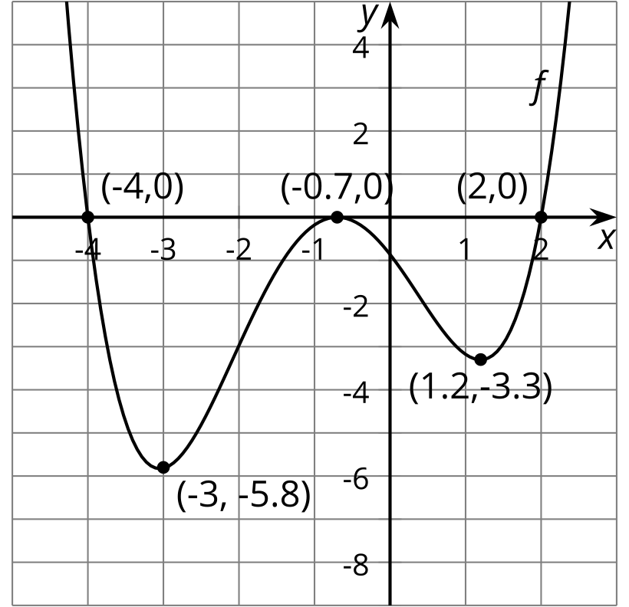
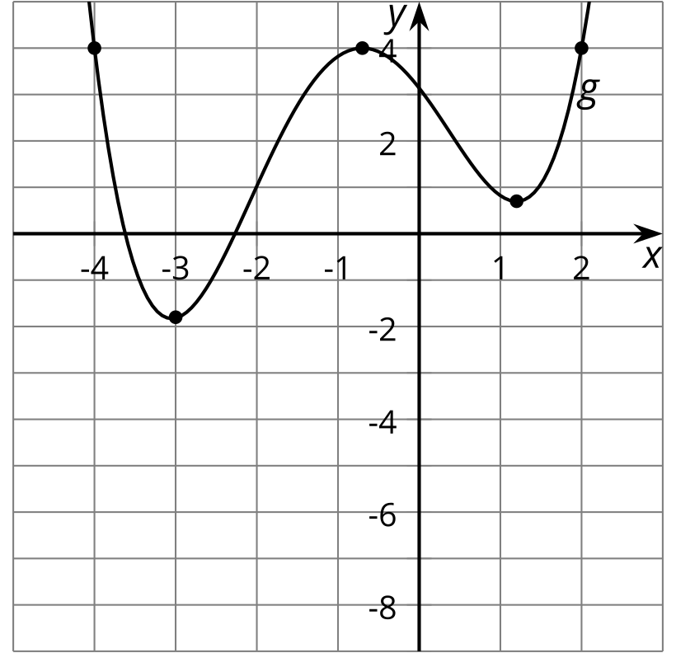
- Complete the $g\left(x\right)$ column of the table.
- If $f\left(0\right)=\text{-}0.86$, what is $g\left(0\right)$? Explain how you know.
- Write an equation for $g\left(x\right)$ in terms of $f\left(x\right)$ for any input $x$.
- The function $h$ can be written in terms of $f$ as $h\left(x\right)=f\left(x\right)−2.5$. Complete the $h\left(x\right)$ column of the table.
- $x$ | - $f\left(x\right)$ | - $g\left(x\right)$ | - $h\left(x\right)=f\left(x\right)−2.5$
- -4 | - 0
- -3 | - -5.8
- -0.7 | - 0
- 1.2 | - -3.3
- 2 | - 0
- Sketch the graph of function $h$.
- 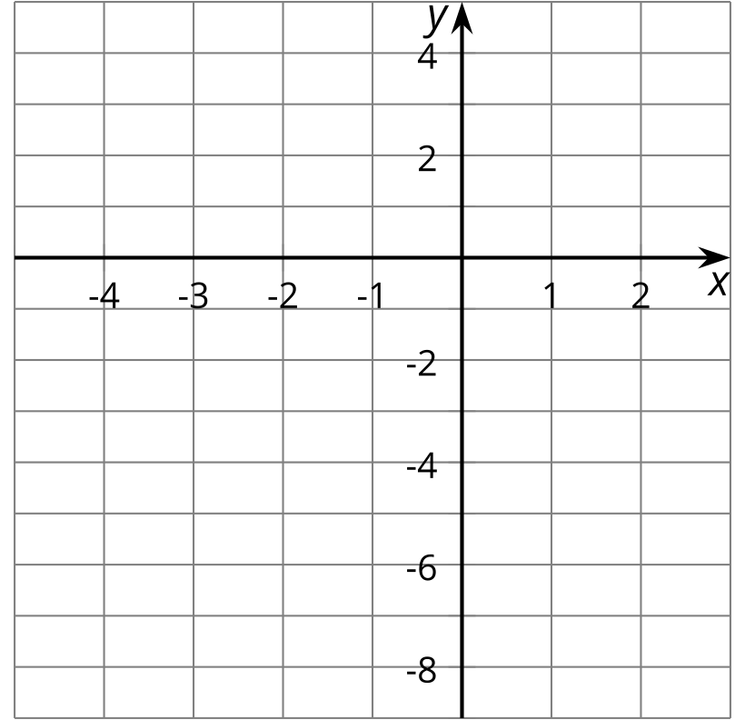
- Write an equation for $g\left(x\right)$ in terms of $h\left(x\right)$ for any input $x$.

3 Heating the Kitchen

Student Task Statement
A bakery kitchen has a thermostat set to ${65}^{∘}\text{F}$. Starting at 5:00 a.m., the temperature in the kitchen rises to ${85}^{∘}\text{F}$ when the ovens and other kitchen equipment are turned on to bake the daily breads and pastries. The ovens are turned off at 10:00 a.m. when the baking finishes.
- Sketch a graph of the function $H$ that gives the temperature in the kitchen $H\left(x\right)$, in degrees Fahrenheit, $x$ hours after midnight.
- 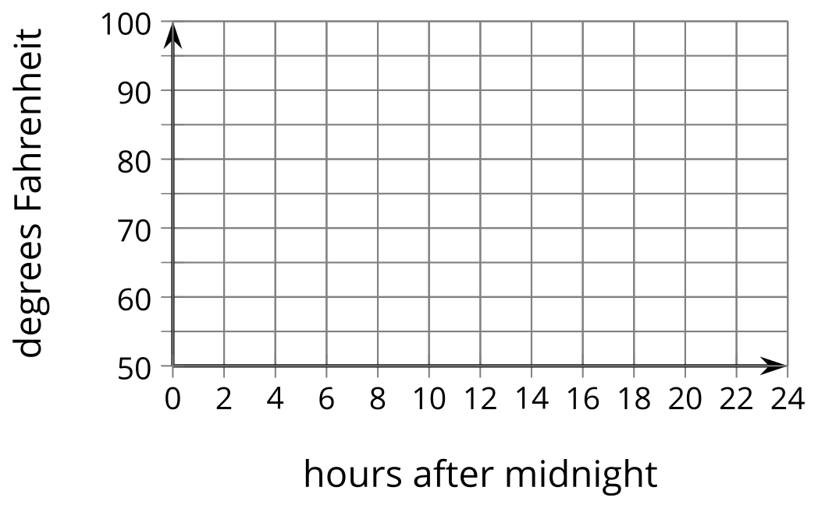
- The bakery owner decides to change the shop hours to start and end 2 hours earlier. This means the daily baking schedule will also start and end two hours earlier. Sketch a graph of the new function $G$, which gives the temperature in the kitchen as a function of time.
- Explain what $H\left(10.25\right)=80$ means in this situation. Why is this reasonable?
- If $H\left(10.25\right)=80$, then what would the corresponding point on the graph of $G$ be? Use function notation to describe the point on the graph of $G$.
- Write an equation for $G$ in terms of $H$. Explain why your equation makes sense.

Images for Activity Synthesis
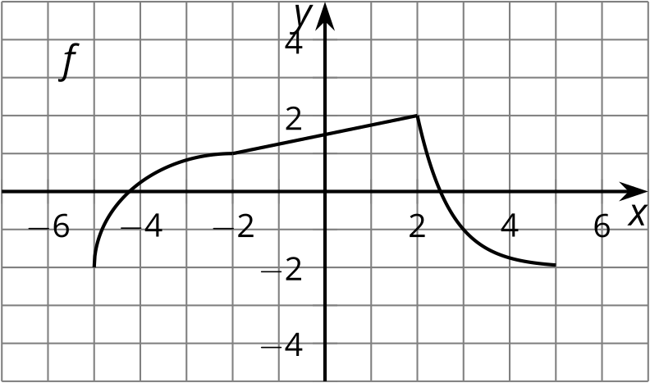
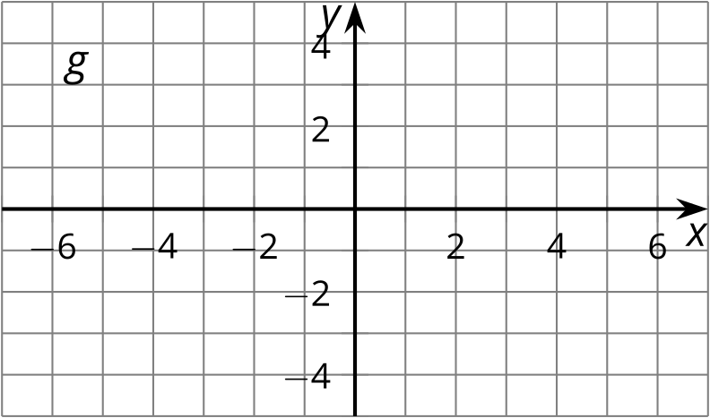
© CC BY 2019 by Illustrative Mathematics®

