Lesson 5 Practice Problems
- Technology required.
- $x$ | - $y$
- 83 | - 102
- 87 | - 115
- 91 | - 107
- 93 | - 122
- 97 | - 125
- 97 | - 127
- 101 | - 120
- 104 | - 127
  - Use graphing technology to create a scatter plot and find the best fit line.
  - What does the best fit line estimate for the $y$ value when $x$ is 100?
- Technology required.
- $x$ | - $y$
- 2.3 | - 6.2
- 2.8 | - 5.7
- 3.1 | - 4.7
- 3 | - 3.2
- 3.5 | - 3
- 3.8 | - 2.8
  - What is the equation of the line of best fit? Round numbers to 2 decimal places.
  - What does the equation estimate for $y$ when $x$ is 2.3? Round to 3 decimal places.
  - How does the estimated value compare to the actual value from the table when $x$ is 2.3?
  - How does the estimated value compare to the actual value from the table when $x$ is 3?
- Which of these scatter plots are best fit by the shown linear model?
  - 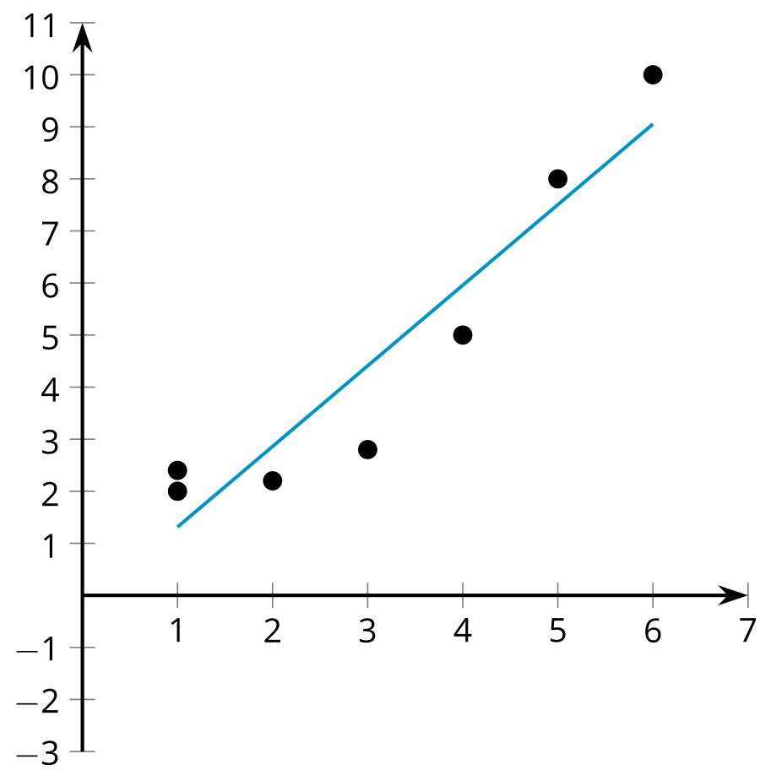
  - 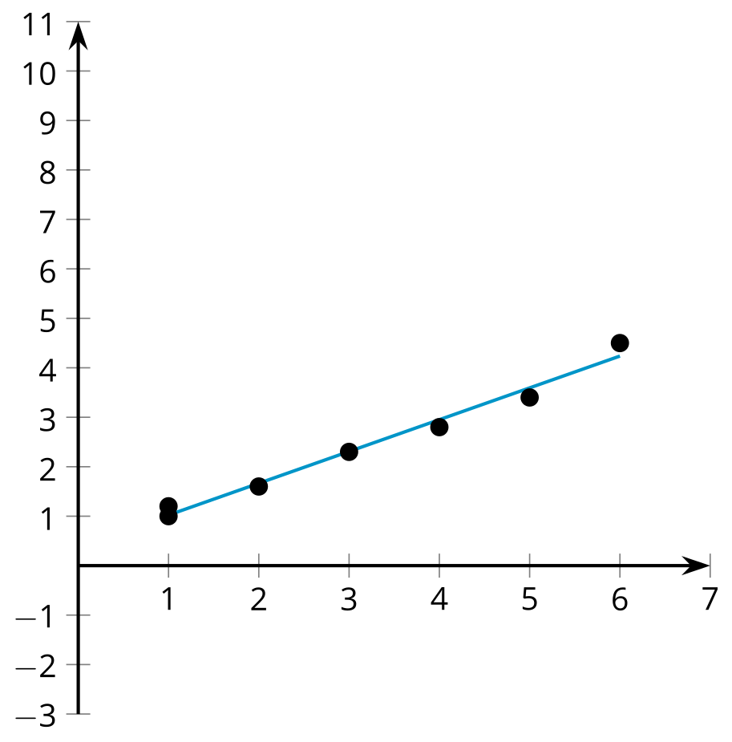
  - 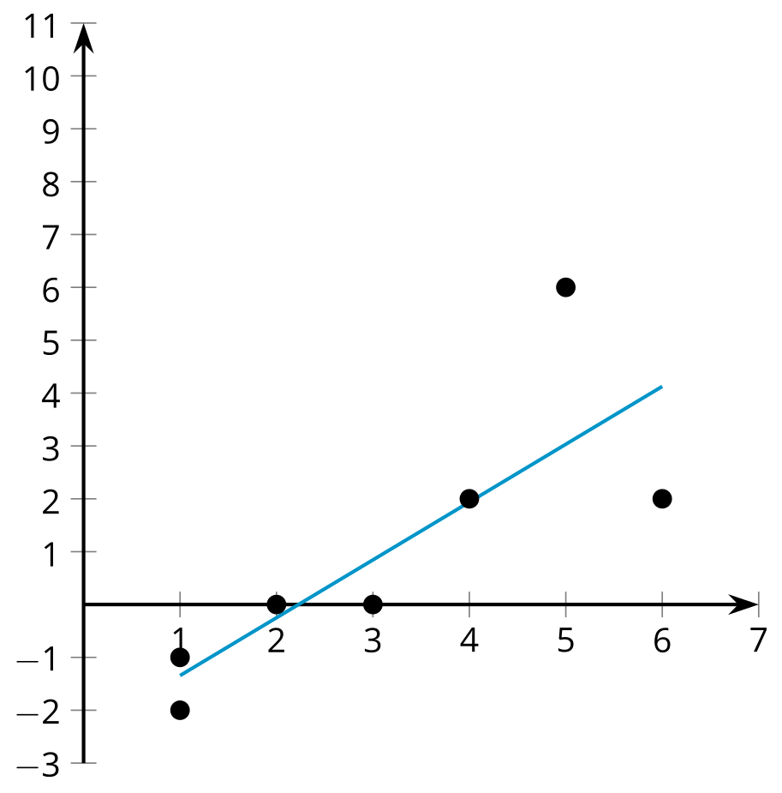
  - 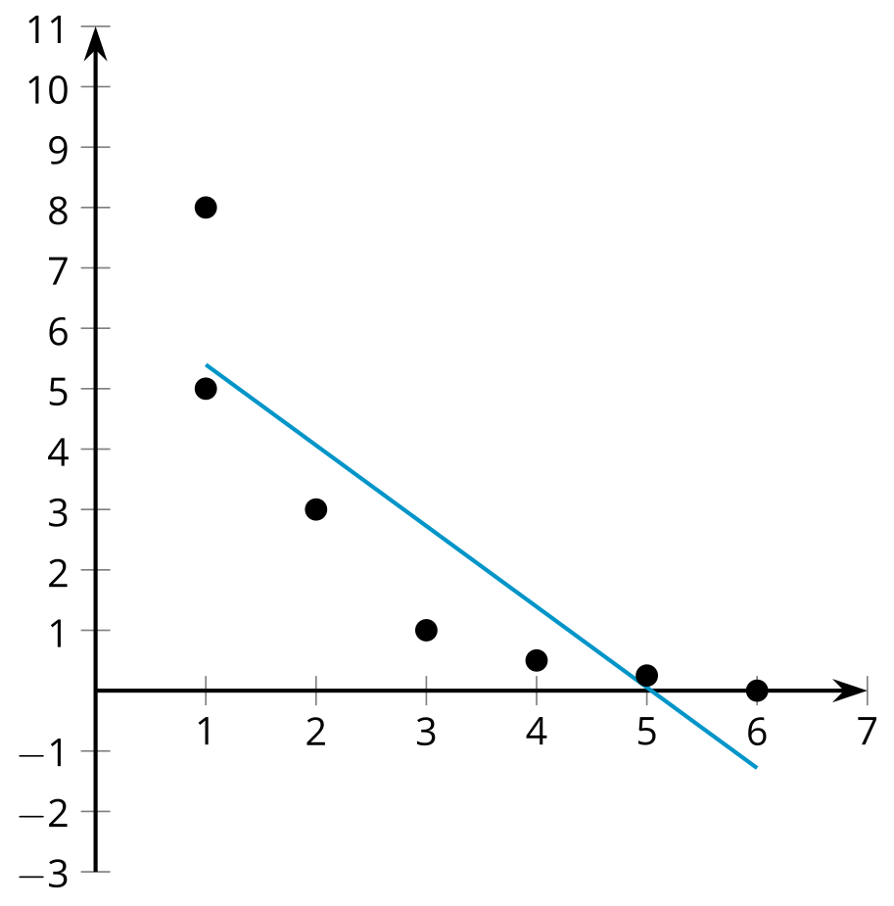
- A seed is planted in a glass pot and its height is measured in centimeters every day.
- 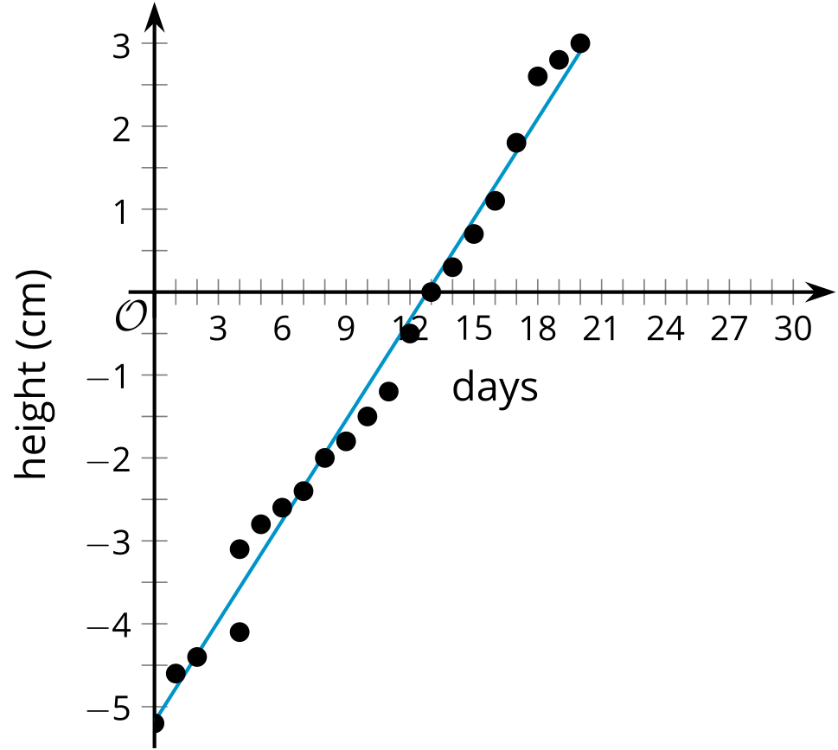
- The best fit line is given by the equation $y=0.404x−5.18$, where $y$ represents the height of the plant above ground level, and $x$ represents the number of days since it was planted.
  - What is the slope of the best fit line? What does the slope of the line mean in this situation? Is it reasonable?
  - What is the $y$-intercept of the best fit line? What does the $y$-intercept of the line mean in this situation? Is it reasonable?
- (From Unit 3, Lesson 4.)
- At a restaurant, the total bill and the percentage of the bill left as a tip is represented in the scatter plot.
- 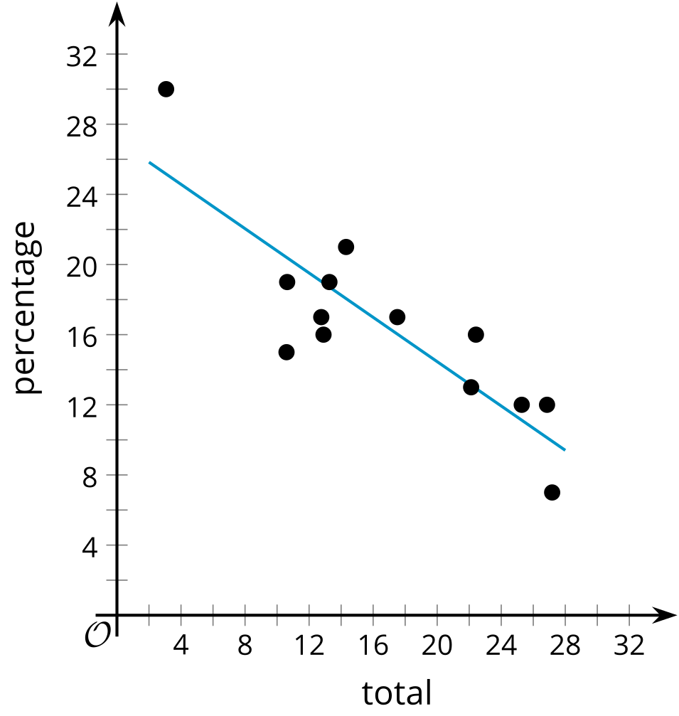
- The best fit line is represented by the equation $y=\text{-}0.632x+27.1$, where $x$ represents the total bill in dollars, and $y$ represents the percentage of the bill left as a tip.
  - What does the best fit line estimate for the percentage of the bill left as a tip when the bill is $15? Is this reasonable?
  - What does the best fit line predict for the percentage of the bill left as a tip when the bill is $50? Is this reasonable?
- (From Unit 3, Lesson 4.)
- A recent study investigated the amount of battery life remaining in alkaline batteries of different ages. The scatter-plot shows this relationship between the different alkaline batteries tested.
- 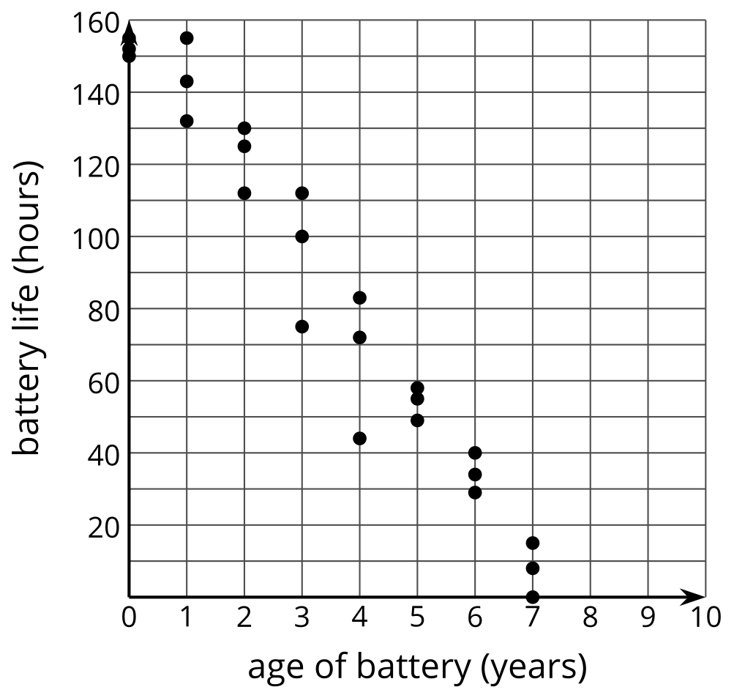
- The scatter plot includes a point at $\left(7,15\right)$. Describe the meaning of this point in this situation.
- (From Unit 3, Lesson 4.)
© CC BY 2019 by Illustrative Mathematics®

