Lesson 3: Volumes of Prism Drawings
- Let's use layers to find volume.

Warm-up: Number Talk: Multiplication
Find the value of each expression mentally.
- $6×4$
- $3×2×4$
- $3×2×5$
- $3×2×6$
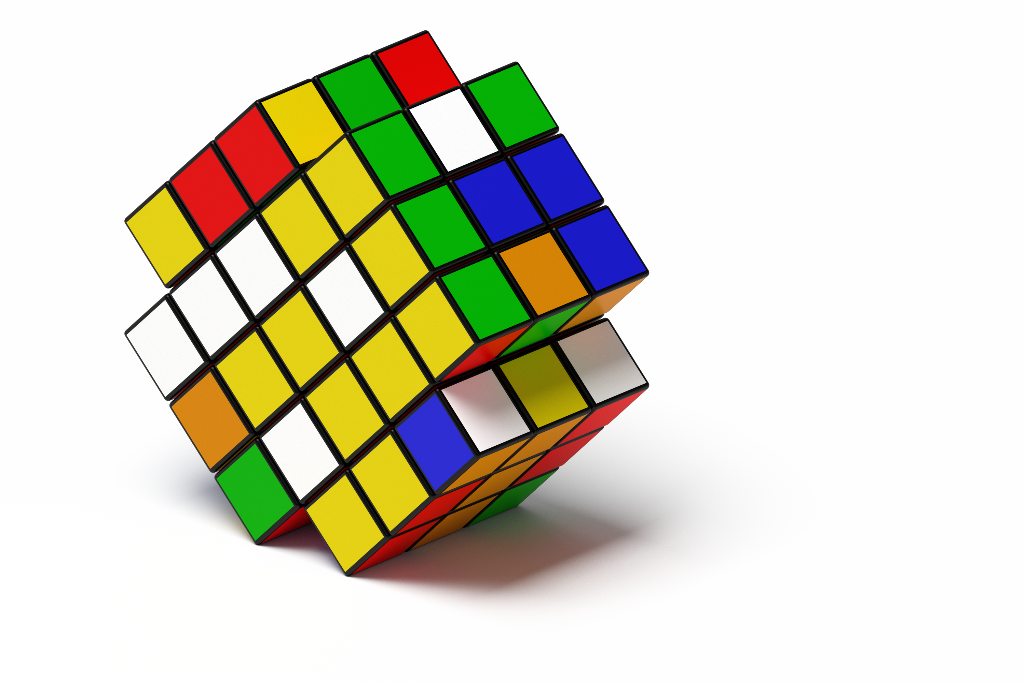

3.1: Build Rectangular Prisms
The prisms on the cards are completely packed with unit cubes.
- Pick a card.
- Build the rectangular prism.
- Find the volume. Explain how you found the volume to your partner.
- Repeat.
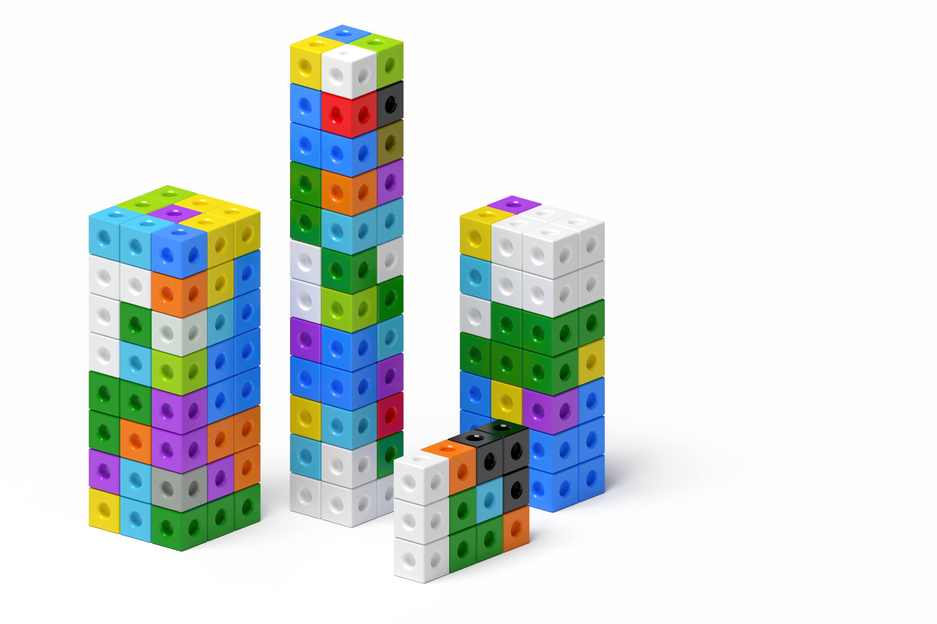

3.2: Layers, layers, and more layers
The prisms are completely packed with unit cubes. Determine the volume of each prism. Explain or show your reasoning.

- 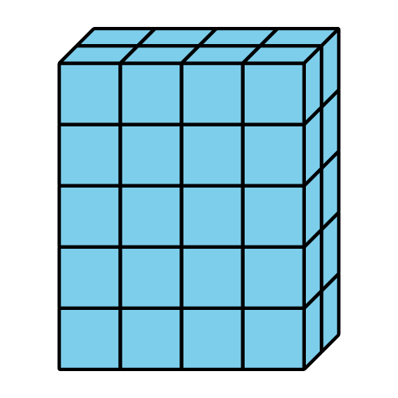

- 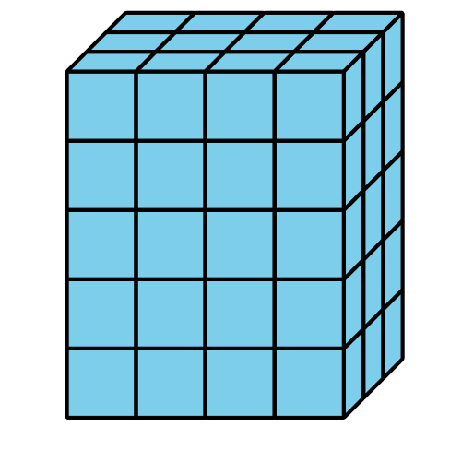

- 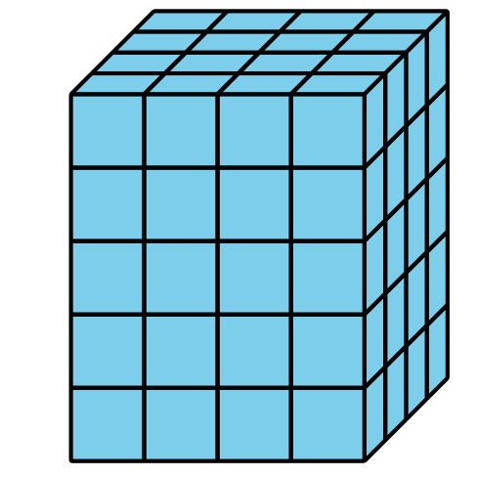
© CC BY 2021 Illustrative Mathematics®

