Lesson 14 Practice Problems
- We know these things about a polynomial function, $f(x)$: it has exactly one relative maximum and one relative minimum, it has exactly three zeros, and it has a known factor of $(x−4)$. Sketch a graph of $f(x)$ given this information.
- 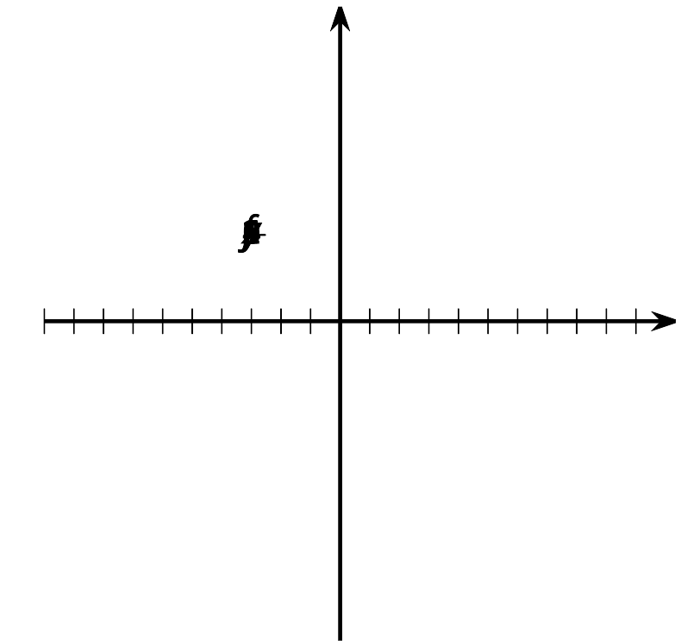
- Mai graphs a polynomial function, $f(x)$, that has three linear factors $(x+6)$, $(x+2)$, and $(x−1)$. But she makes a mistake. What is her mistake?

- 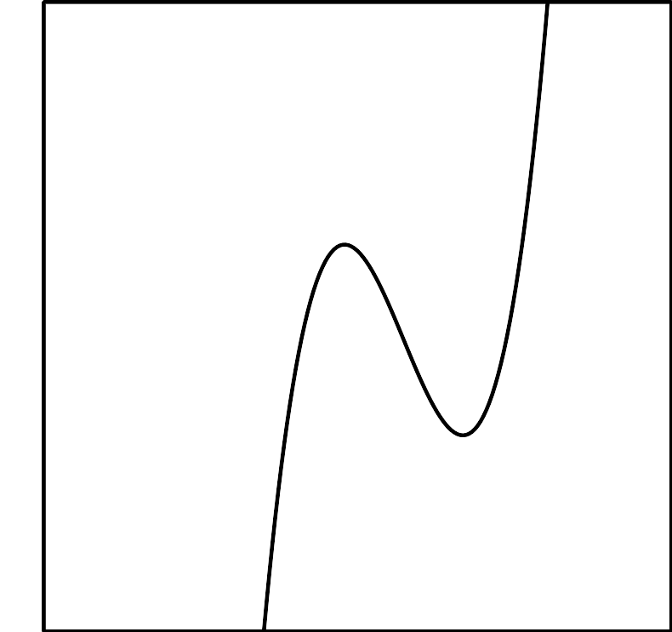
- Here is the graph of a polynomial function with degree 4.
- Select all of the statements that are true about the function.
- 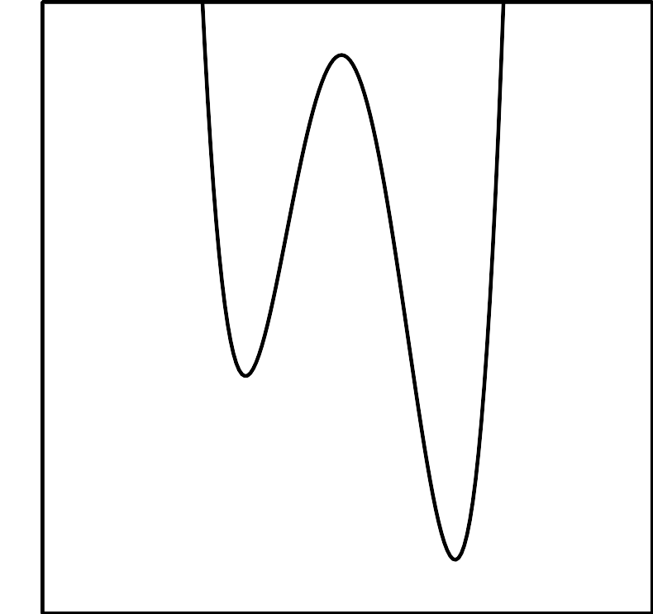
  - The leading coefficient is positive.
  - The constant term is negative.
  - It has 2 relative maximums.
  - It has 4 linear factors.
  - One of the factors is $(x−1)$.
  - One of the zeros is $x=2$.
  - There is a relative minimum between $x=1$ and $x=3$.
- State the degree and end behavior of $f(x)=2x^{3}−3x^{5}−x^{2}+1$. Explain or show your reasoning.
- (From Unit 2, Lesson 9.)
- Is this the graph of $g(x)=(x−1)^{2}(x+2)$ or $h(x)=(x−1)(x+2)^{2}$? Explain how you know.
- 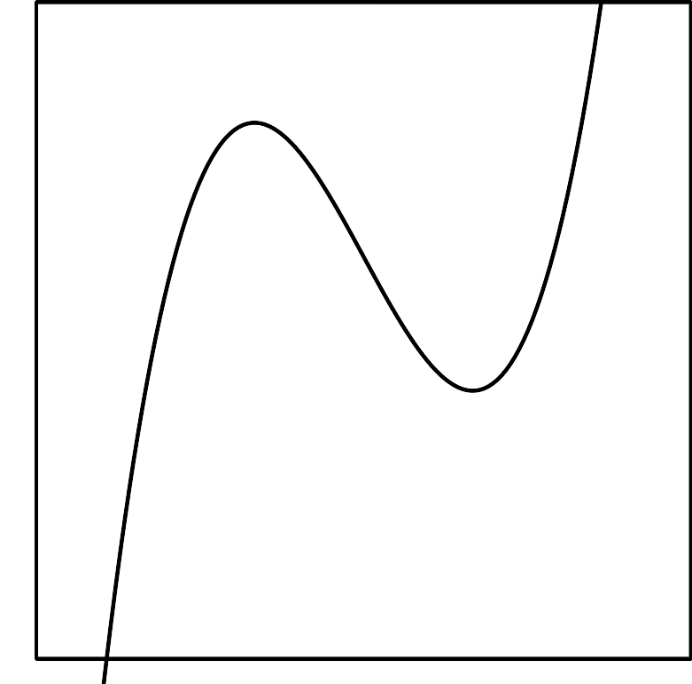
- (From Unit 2, Lesson 10.)
- Kiran thinks he knows one of the linear factors of $P(x)=x^{3}+x^{2}−17x+15$. After finding that $P(3)=0$, Kiran suspects that $x−3$ is a factor of $P(x)$, so he sets up a diagram to check. Here is the diagram he made to check his reasoning, but he set it up incorrectly. What went wrong?

 | - $x^{2}$ | - $4x$ | - -5
- $x$ | - $x^{3}$ | - $4x^{2}$ | - $\text{-}5x$
- 3 | - $3x^{2}$ | - $12x$ | - 15
- (From Unit 2, Lesson 12.)
- The polynomial function $B(x)=x^{3}+8x^{2}+5x−14$ has a known factor of $(x+2)$. Rewrite $B(x)$ as a product of linear factors.
- (From Unit 2, Lesson 13.)
© CC BY 2019 by Illustrative Mathematics®

