Lesson 3: Compose Three-digit Numbers
- Let’s compose three-digit numbers.

Warm-up: Number Talk: Add Tens and Ones
Find the value of each expression mentally.
- $42+42$
- $21+63$
- $50+34$
- $48+36$

3.1: Sort Blocks by Value
- Sort the blocks.
  - We have _________ hundreds.
  - We have _________ tens.
  - We have _________ ones.
- Represent the same value with the fewest number of blocks possible.
  - We have _________ hundreds.
  - We have _________ tens.
  - We have _________ ones.
- Represent the value of your blocks using base-ten diagrams, words, or numbers.
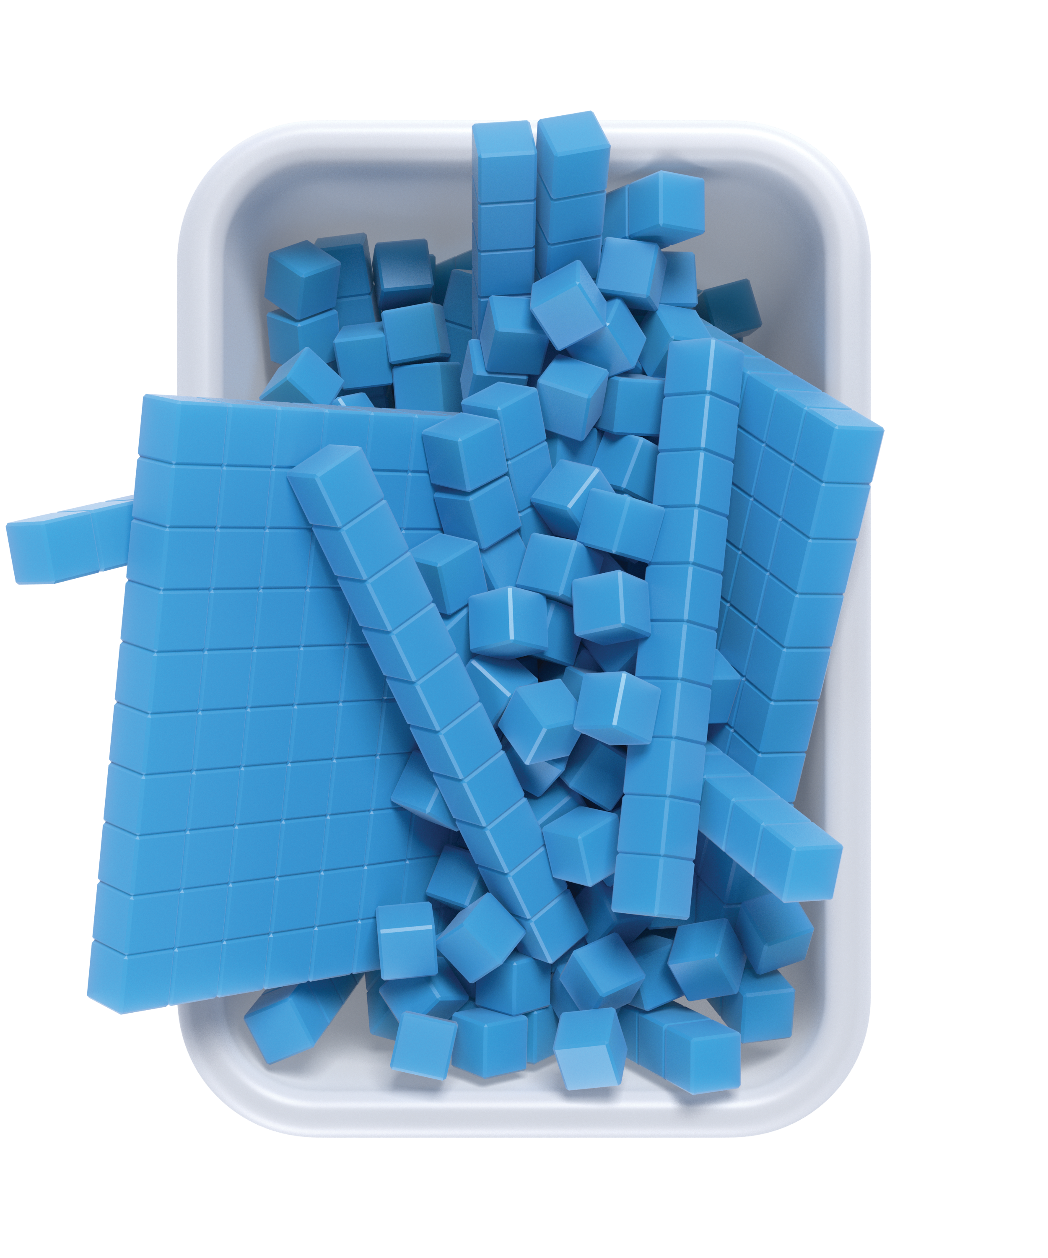

3.2: The Same But Different
Mai’s Blocks
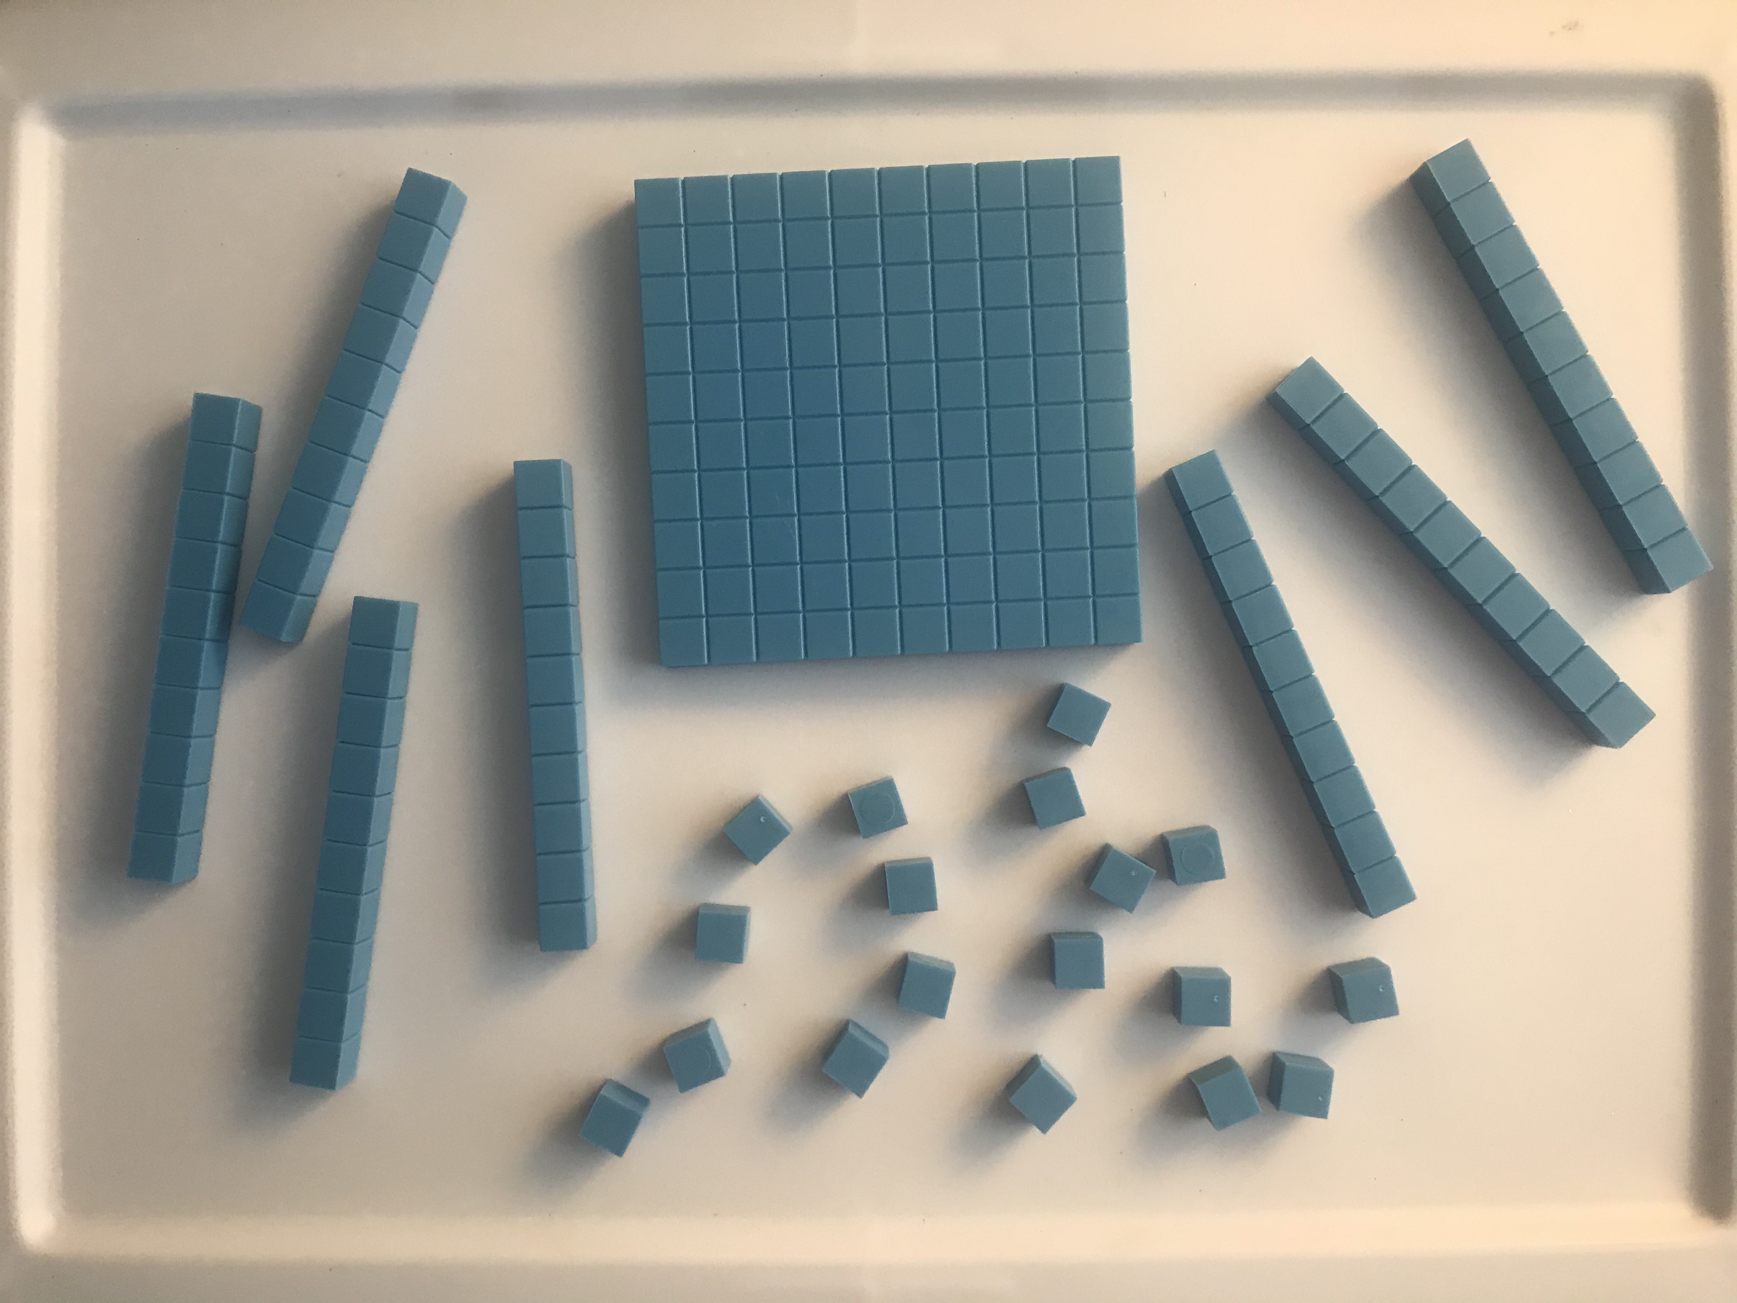
- Mai has ______ hundreds _____ tens _____ ones.
- Draw a base-ten diagram to represent the same total value with the fewest number of each unit.
- What is the value of Mai’s blocks?
- Diego’s Blocks
- 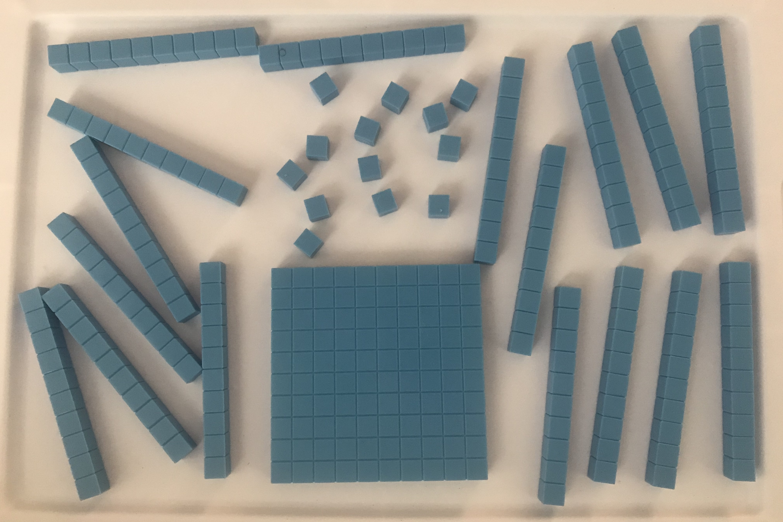
- Diego has ______ hundreds _____ tens _____ ones.
- Draw a base-ten diagram to represent the same total value with the fewest number of each unit.
- What is the value of Diego’s blocks?
© CC BY 2021 Illustrative Mathematics®

