Unit 6 Lesson 6: Compose and Decompose Shapes

WU Notice and Wonder: A Picture of Shapes (Warm up)

Student Task Statement
What do you notice? What do you wonder?
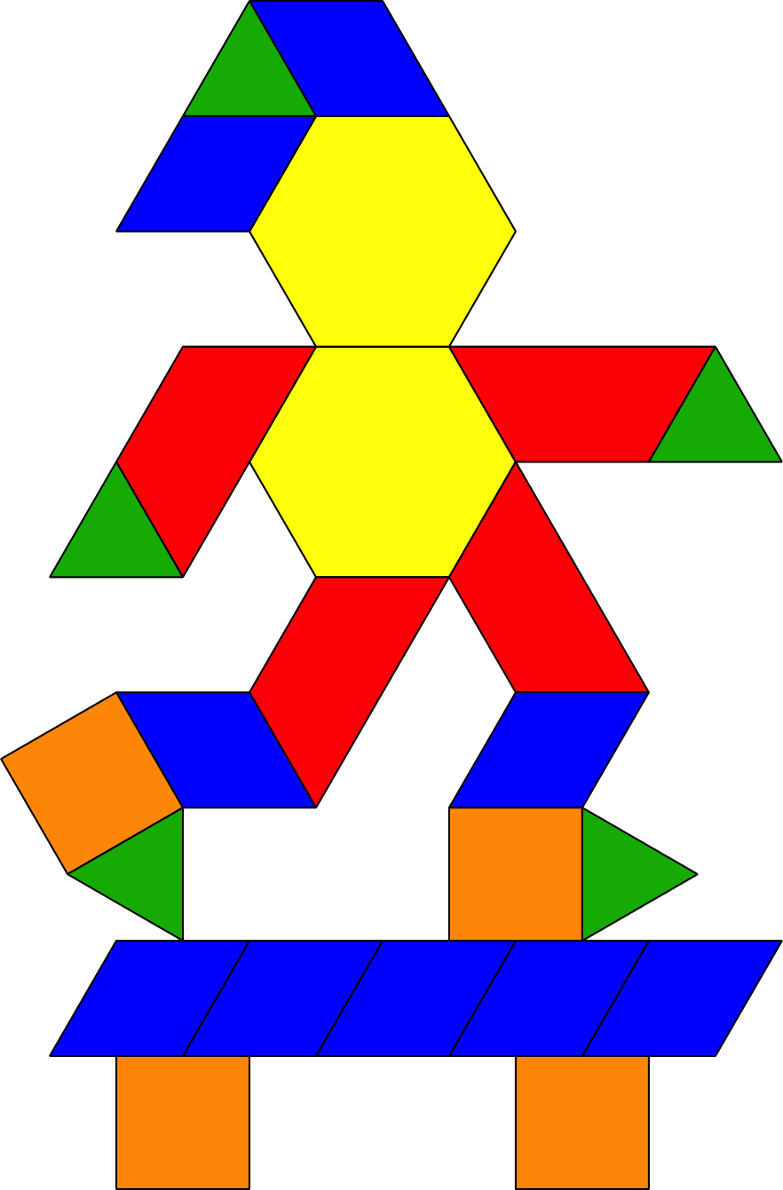

1 Many Ways to Compose Shapes

Student Task Statement
Mai used pattern blocks to make this design. Work with a partner to make the same design without using any yellow hexagons.
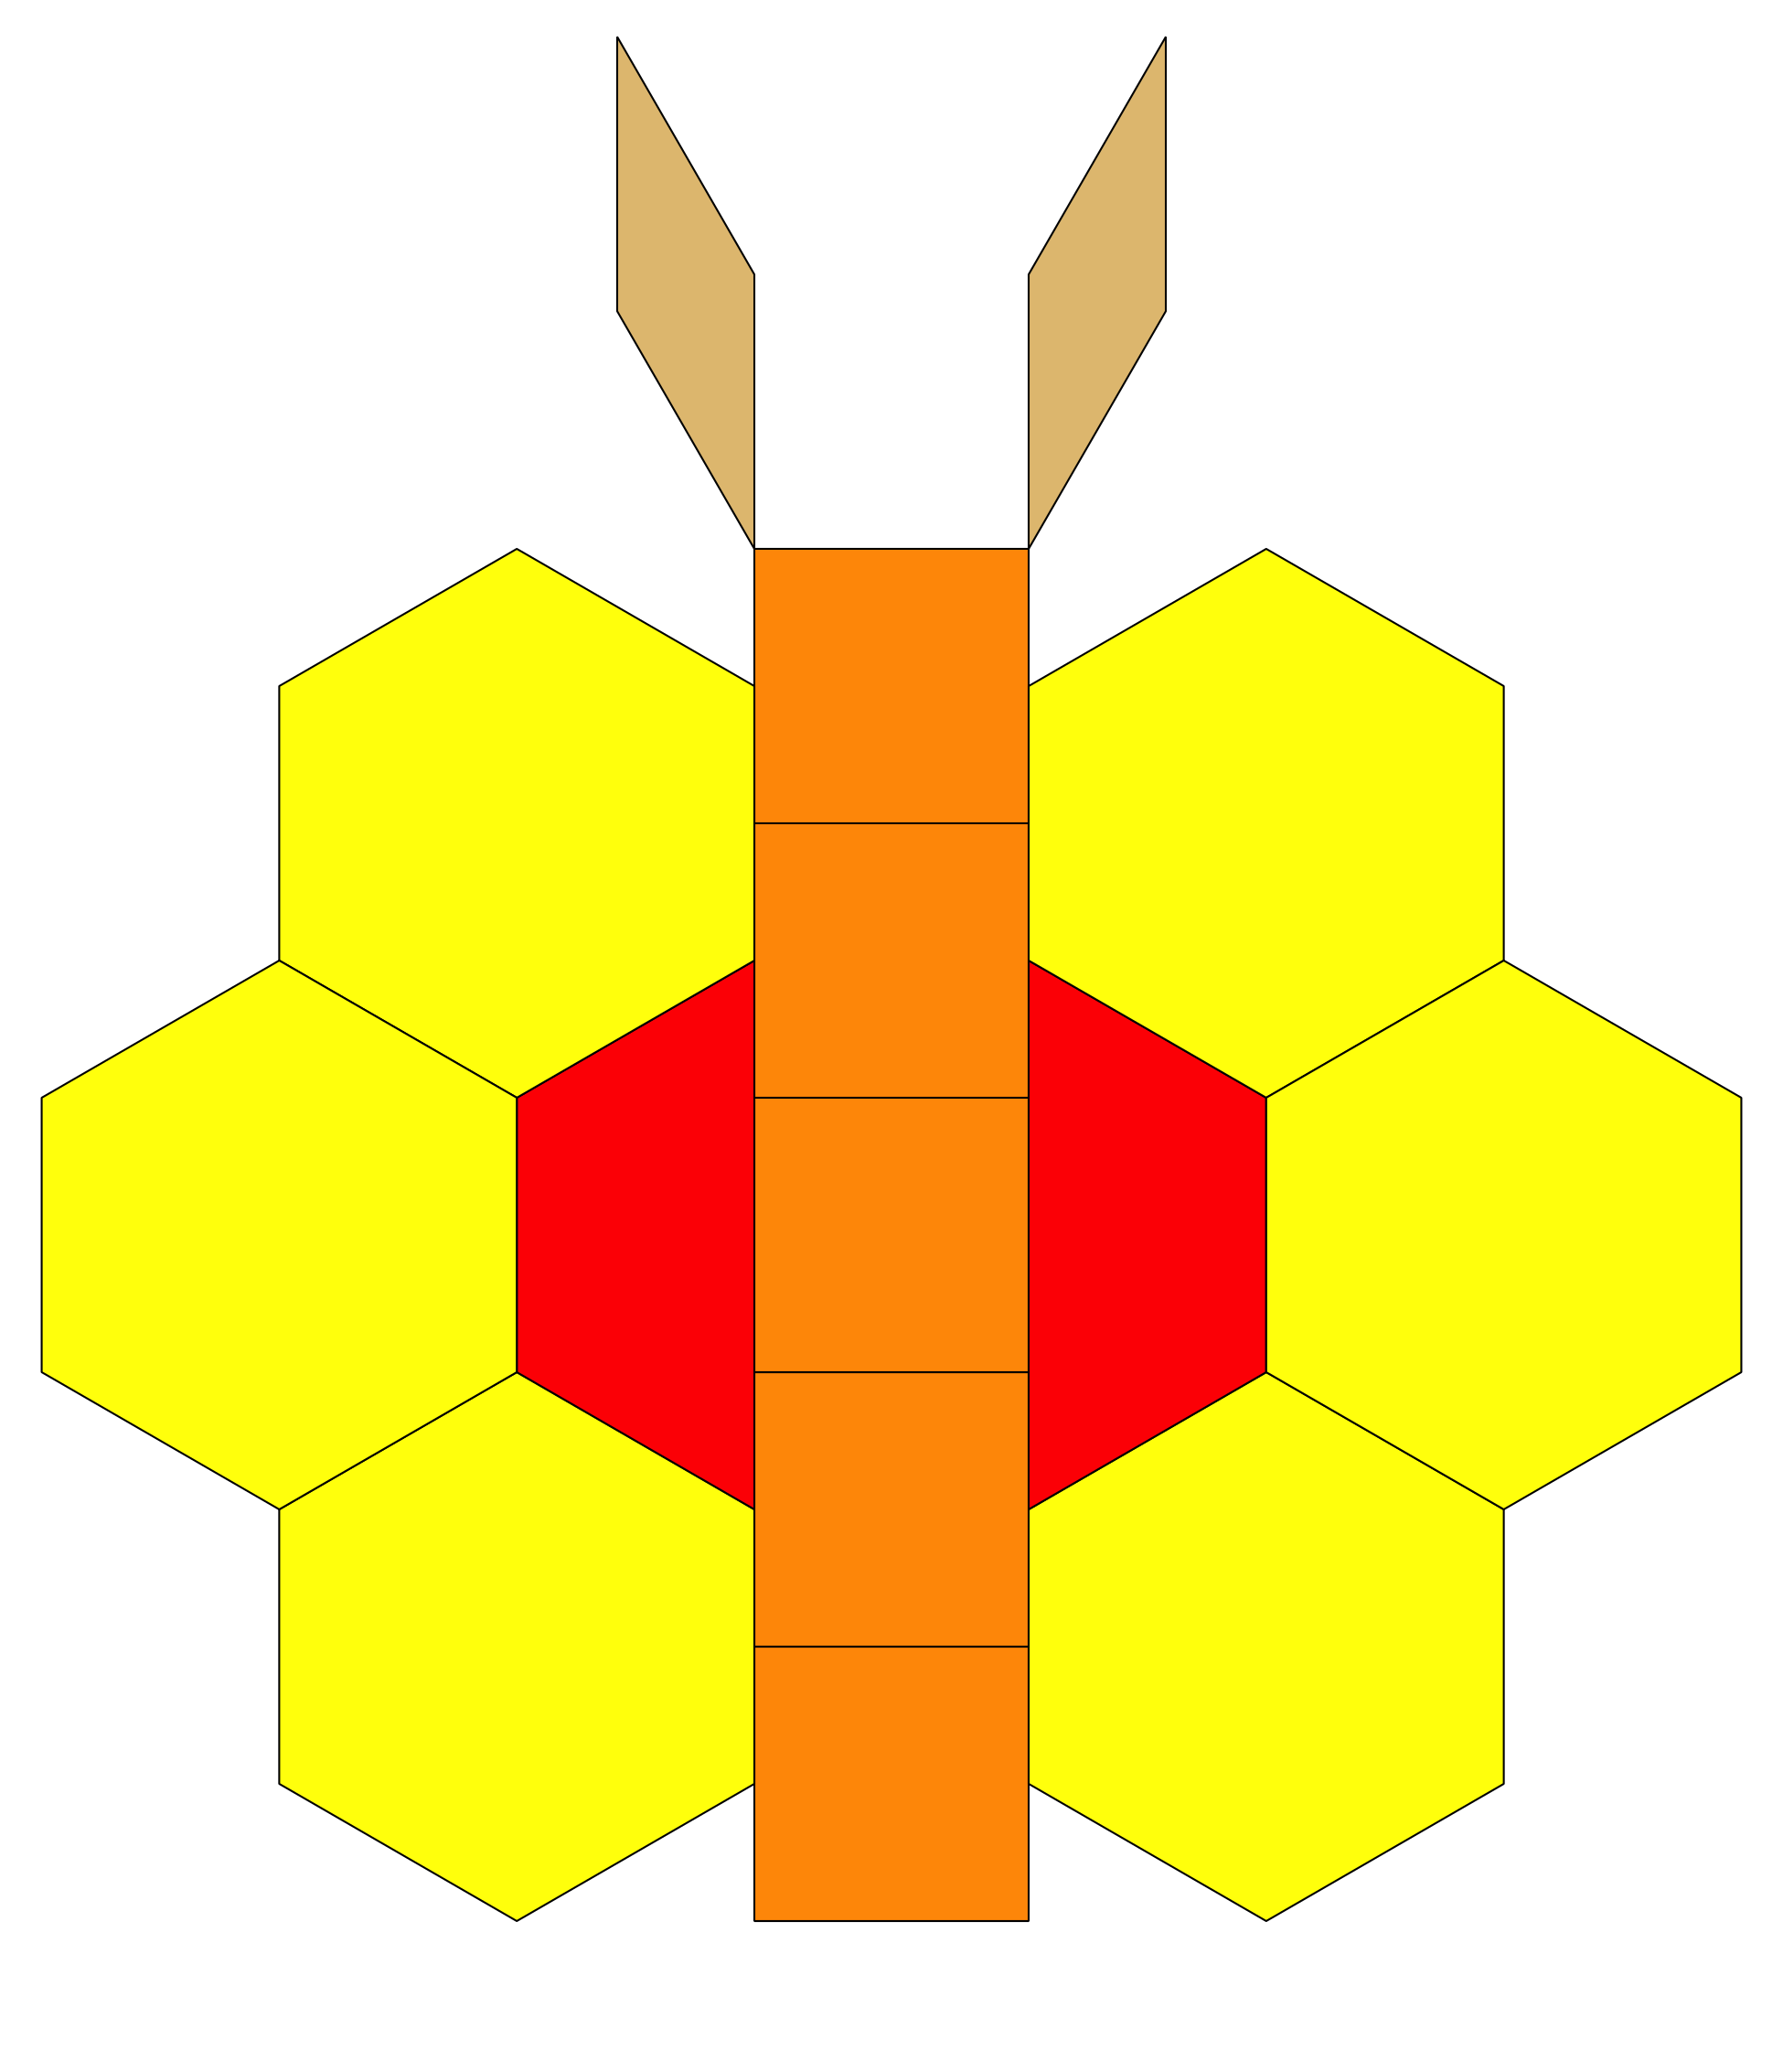

Activity Synthesis
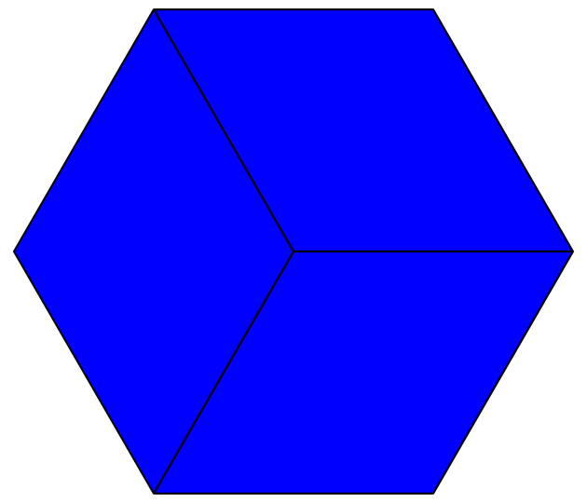
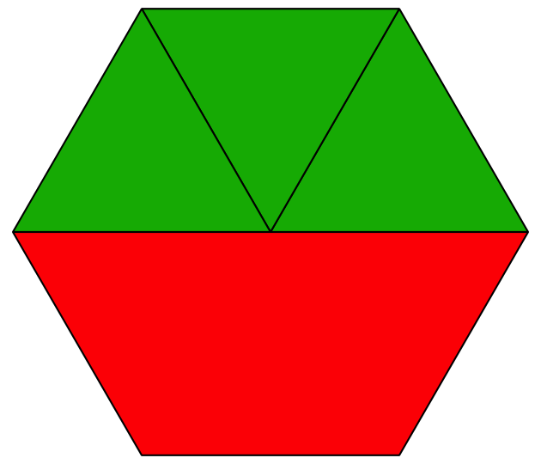
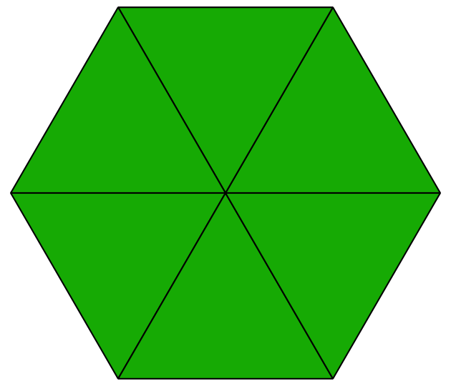
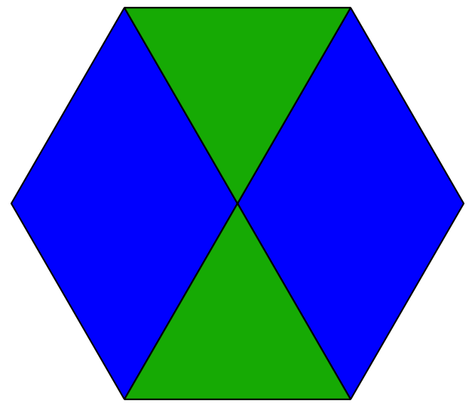
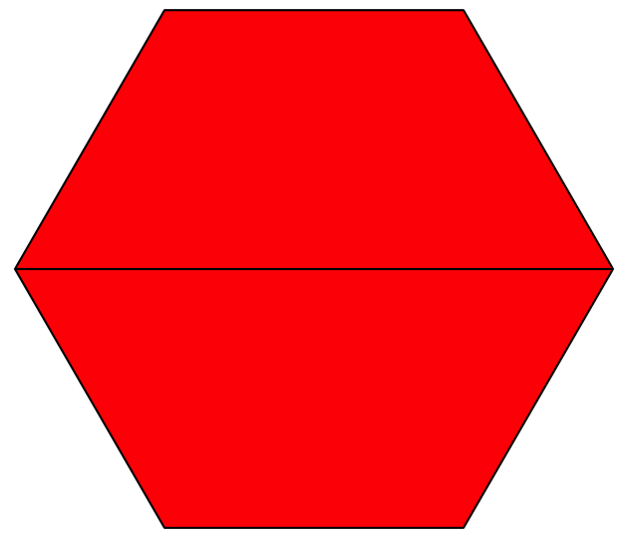
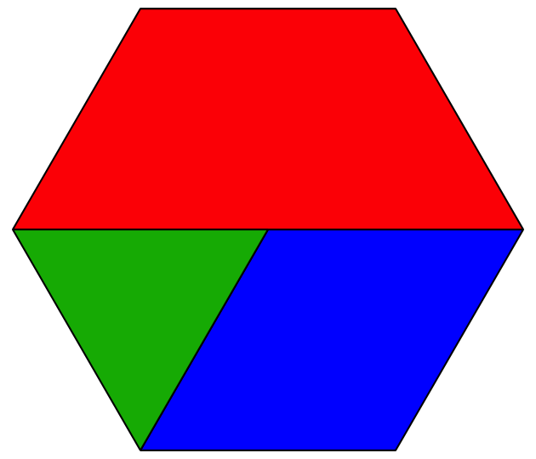

2 Compose Shapes with Equal-size Pieces

Student Task Statement
What is the same? What is different?
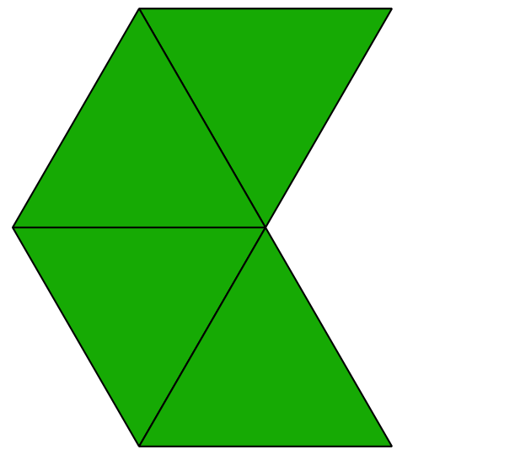
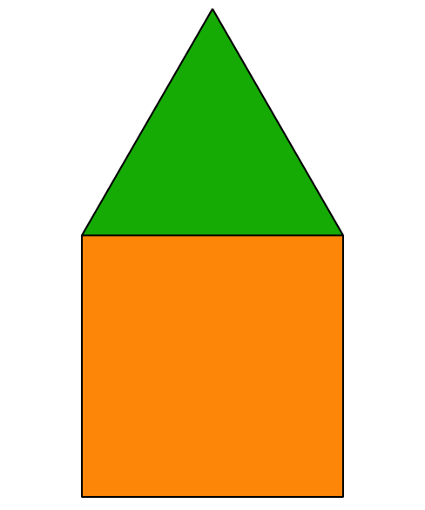
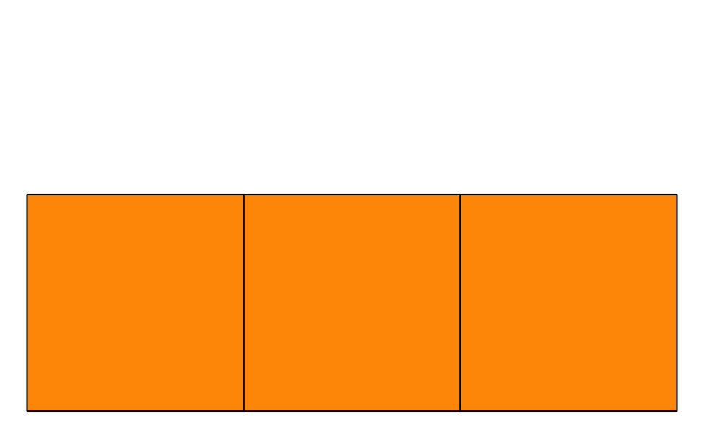
- Compose 3 different shapes using 2, 3, or 4 of the same equal-size shape.
- Show the outline of each block on the grid paper.
- Name each shape and explain how you composed it.
- I used ________________________________
- to compose a _____________________________.
- I used ________________________________
- to compose a _____________________________.
- I used ________________________________
- to compose a _____________________________.
© CC BY 2021 Illustrative Mathematics®

