Unit 2 Lesson 17: How Do the Stories Compare?

WU Which One Doesn’t Belong: Equations (Warm up)

Student Task Statement
Which one doesn’t belong?
- $6+4=10$
- $10−4=6$
- $2+2+2=6$
- $6=2+4$

1 Compare Stories

Student Task Statement
- Compare these stories about playing 4 corners.
- 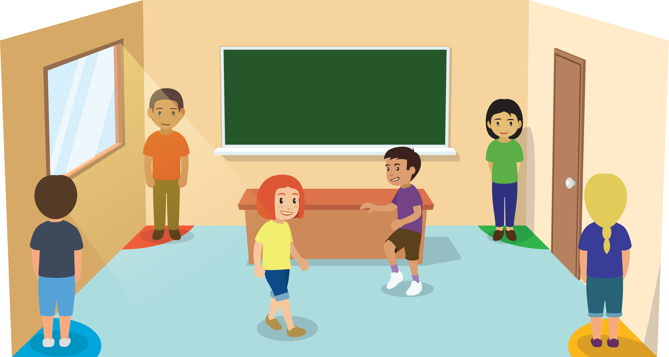
- There are 6 students playing 4 corners.
Some more students come to play.
Now there are 9 students playing 4 corners.
How many students came to play?
- 9 students are playing 4 corners.
7 students are waiting in a corner.
The other students are still deciding which corner to pick.
How many students are still deciding which corner to pick?
  - How are these problems alike?
  - How are they different?
  - Be prepared to share your thinking.
- Compare these stories about playing charades.
- 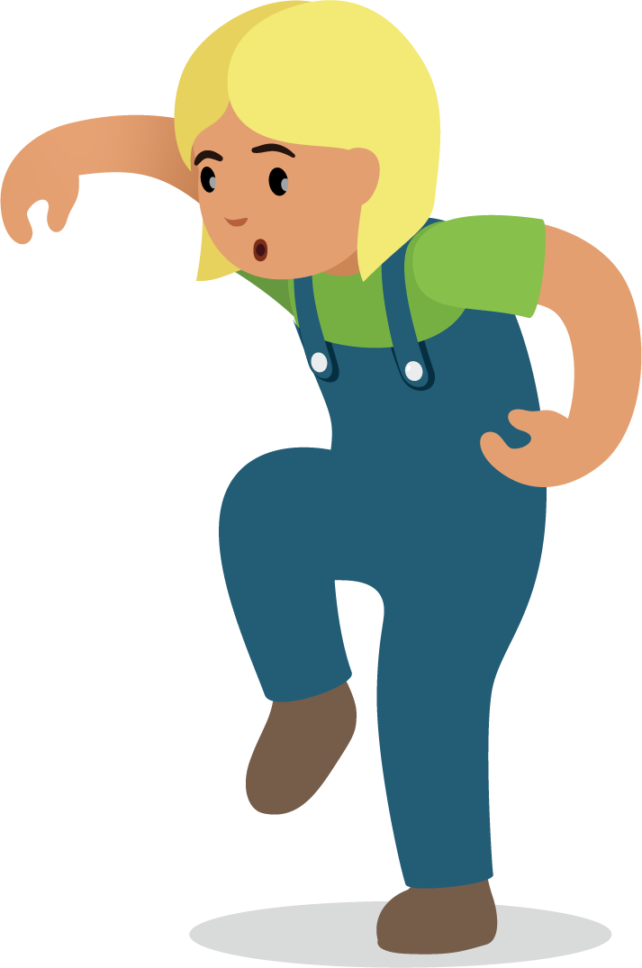
- There were 9 students playing charades.
6 students leave to play something different.
How many students are playing charades now?
- 9 students are playing charades.
5 students are on Team A.
The rest of the students are on Team B.
How many students are on Team B?
  - How are these problems alike?
  - How are they different?
  - Be prepared to share your thinking.

2 Outdoor Games

Student Task Statement
Show your thinking using drawings, numbers, or words.
Equation: ________________________________
© CC BY 2021 Illustrative Mathematics®

