Lesson 7: Introduction to Liquid Volume
- Let’s learn about liquid volume.

Warm-up: Notice and Wonder: The Bowl and the Jar
What do you notice? What do you wonder?
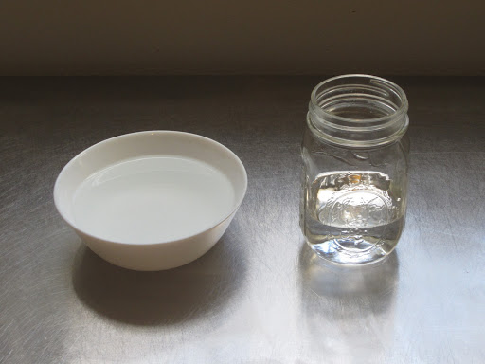

7.1: Liquid Volume Estimation Exploration
Your teacher will give you two containers labeled “A” and “B,” and another container labeled “unit.”
- How many units do you think container A will hold?
- Record an estimate that is:
- too low | - about right | - too high
- How many units do you think container B will hold?
- Record an estimate that is:
- too low | - about right | - too high
- Use the unit container to compare the liquid volume that containers A and B hold. Which container holds the greater volume? How do you know?

7.2: Liquid Volume in Liters
How many liters of water will fit in the large container?
Record an estimate that is:
too low | about right | too high
© CC BY 2021 Illustrative Mathematics®

