Unit 8 Lesson 13: How Many Do You See?

WU How Many Do You See: Equal Groups (Warm up)

Student Task Statement
How many do you see? How do you see them?
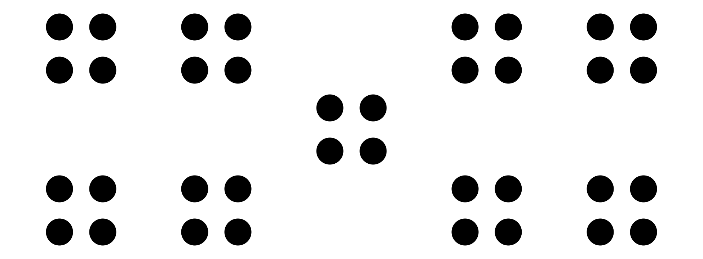

1 Design Your How Many Do You See

Student Task Statement
- Draw a dot image that would encourage your classmates to count equal groups.
- Write down possible ways students might see the dots in your image.
- Ways students might see the dots:

2 Facilitate Your How Many Do You See

Student Task Statement
- Ask your classmates, “How many do you see? How do you see them?”
- Flash your image.
- Give 30 seconds quiet think time.
- Display your image.
- Give them a minute to discuss together.
- Ask them to share how many they saw and how they saw them.
- Record their ideas.
© CC BY 2021 Illustrative Mathematics®

