Lesson 4: Points and Lines All Around
- Let’s find parallel and intersecting lines all around us.

Warm-up: Which One Doesn’t Belong: Four-sided Shapes
Which one doesn’t belong?
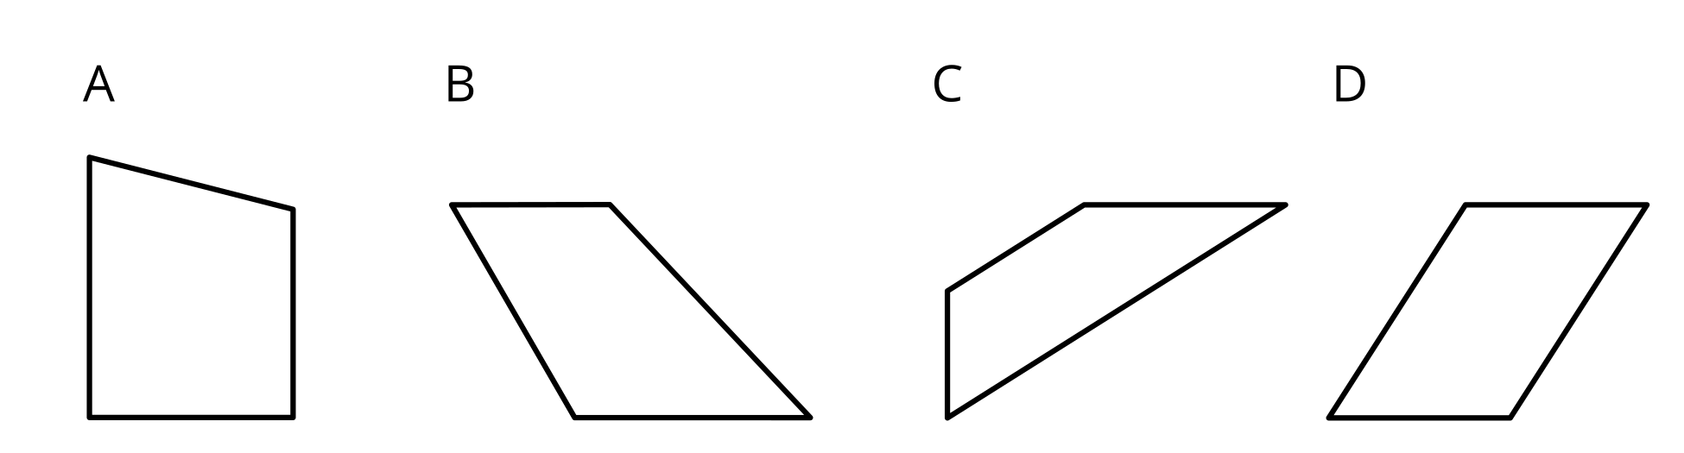

4.1: Spot Lines and Line Segments
- Here is a map of a neighborhood in Staten Island, New York.
- 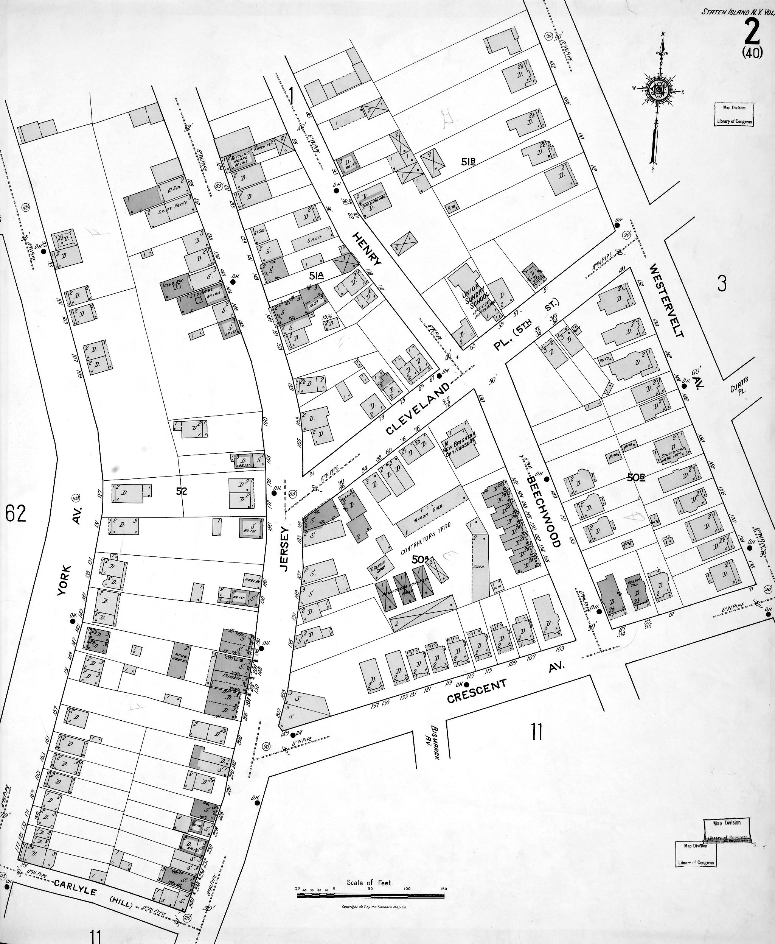
- On the map, find and label the following items:
  - 4 line segments of different lengths
  - 3 pairs of parallel lines
  - 2 pairs of lines that are not parallel
- (Consider using different colors for the different types of lines.)
- In the words WHALE and JOY,
- which letter has:
  - No parallel segments? _________________________
  - Exactly one pair of parallel segments? _________________________
  - More than one pair of parallel segments? _________________________
  - Only one segment? _________________________
If you have time: Which does the uppercase alphabet use more: parallel segments or intersecting segments?

4.2: Draw and Design with Lines
- Draw a sketch of a part of our classroom and be sure to include:
  - at least 3 pairs of parallel line segments
  - intersecting line segments that make square corners
  - intersecting line segments that don’t make square corners
- Trade sketches with a partner and find the specified lines in each other’s sketches.
- Here are some symbols and logos that you may recognize. All of them have intersecting and parallel line segments.
- Design a logo with at least 8 parallel segments and 8 intersecting line segments.
- Use a ruler for any straight parts of your logo.
© CC BY 2021 Illustrative Mathematics®

