Unit 5 Lesson 7 Cumulative Practice Problems
- Here is a rectangle that has been partitioned into four smaller rectangles.
- 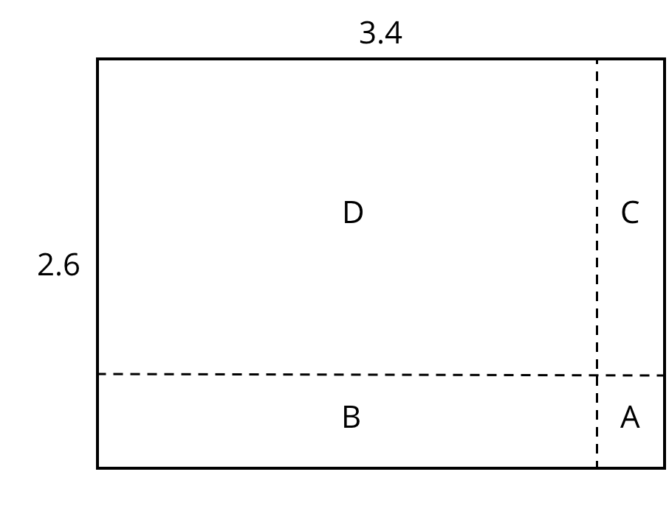
- For each expression, choose the sub-rectangle whose area, in square units, matches the expression.
  - $3⋅(0.6)$
  - $(0.4)⋅2$
  - $(0.4)⋅(0.6)$
  - $3⋅2$
- Here is an area diagram that represents $(3.1)⋅(1.4)$.
- 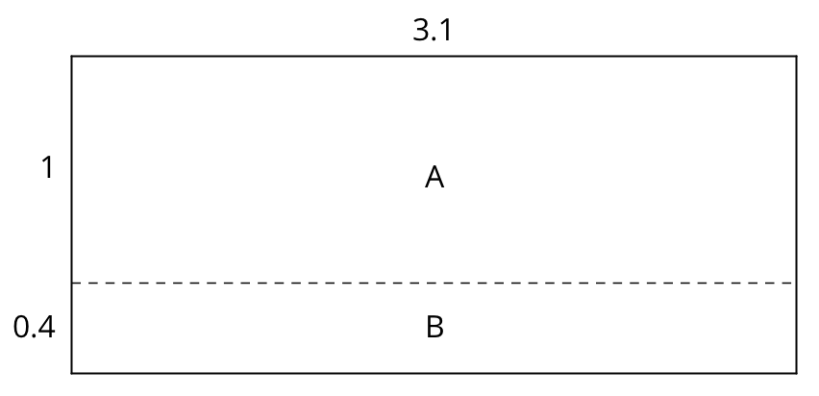
  - Find the areas of sub-rectangles A and B.
  - What is the area of the 3.1 by 1.4 rectangle?
- Draw an area diagram to find $(0.36)⋅(0.53)$. Label and organize your work so that it can be followed by others.
- Find each product. Show your reasoning.
  - $(2.5)⋅(1.4)$
  - $(0.64)⋅(0.81)$
- Complete the calculations so that each shows the correct sum.
- 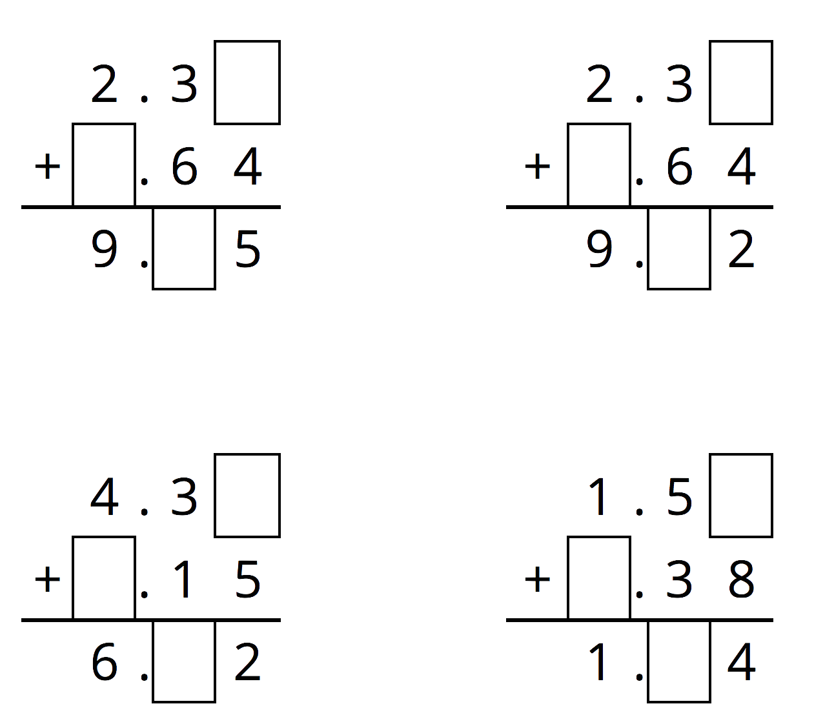
- (From Unit 5, Lesson 3.)
- Diego bought 12 mini muffins for $4.20.
  - At this rate, how much would Diego pay for 4 mini muffins?
  - How many mini muffins could Diego buy with $3.00? Explain or show your reasoning. If you get stuck, consider using the table.
- number of  mini muffins | - price in  dollars
- 12 | - 4.20
- (From Unit 2, Lesson 12.)
© CC BY Open Up Resources. Adaptations CC BY IM.

