Unit 5 Lesson 6 Cumulative Practice Problems
- Create a graph that shows three linear relationships with different $y$-intercepts using the following slopes, and write an equation for each line.
- Slopes:
  - $\frac{1}{5}$
  - $\frac{3}{5}$
  - $\frac{6}{5}$
- 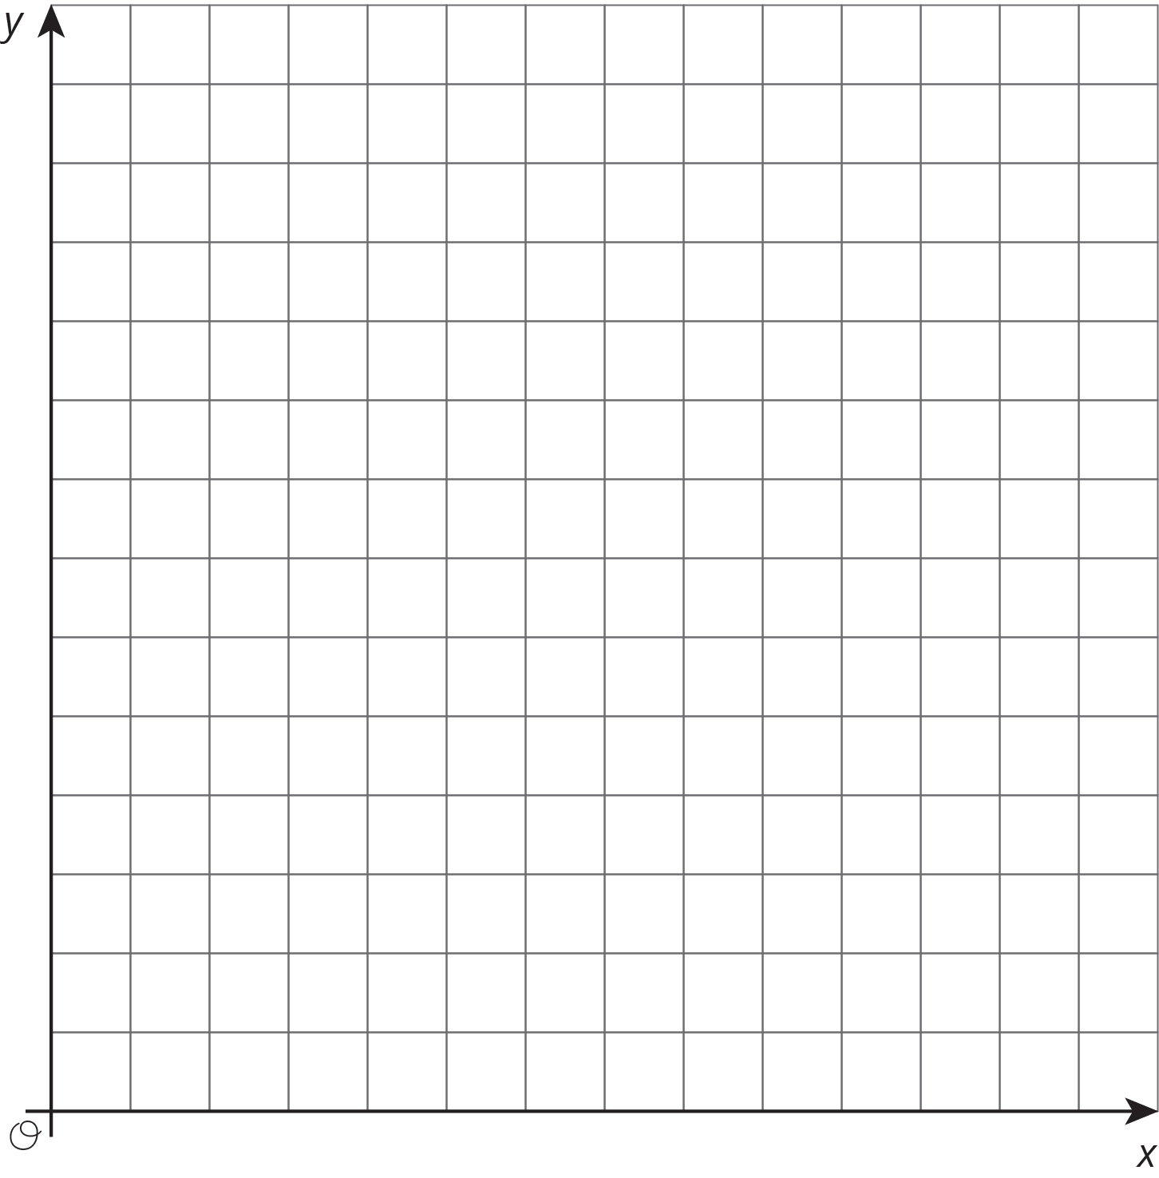
- The graph shows the height in inches, $h$, of a bamboo plant $t$ months after it has been planted.
- 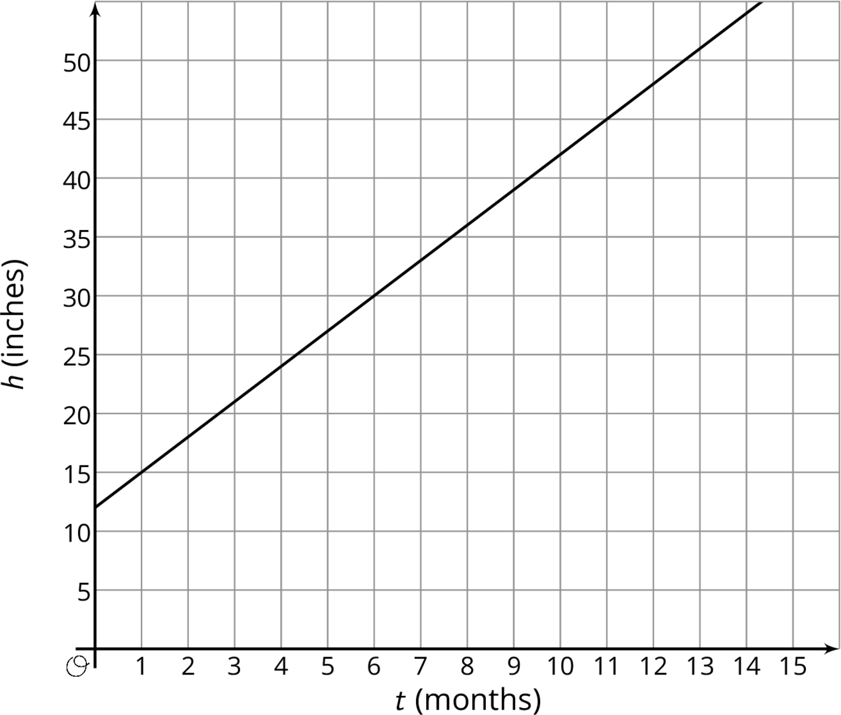
  - Write an equation that describes the relationship between $h$ and $t$.
  - After how many months will the bamboo plant be 66 inches tall? Explain or show your reasoning.
- Here are recipes for two different banana cakes. Information for the first recipe is shown in the table.
- sugar (cups) | - flour (cups)
- $\frac{1}{2}$ | - $\frac{3}{4}$
- $2\frac{1}{2}$ | - $3\frac{3}{4}$
- 3 | - $4\frac{1}{2}$
- The relationship between cups of flour $y$ and cups of sugar $x$ in the second recipe is $y=\frac{7}{4}x$
  - If you used 4 cups of sugar, how much flour does each recipe need?
  - What is the constant of proportionality for each situation and what does it mean?
- (From Unit 5, Lesson 3.)
- Show that the two figures are similar by identifying a sequence of translations, rotations, reflections, and dilations that takes the larger figure to the smaller one.
- 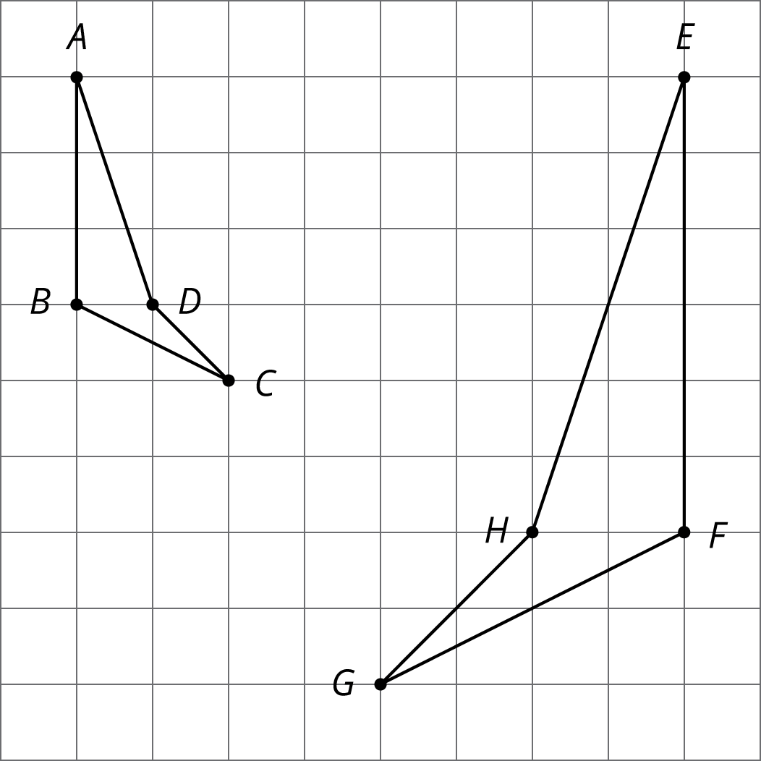
- (From Unit 2, Lesson 11.)
© CC BY Open Up Resources. Adaptations CC BY IM.

