Unit 7 Lesson 14 Cumulative Practice Problems
- Here are 4 points on a coordinate plane.
- 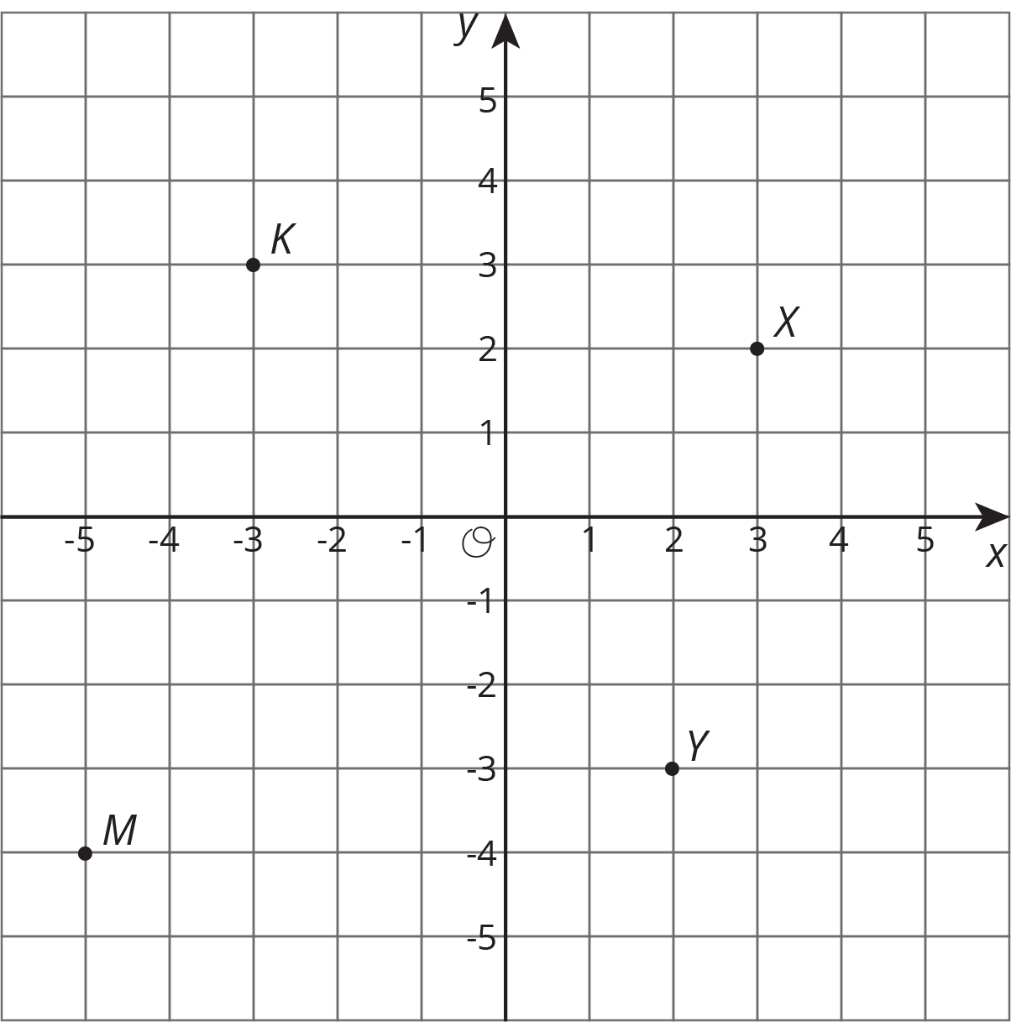
  - Label each point with its coordinates.
  - Plot a point that is 3 units from point $K$. Label it $P$.
  - Plot a point that is 2 units from point $M$. Label it $W$.
- Each set of points are connected to form a line segment. What is the length of each?
  - A = $(3,5)$ and B = $(3,6)$
  - C = $(\text{-}2,\text{-}3)$ and D = $(\text{-}2,\text{-}6)$
  - E = $(\text{-}3,1)$ and F = $(\text{-}3,\text{-}1)$
- On the coordinate plane, plot four points that are each 3 units away from point $P=(\text{-}2,\text{-}1)$. Write the coordinates of each point.
- 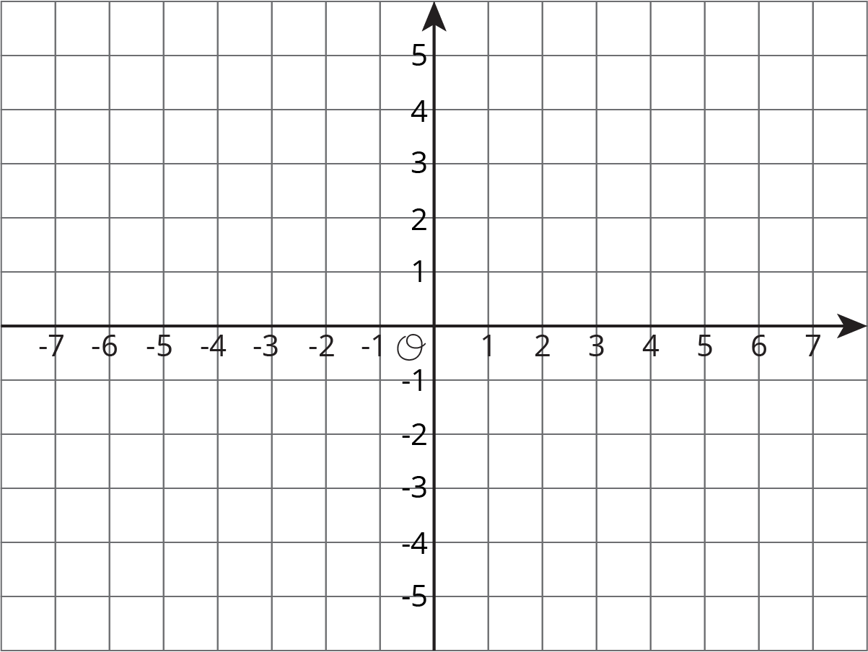
- Noah’s recipe for sparkling orange juice uses 4 liters of orange juice and 5 liters of soda water.
  - Noah prepares large batches of sparkling orange juice for school parties. He usually knows the total number of liters, $t$, that he needs to prepare. Write an equation that shows how Noah can find $s$, the number of liters of soda water, if he knows $t$.
  - Sometimes the school purchases a certain number, $j$, of liters of orange juice and Noah needs to figure out how much sparkling orange juice he can make. Write an equation that Noah can use to find $t$ if he knows $j$.
- (From Unit 6, Lesson 16.)
- For a suitcase to be checked on a flight (instead of carried by hand), it can weigh at most 50 pounds. Andre’s suitcase weighs 23 kilograms. Can Andre check his suitcase? Explain or show your reasoning. (Note: 10 kilograms $≈$ 22 pounds)
- (From Unit 3, Lesson 4.)
© CC BY Open Up Resources. Adaptations CC BY IM.

