Lesson 6: The Median
Let's explore the median of a data set and what it tells us.

6.1: The Plot of the Story
- Here are two dot plots and two stories. Match each story with a dot plot that could represent it. Be prepared to explain your reasoning.
- 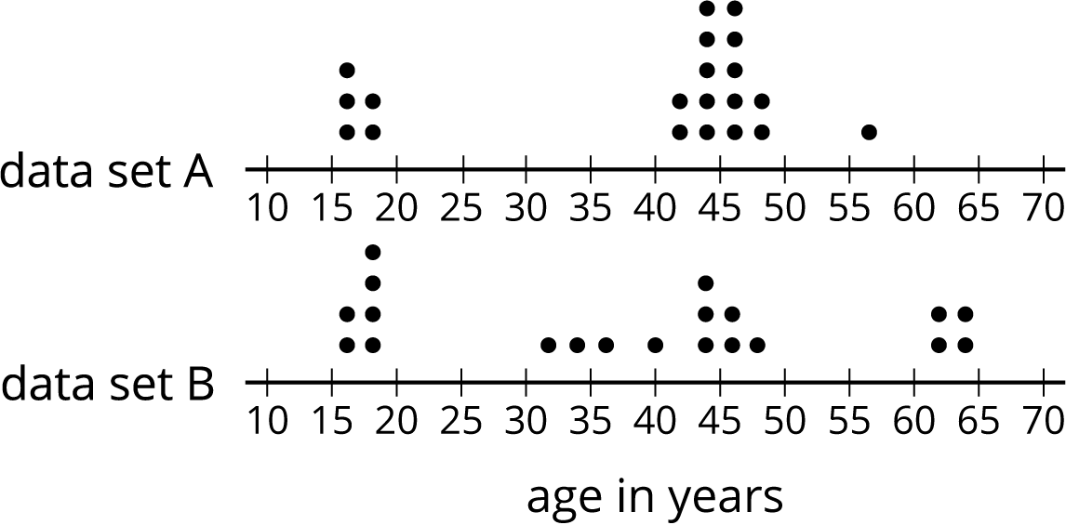

  - Twenty people—high school students, teachers, and invited guests—attended a rehearsal for a high school musical. The mean age was 38.5 years and the MAD was 16.5 years.
  - High school soccer team practice is usually watched by supporters of the players. One evening, twenty people watched the team practice. The mean age was 38.5 years and the MAD was 12.7 years.
- Another evening, twenty people watched the soccer team practice. The mean age was similar to that from the first evening, but the MAD was greater (about 20 years).
- Make a dot plot that could illustrate the distribution of ages in this story.
- 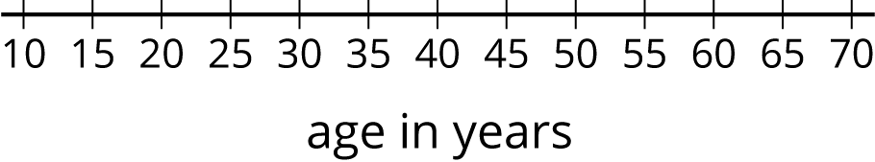

6.2: Finding the Middle
- Your teacher will give you an index card. Write your first and last names on the card. Then record the total number of letters in your name. After that, pause for additional instructions from your teacher.
- Here is the data set on numbers of siblings from an earlier activity.
- 1
- 0
- 2
- 1
- 7
- 0
- 2
- 0
- 1
- 10
  - Sort the data from least to greatest, and then find the median.
  - In this situation, do you think the median is a good measure of a typical number of siblings for this group? Explain your reasoning.
- Here is the dot plot showing the travel time, in minutes, of Elena’s bus rides to school.
- 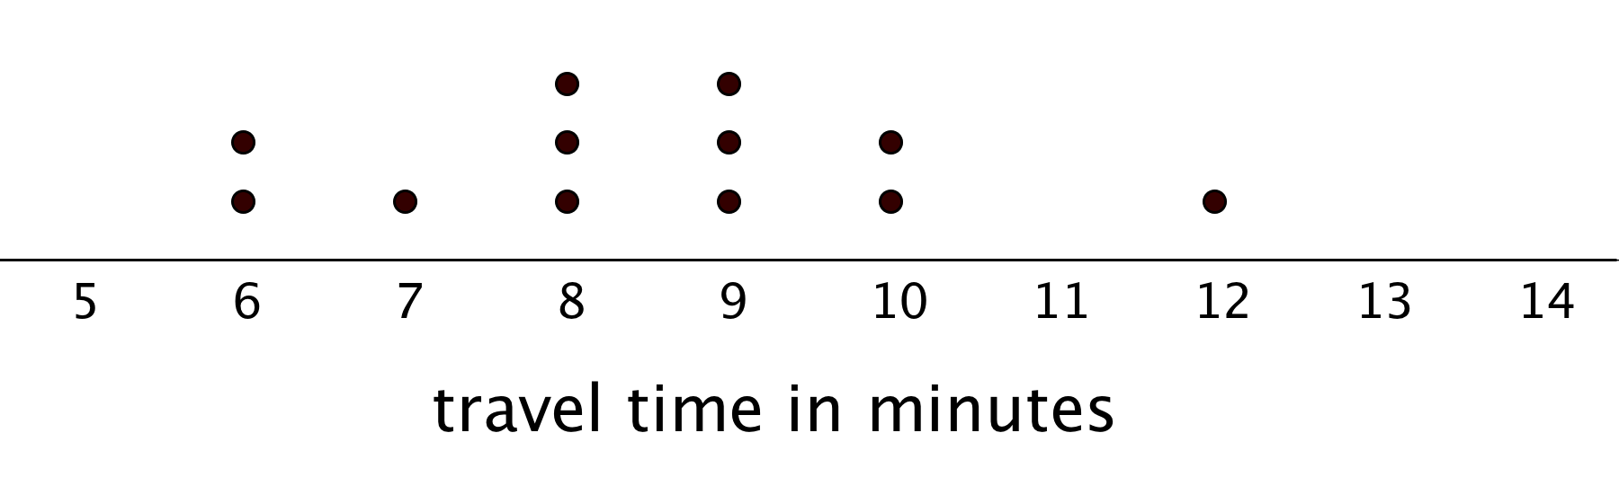
  - Find the median travel time. Be prepared to explain your reasoning.
  - What does the median tell us in this context?

6.3: Mean or Median?
- Your teacher will give you six cards. Each has either a dot plot or a histogram. Sort the cards into two piles based on the distributions shown. Be prepared to explain your reasoning.
- Discuss your sorting decisions with another group. Did you have the same cards in each pile? If so, did you use the same sorting categories? If not, how are your categories different?
- Pause here for a class discussion.
- Use the information on the cards to answer the following questions.
  - Card A: What is a typical age of the dogs being treated at the animal clinic?
  - Card B: What is a typical number of people in the Irish households?
  - Card C: What is a typical travel time for the New Zealand students?
  - Card D: Would 15 years old be a good description of a typical age of the people who attended the birthday party?
  - Card E: Is 15 minutes or 24 minutes a better description of a typical time it takes the students in South Africa to get to school?
  - Card F: Would 21.3 years old be a good description of a typical age of the people who went on a field trip to Washington, D.C.?
- How did you decide which measure of center to use for the dot plots on Cards A–C? What about for those on Cards D–F?

Are you ready for more?
Most teachers use the mean to calculate a student’s final grade, based on that student’s scores on tests, quizzes, homework, projects, and other graded assignments.
Diego thinks that the median might be a better way to measure how well a student did in a course. Do you agree with Diego? Explain your reasoning.

Lesson 6 Summary
The median is another measure of center of a distribution. It is the middle value in a data set when values are listed in order. Half of the values in a data set are less than or equal to the median,and half of the values are greater than or equal to the median.
To find the median, we order the data values from least to greatest and find the number in the middle.
Suppose we have 5 dogs whose weights, in pounds, are shown in the table. The median weight for this group of dogs is 32 pounds because three dogs weigh less than or equal to 32 pounds and three dogs weigh greater than or equal to 32 pounds.
20
25
32
40
55
Now suppose we have 6 cats whose weights, in pounds, are as shown in the table. Notice that there are two values in the middle: 7 and 8.
4
6
7
8
10
10
The median weight must be between 7 and 8 pounds, because half of the cats weigh less or equal to 7 pounds and half of the cats weigh greater than or equal to 8 pounds.
In general, when we have an even number of values, we take the number exactly in between the two middle values. In this case, the median cat weight is 7.5 pounds because $\left(7+8\right)÷2=7.5$.
Here is a set of 30 cookies. It has a mean weight of 21 grams, but the median weight is 23 grams.
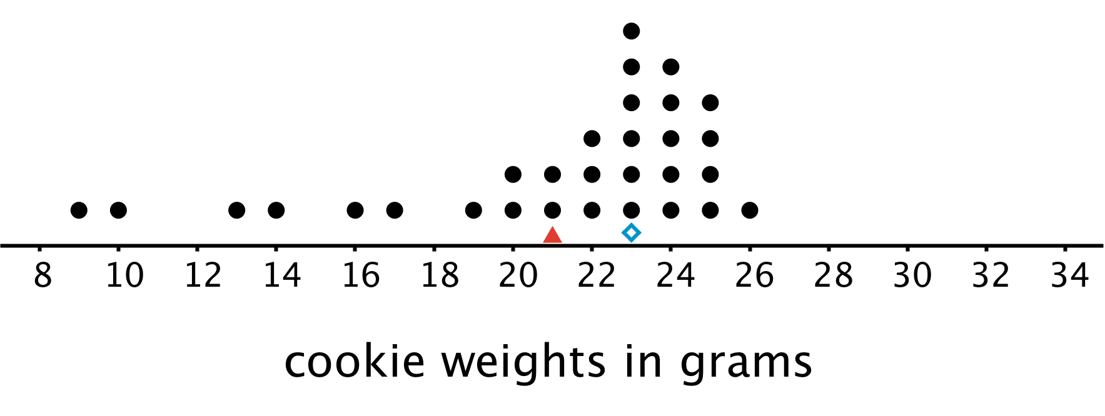
In this case, the median is closer to where most of the data points are clustered and is therefore a better measure of center for this distribution. That is, it is a better description of a typical cookie weight. The mean weight is influenced (in this case, pulled down) by a handful of much smaller cookies, so it is farther away from most data points.
In general, when a distribution is symmetrical or approximately symmetrical, the mean and median values are close. But when a distribution is not roughly symmetrical, the two values tend to be farther apart. Because the mean is fairly influenced by each value in the data set, it is generally preferred for distributions where it makes sense to use it. In cases when the distribution is less symmetric, the median is often reported as the typical value.
© CC BY Open Up Resources. Adaptations CC BY IM.

