Unit 6 Lesson 15: Write Equations for Story Problems

Estimation Exploration: Paper Cranes (Warm up)

Student Task Statement
How many cranes are there in the image?
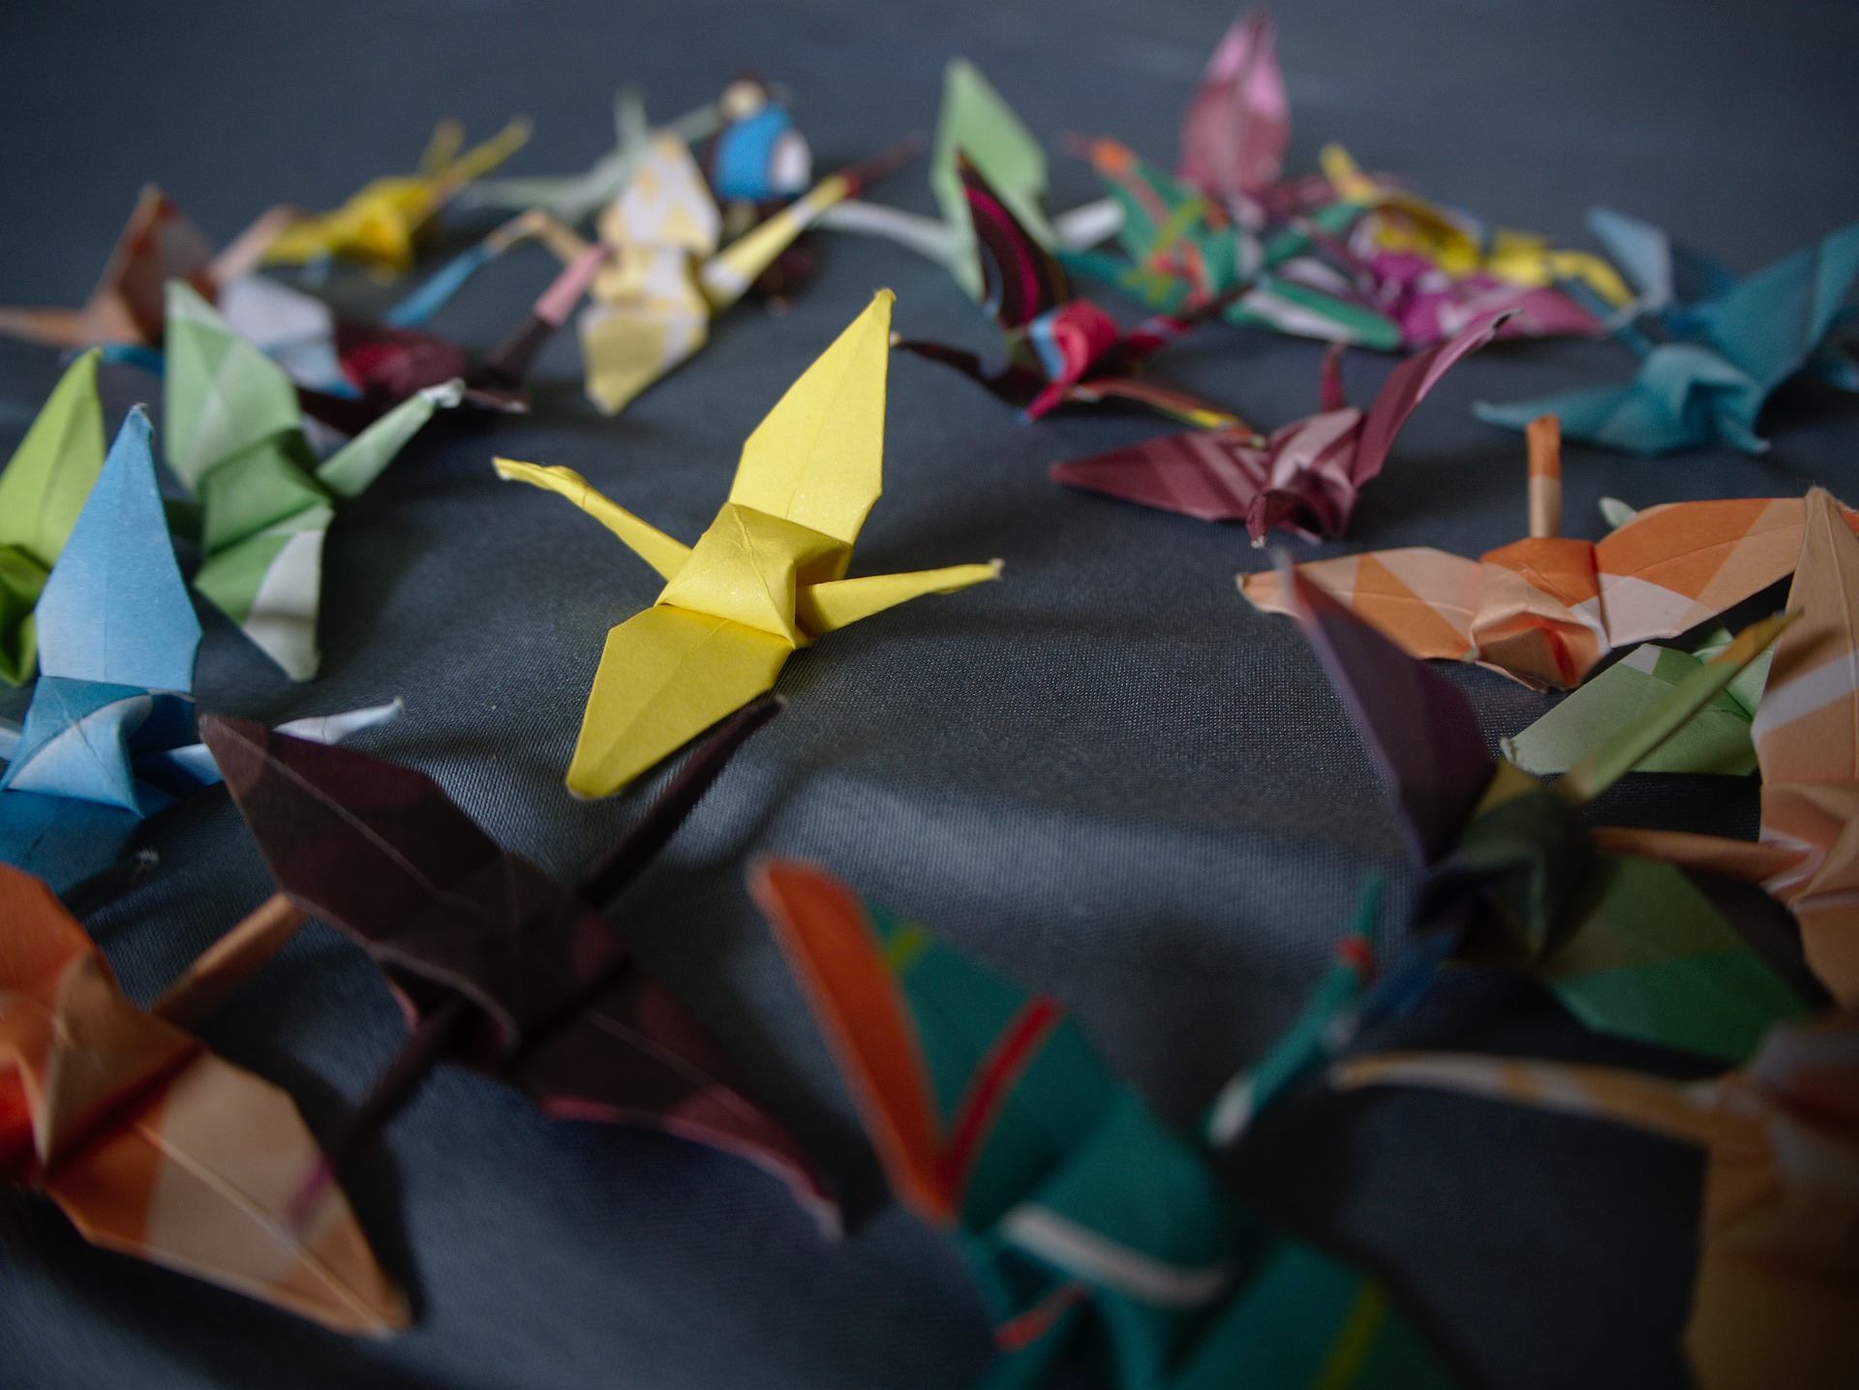
Record an estimate that is:
too low | about right | too high

1 Story Problems about Origami

Student Task Statement
Show your thinking using drawings, numbers, or words.
- Clare made some paper cranes.
She gives 12 of them to Han.
Now Clare has 7 cranes left.
How many cranes did she make?
- 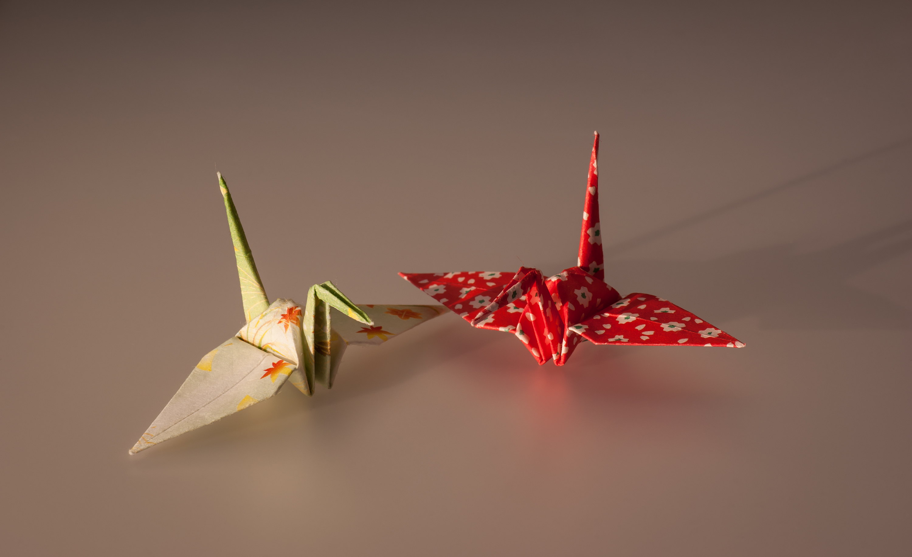
- Tyler made 15 origami butterflies.
Jada made 9 fewer origami butterflies than Tyler.
How many origami butterflies did Jada make?
- Elena made some red flowers.
Then she made 12 blue flowers.
Now she has 18 flowers altogether.
How many red flowers did she make?
- Mai made 8 paper frogs.
Diego made 17 paper frogs.
How many more frogs did Diego make than Mai?
- 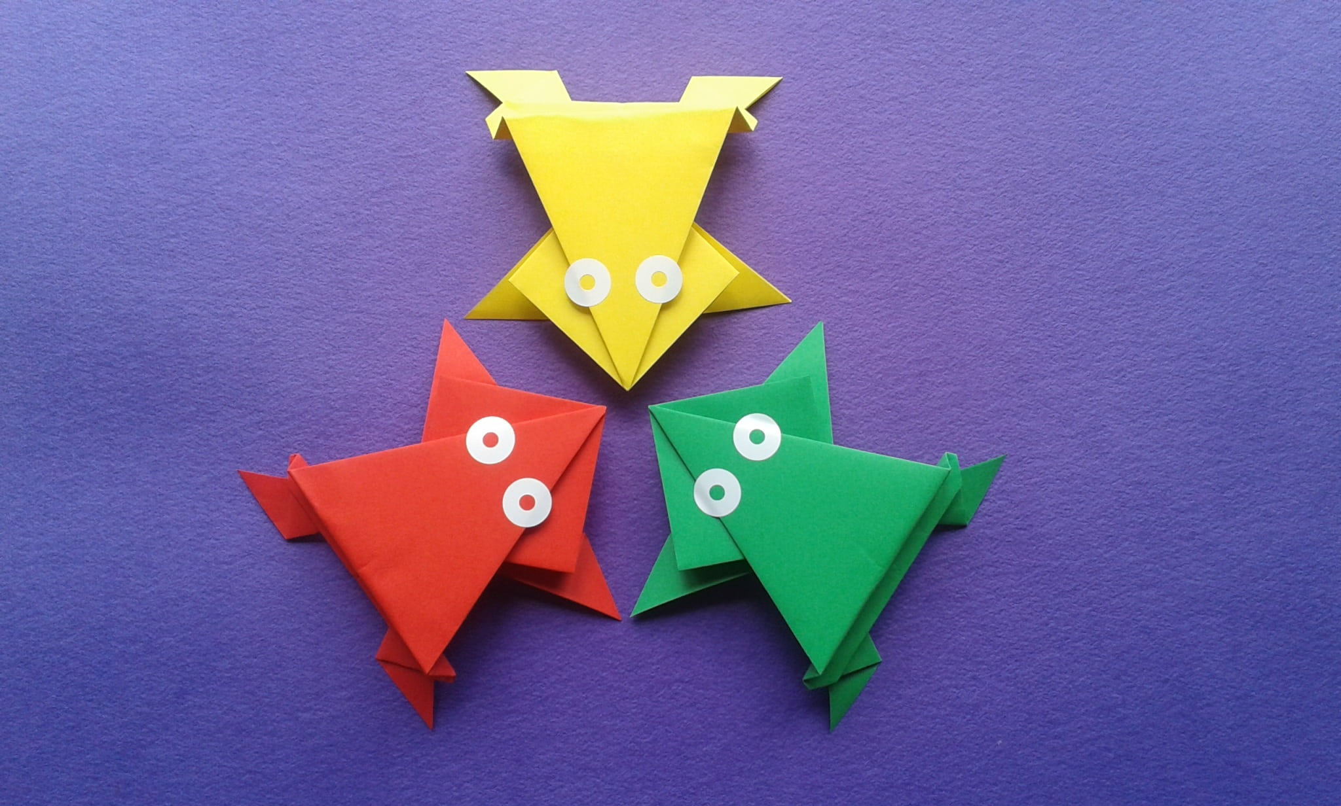

2 Gallery Walk: Write Equations

Student Task Statement
Write an equation that matches your classmates' work for each story problem.
- Equation: ________________________________
- Equation: ________________________________
- Equation: ________________________________
- Equation: ________________________________
© CC BY 2021 Illustrative Mathematics®

