Unit 2 Lesson 18: Graphs of Rational Functions (Part 2)

1 Rewritten Equations (Warm up)

Student Task Statement
Decide if each of these equations is true or false for $x$ values that do not result in a denominator of 0. Be prepared to explain your reasoning.
- $\frac{x+7}{x}=1+\frac{7}{x}$
- $\frac{x}{x+7}=1+\frac{x}{7}$

2 Publishing a Paperback

Student Task Statement
Let $c$ be the function that gives the average cost per book $c\left(x\right)$, in dollars, when using an online store to print $x$ copies of a self-published paperback book. Here is a graph of $c\left(x\right)=\frac{120+4x}{x}.$
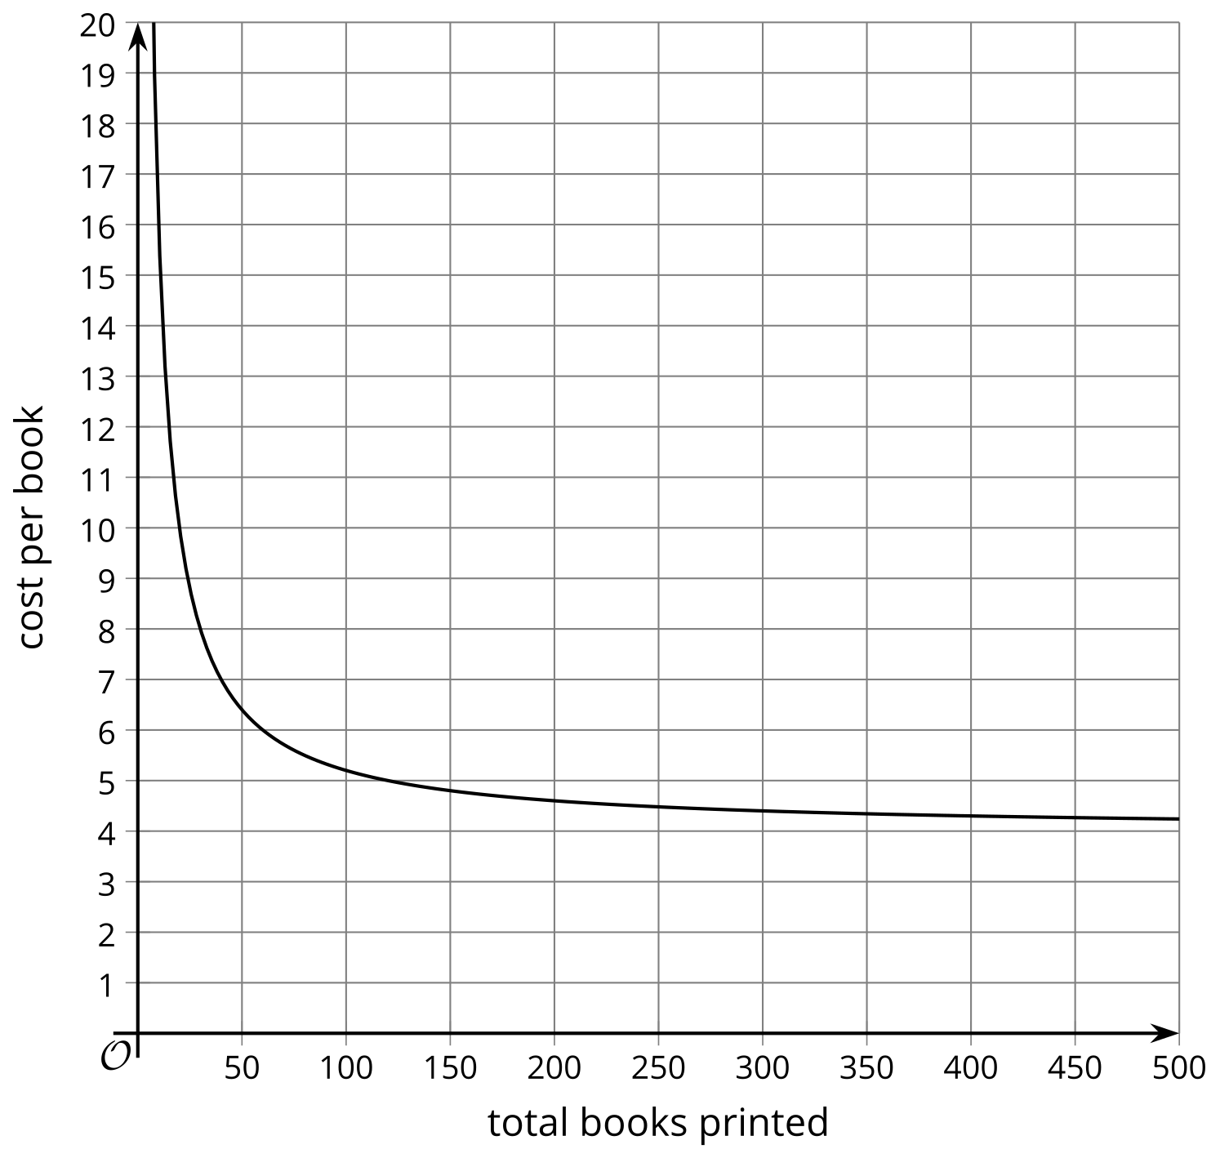
- What is the approximate cost per book when 50 books are printed? 100 books?
- The author plans to charge $8 per book. About how many should be printed to make a profit?
- What is the value of $c\left(x\right)$ when $x=\frac{1}{2}$? How does this relate to the context?
- What does the end behavior of the function say about the context?

3 Horizontal Asymptotes

Student Task Statement
Here are four graphs of rational functions.

A
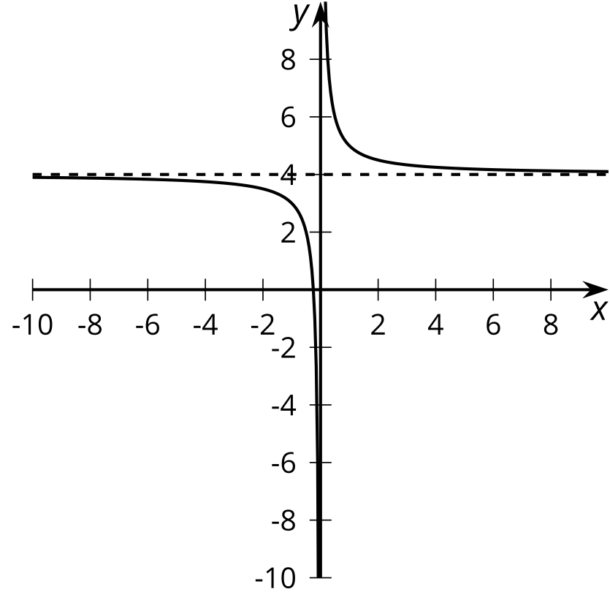

B
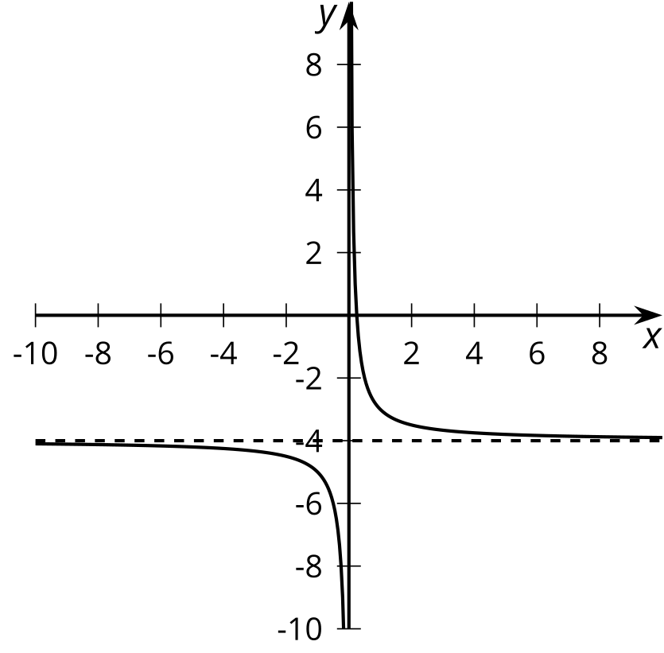

C
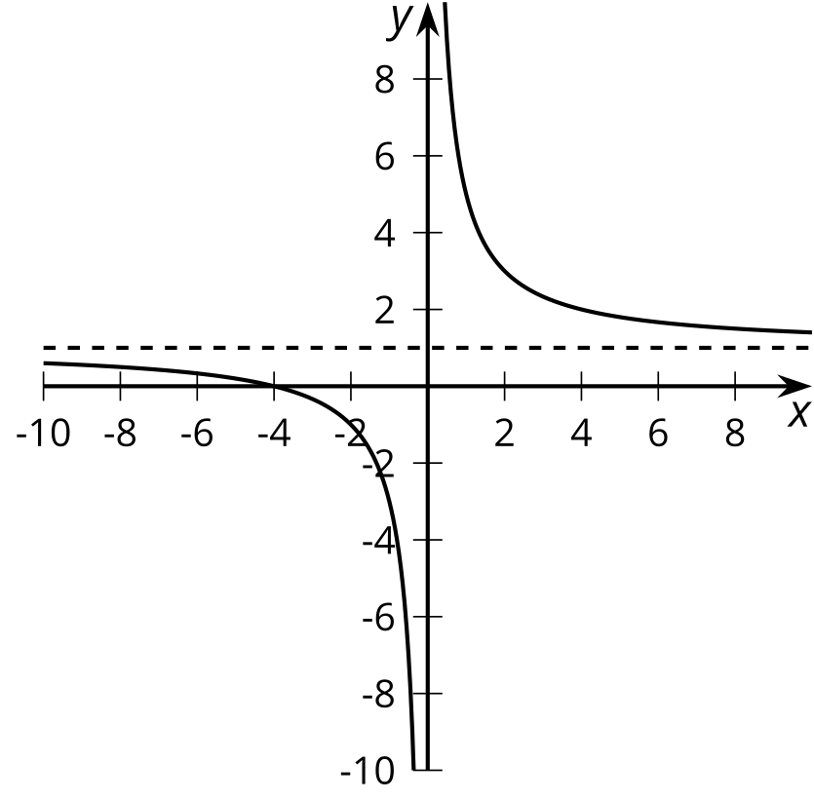

D
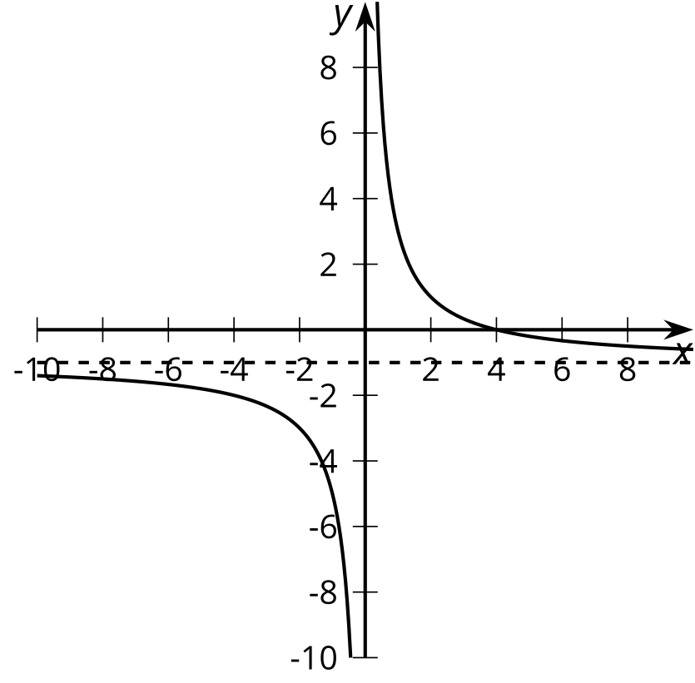
​​​​​
- Match each function with its graphical representation.
  - $a\left(x\right)=\frac{4}{x}−1$
  - $b\left(x\right)=\frac{1}{x}−4$
  - $c\left(x\right)=\frac{1+4x}{x}$
  - $d\left(x\right)=\frac{x+4}{x}$
  - $e\left(x\right)=\frac{1−4x}{x}$
  - $f\left(x\right)=\frac{4−x}{x}$
  - $g\left(x\right)=1+\frac{4}{x}$
  - $h\left(x\right)=\frac{1}{x}+4$
- Where do you see the horizontal asymptote of the graph in the expressions for the functions?
© CC BY 2019 by Illustrative Mathematics®

