Lesson 7: Cubic Units of Measure
- Let’s use different sized cubic units to measure volume.

Warm-up: Notice and Wonder: Two Prisms
What do you notice? What do you wonder?
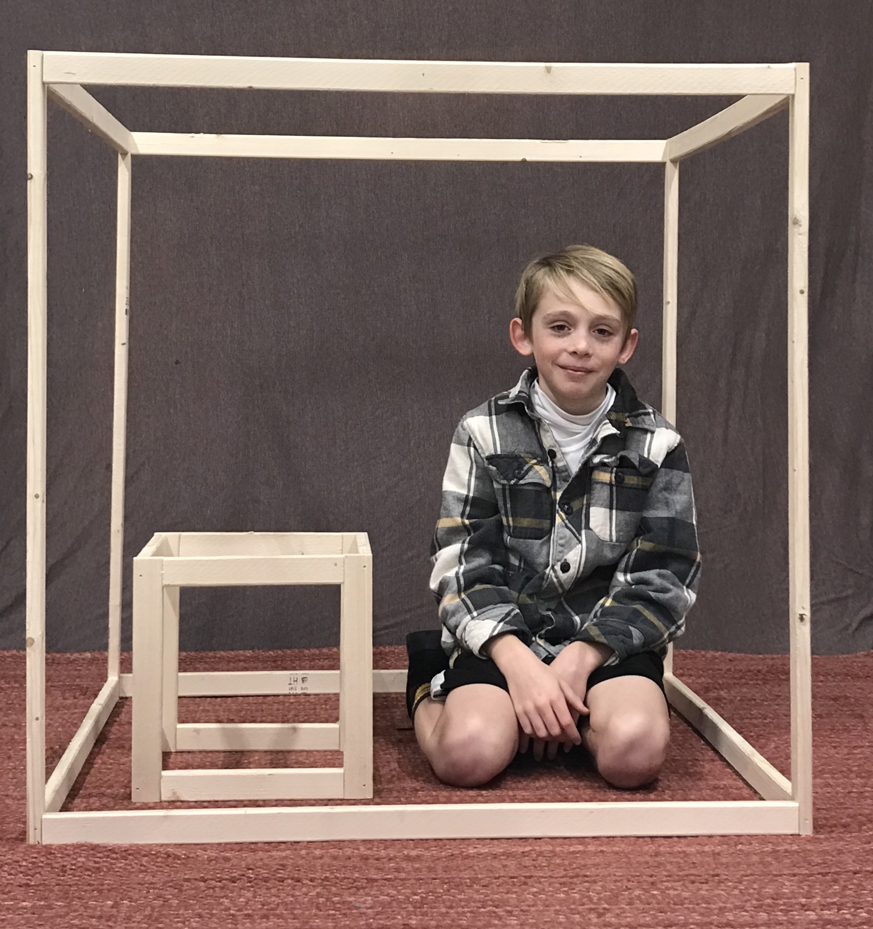

7.1: What are the Units?
For each object, choose the cubic unit you would use to measure the volume: cubic centimeter, cubic inch, or cubic foot.
object | unit you would use
the volume of a moving truck
the volume of a freezer
the volume of a juice box
the volume of a classroom
the volume of a dumpster
the volume of a lunch box
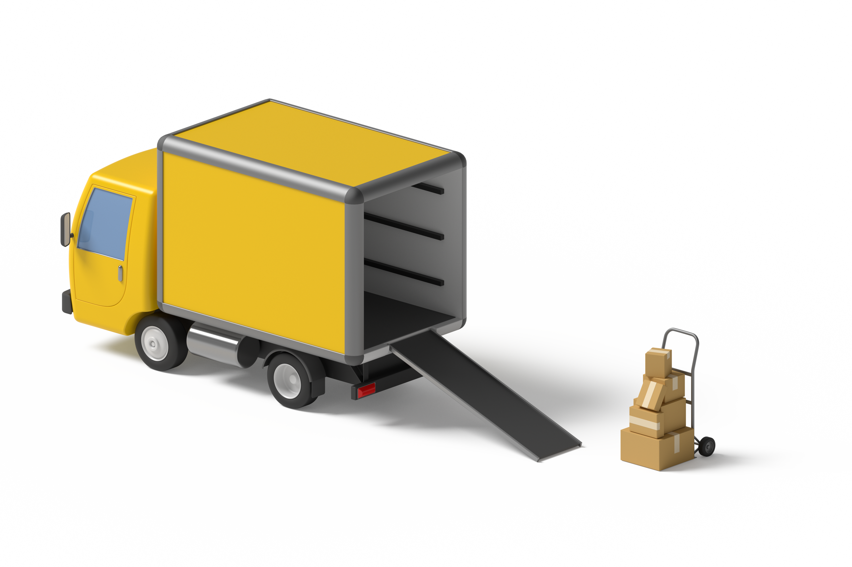

7.2: Info Gap: Sizing Up Cubic Units
This is a diagram of a freezer. What is the volume of the freezer?
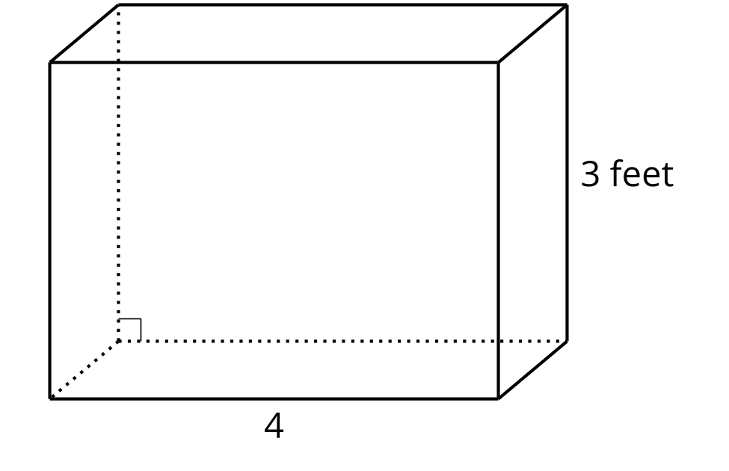
Problem 1:
- Partner A has the problem card.
- Partner B has the data card.
Problem 2:
- Partner B has the problem card.
- Partner A has the data card.
Your teacher will give you either a problem card or a data card. Do not show or read your card to your partner.
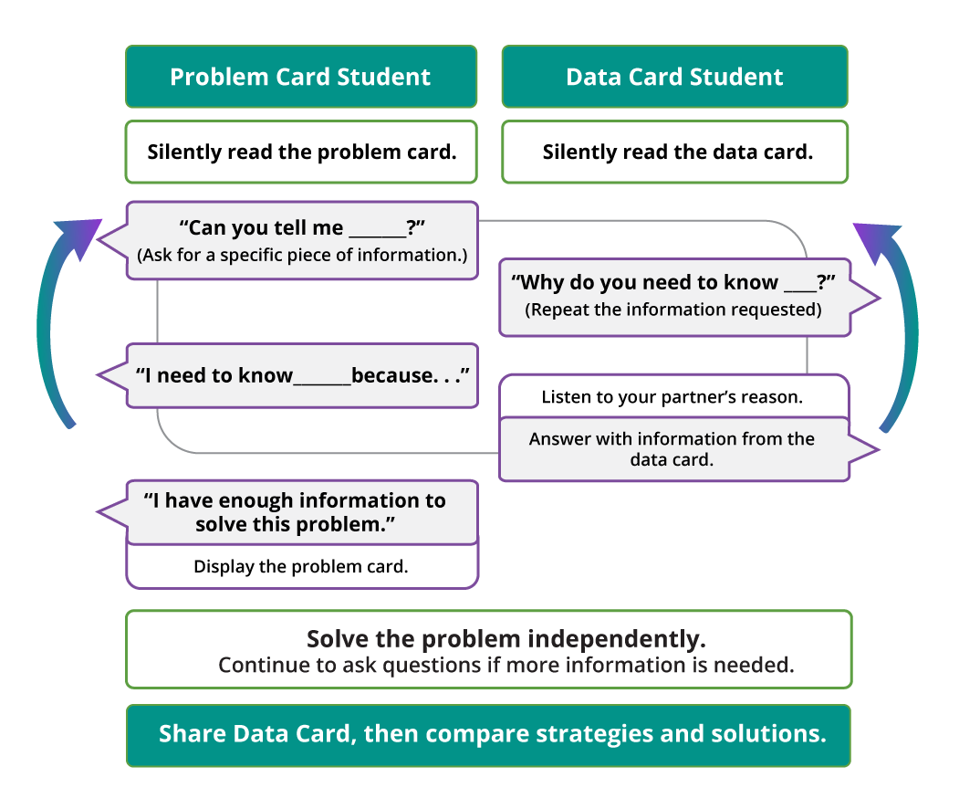
Pause here so your teacher can review your work. Ask your teacher for a new set of cards and repeat the activity, trading roles with your partner.

Section Summary
Section Summary
We find the volume of a right rectangular prism by multiplying the side lengths or by multiplying the area of a base by the corresponding height.
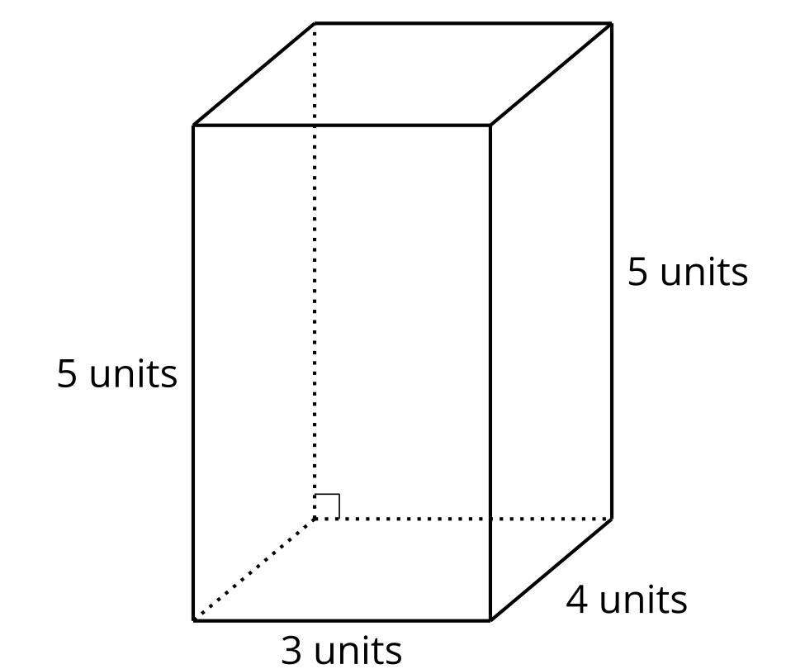
$4×\left(5×3\right)$
$\left(4×5\right)×3$
$15×4$
Each of these expressions represents the volume of this prism. The volume of this rectangular prism is 60 cubic units.
We can use different sized cubic units to measure the volume of different sized objects.
In this section, we used cubic inches, cubic feet, cubic yards, and cubic centimeters.
© CC BY 2021 Illustrative Mathematics®

