Lesson 18 Practice Problems
- Rewrite the rational function $g(x)=\frac{x−4}{x}$ in the form $g(x)=c+\frac{r}{x}$, where $c$ and $r$ are constants.
- The average cost (in dollars) per mile for riding $x$ miles in a cab is $c(x)=\frac{2.5+2x}{x}$. As $x$ gets larger and larger, what does the end behavior of the function tell you about the situation?
- The graphs of two rational functions $f$ and $g$ are shown. One of them is given by the expression $\frac{2−3x}{x}$. Which graph is it? Explain how you know.
- Which polynomial function’s graph is shown here?
- 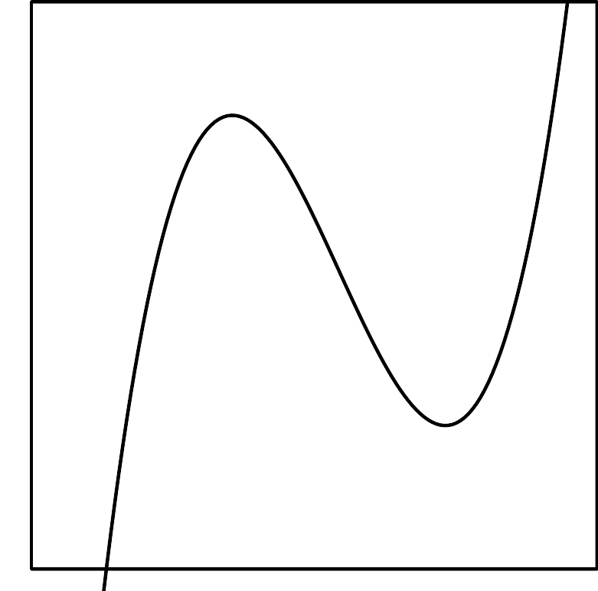
  - $f(x)=(x+1)(x+2)(x+5)$
  - $f(x)=(x+1)(x−2)(x−5)$
  - $f(x)=(x−1)(x+2)(x+5)$
  - $f(x)=(x−1)(x−2)(x−5)$
- (From Unit 2, Lesson 7.)
- State the degree and end behavior of $f(x)=5x^{3}−2x^{4}−6x^{2}−3x+7$. Explain or show your reasoning.
- (From Unit 2, Lesson 9.)
- The graphs of two rational functions $f$ and $g$ are shown. Which function must be given by the expression of $\frac{10}{x−3}$? Explain how you know.
- (From Unit 2, Lesson 17.)
© CC BY 2019 by Illustrative Mathematics®

