Lesson 7: Center Day 1
- Let’s use place value to identify numbers and practice adding and subtracting.

Warm-up: True or False: Compare to 100
Decide if each statement is true or false. Be prepared to explain your reasoning.
- $100>99$
- $100<99+1$
- $98+3>100$
- $50+50+50>100$

7.2: Centers: Choice Time
Choose a center.
Jump the Line
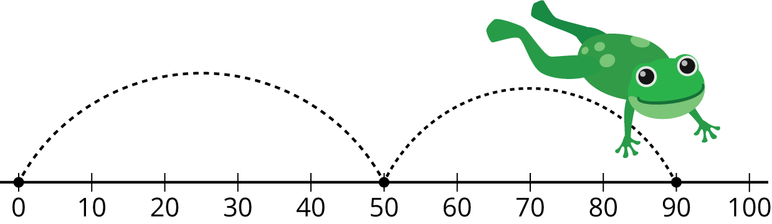
Mystery Number
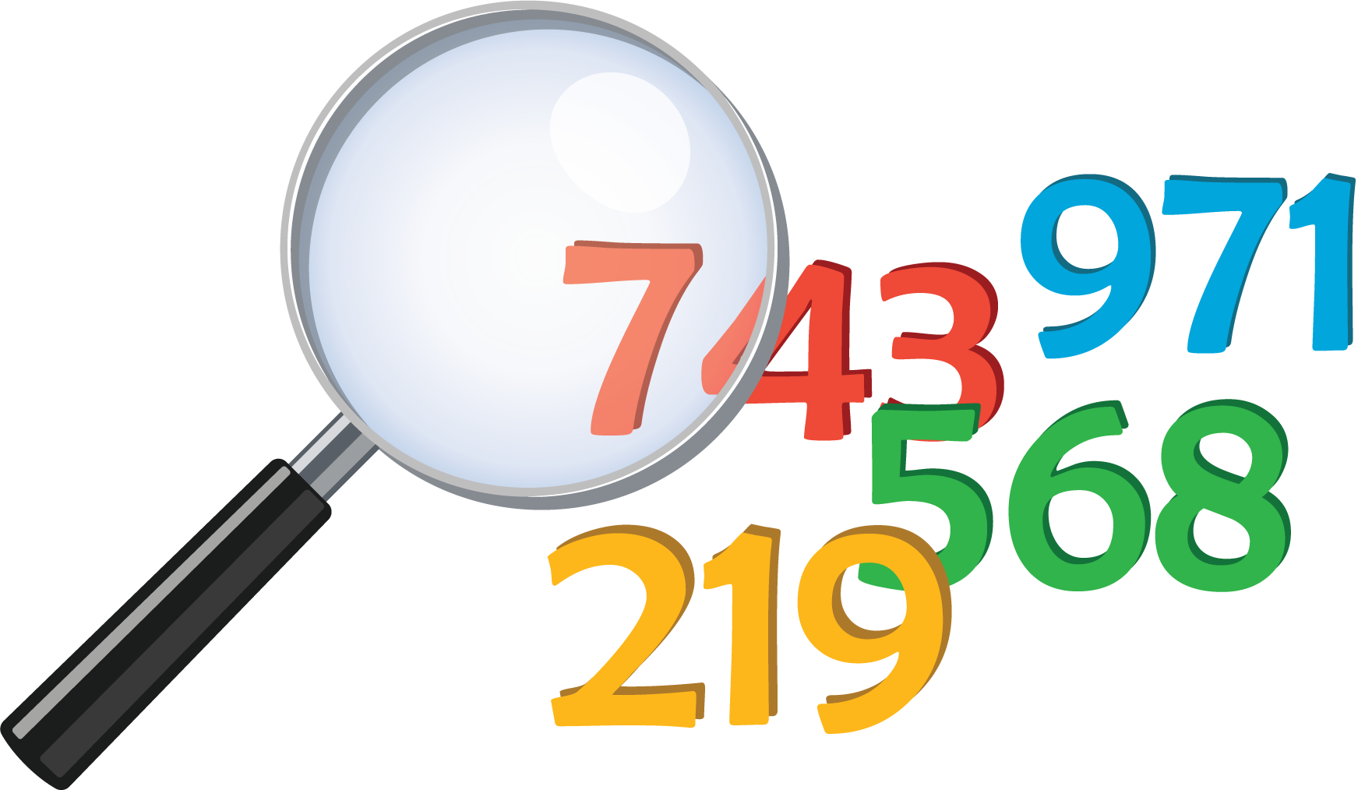
Number Puzzles
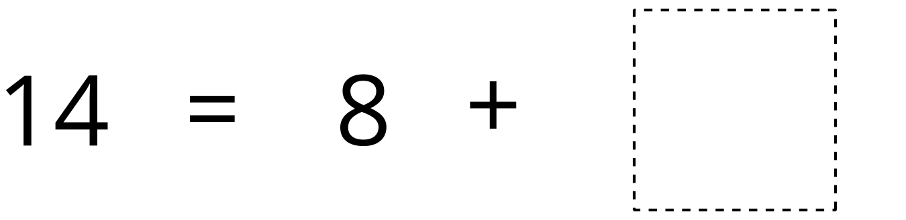
© CC BY 2021 Illustrative Mathematics®

