Unit 6 Lesson 10: Center Day 2

WU How Many Do You See: Base-Ten Blocks (Warm up)

Student Task Statement
How many do you see? How do you see them?
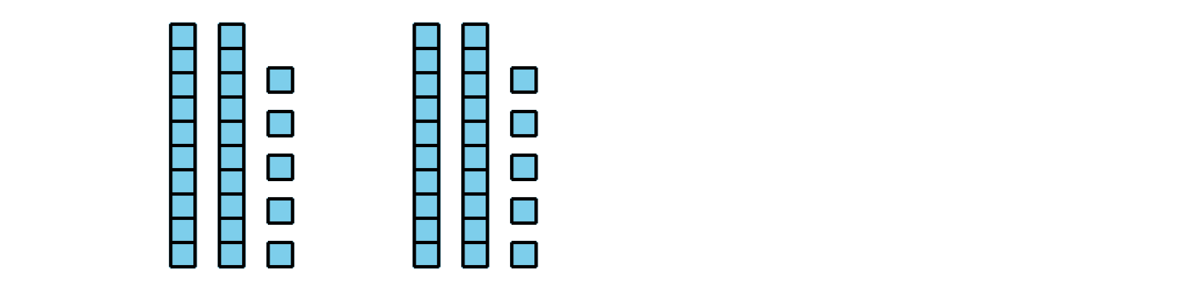
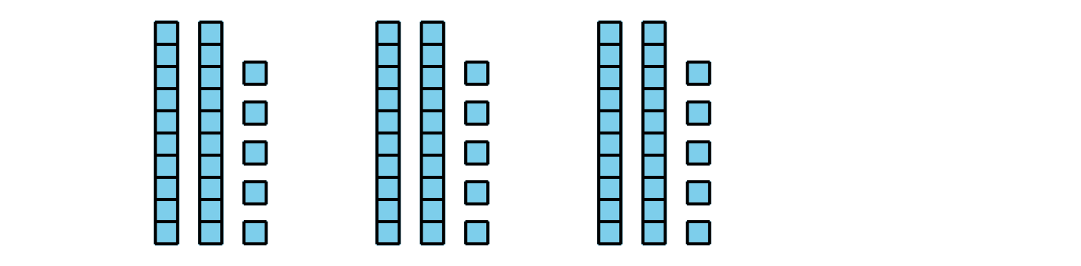
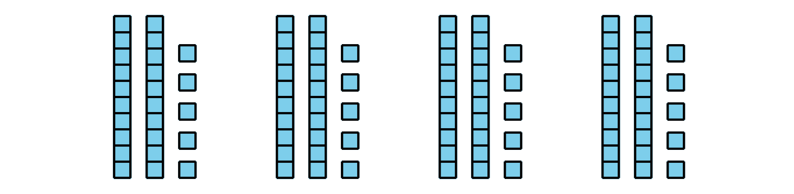

1 Introduce How Are They the Same?

Student Task Statement

2 Centers: Choice Time

Student Task Statement
Choose a center:
How Are They the Same?
Which One?
Can You Draw It?
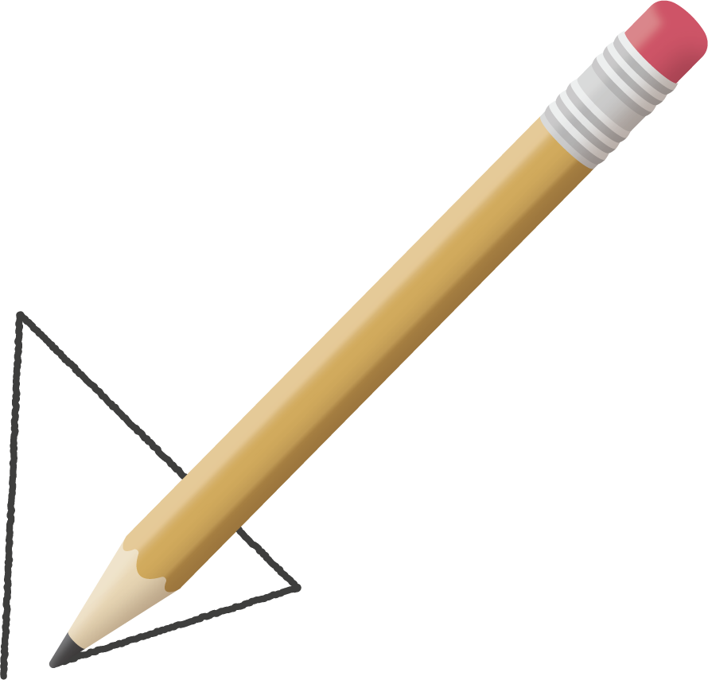
© CC BY 2021 Illustrative Mathematics®

