Unit 2 Lesson 21: Center Day 4

WU Number Talk: Missing Values (Warm up)

Student Task Statement
Find the missing value mentally.
- 4+1=5
- 5−1=4
- 6+2=8
- 8−2=6

1 Introduce Number Puzzles, Within 10

Student Task Statement

2 Centers: Choice Time

Student Task Statement
Choose a center.
Capture Squares
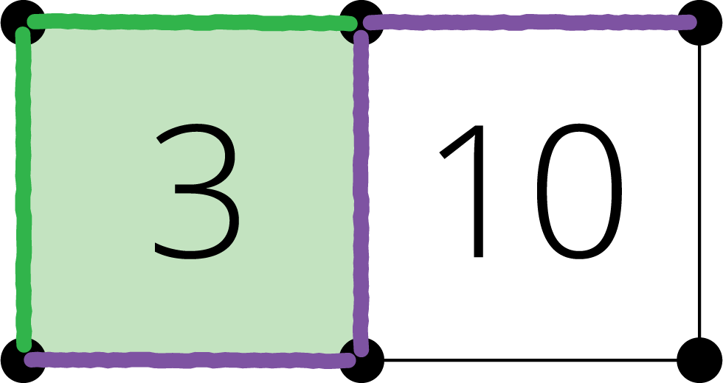
Math Stories
What's Behind My Back
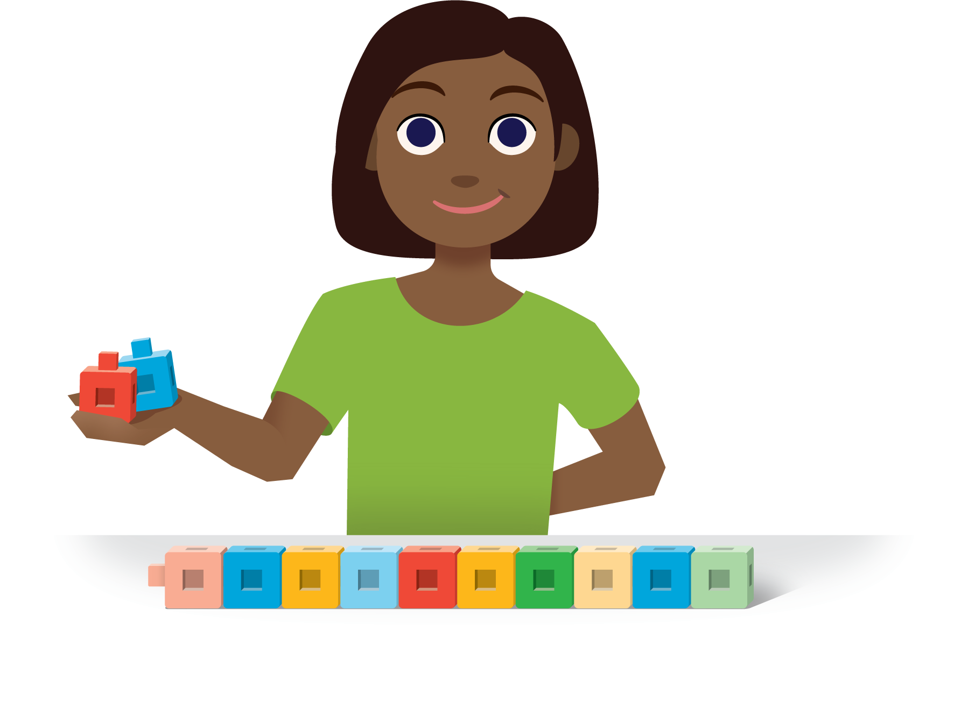
© CC BY 2021 Illustrative Mathematics®

