Lesson 3: Shapes That Are Flat

Standards Alignments
Addressing | 1.G.A

Teacher-facing Learning Goals
- Sort two-dimensional shapes in a way that makes sense to them.
- Use their own language to describe two-dimensional shapes.

Student-facing Learning Goals
- Let’s sort flat shapes and explain how we sorted.

Lesson Purpose
The purpose of this lesson is for students to describe two-dimensional shapes using their own language, sort them, and explain how they sorted.
In kindergarten, students named and described squares, rectangles, triangles, and circles, and the shapes represented by pattern blocks. In prior lessons, students used the names of two-dimensional shapes when describing three-dimensional shapes.
In this lesson, students use their understanding of two-dimensional shapes to sort them. Students may choose to sort according to defining attributes or not. What is most important is that students can name the categories they used to sort. Students look at different ways their classmates sorted the shapes and determine how they sorted.
The shape cards used in this lesson will be used again throughout the section.

Access for:

Students with Disabilities
- Engagement (Activity 1)

English Learners
- MLR7 (Activity 1)

Instructional Routines
Which One Doesn’t Belong? (Warm-up)

Materials to Gather
- Materials from a previous activity: Activity 2

Materials to Copy
- Flat Shape Cards Grade 1 (groups of 2): Activity 1

Lesson Timeline
Warm-up | 10 min
Activity 1 | 15 min
Activity 2 | 20 min
Lesson Synthesis | 10 min
Cool-down | 5 min

Teacher Reflection Question
Reflect on the knowledge of two-dimensional shapes students are bringing with them from kindergarten. What unfinished learning or misunderstandings do your students have about shapes? How did you leverage those misconceptions in a positive way to further the understanding of the class?

Cool-down
(to be completed at the end of the lesson) 5min
Sort the Shapes

Standards Alignments
Addressing | 1.G.A

Student-facing Task Statement
Han sorted some shapes.
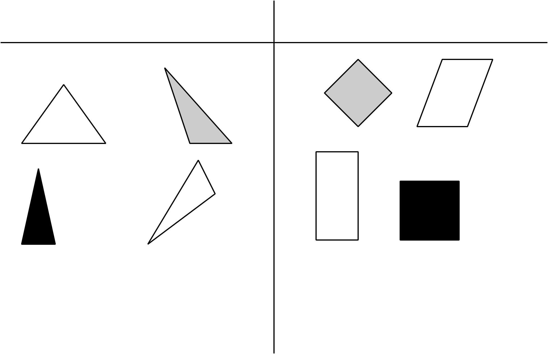
Draw each shape in the group it belongs.
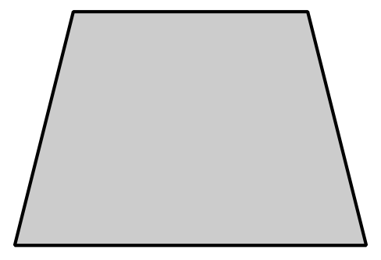
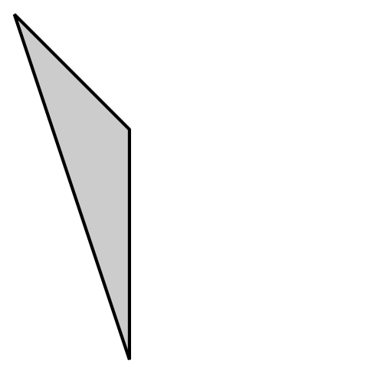

Student Responses
- Draws the shape in the group of shapes with four sides.
- Draws the shape in the group of shapes with three sides.

