Lesson 8: The Size of Angles in Degrees
- Let’s describe the size of angles using degrees.

Warm-up: What Do You Know about 360?
What do you know about 360?

8.1: A Full Turn
A ray that turns all the way around its endpoint and back to its starting place has made a full turn.
We say that the ray has turned 360 degrees.
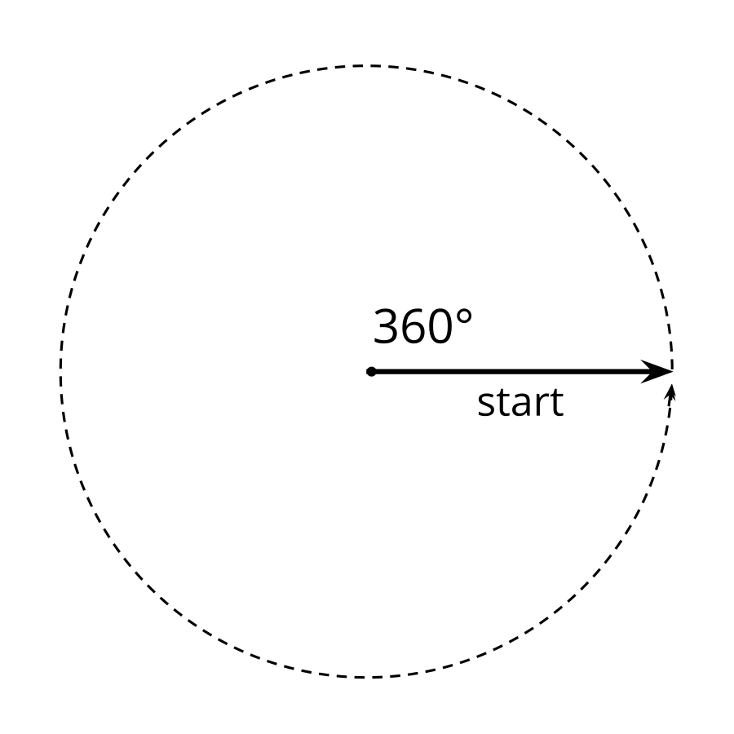
- How many degrees has the ray turned from where it started?
- a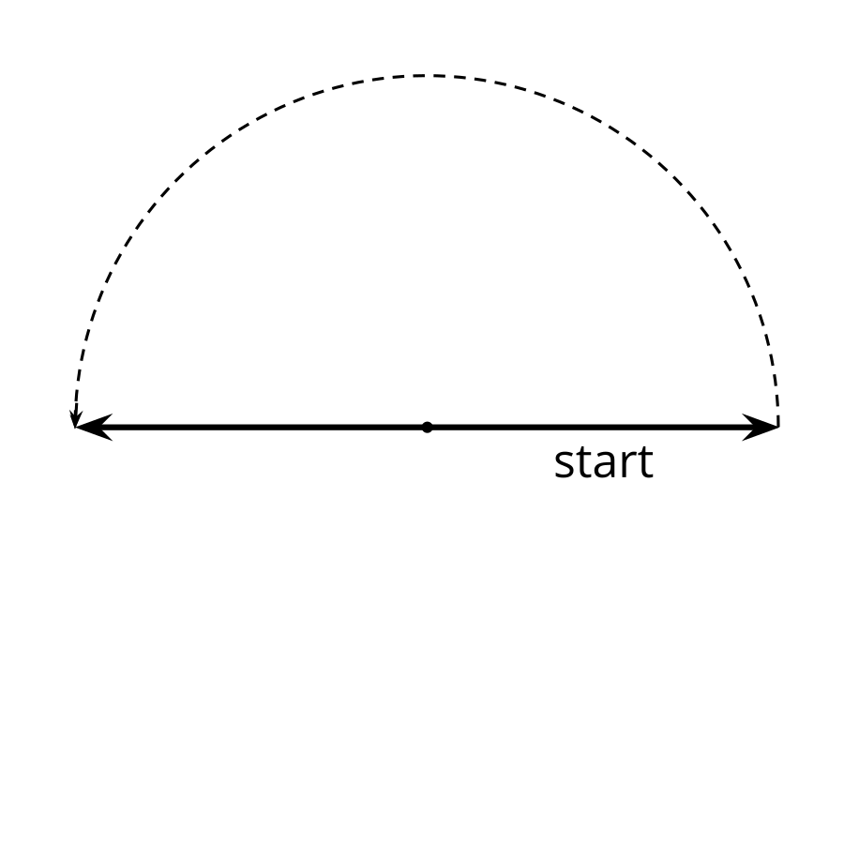
- b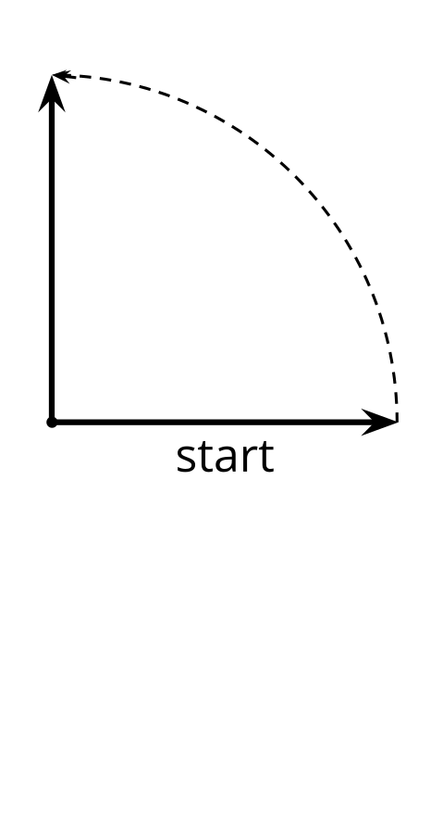
- c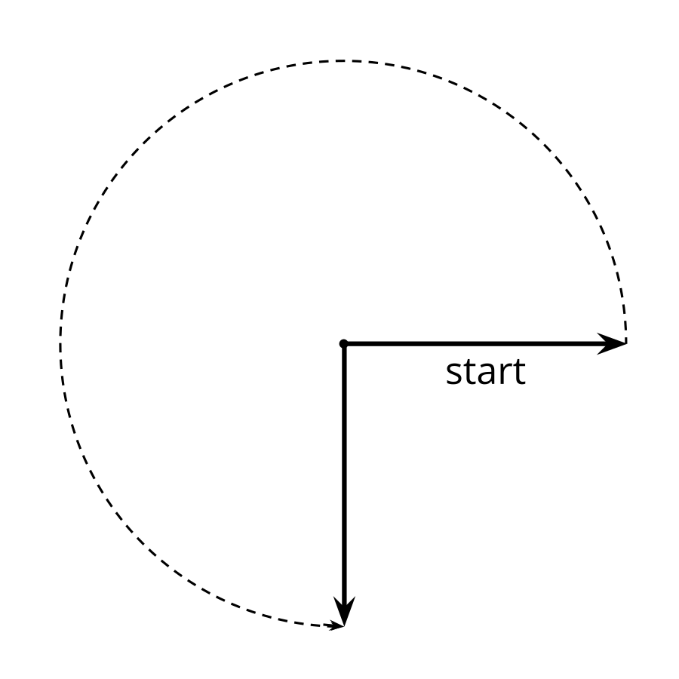
- Sketch two angles:
  - an angle where a ray has turned ${50}^{∘}$
  - an angle where a ray has turned ${130}^{∘}$

8.2: Make a Measuring Tool
Your teacher will give you a sheet of paper in the shape of half a circle. It shows a ${120}^{∘}$ angle and a ${180}^{∘}$ angle from the ray on the bottom right.
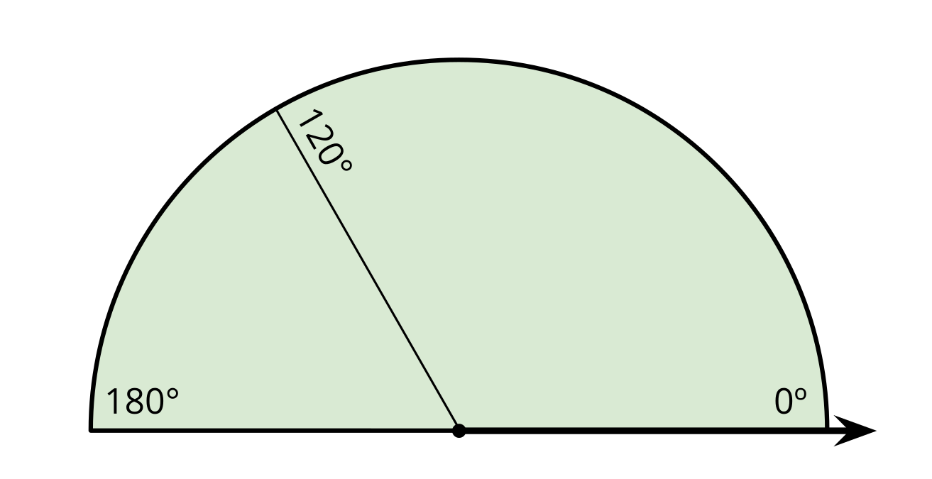
On the half-a-circle paper:
- Draw a line segment to show a ${90}^{∘}$ angle from the same ray. Label it with the measurement. Be as precise as possible.
- Draw lines to show the following angles (measured from the same ray). Label each line with the measurement.
- ${60}^{∘}$ | - ${45}^{∘}$ | - ${30}^{∘}$ | - ${150}^{∘}$ | - ${135}^{∘}$

- Can you find a $1^{∘}$ angle from that same ray? Explain or show how you might do it.
- You just made a measuring tool!
- How can it be used to estimate the size of an angle? Discuss your ideas with your group. Then, use your tool to estimate the sizes of at least two angles.
- 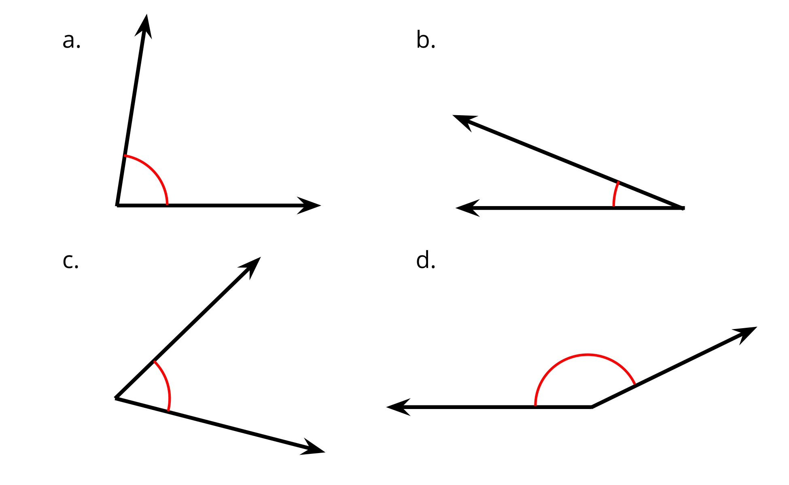
© CC BY 2021 Illustrative Mathematics®

