Unit 5 Lesson 11 Cumulative Practice Problems
- Use long division to show that the fraction and decimal in each pair are equal.
- $\frac{3}{4}$ and 0.75
- $\frac{3}{50}$ and 0.06
- $\frac{7}{25}$ and 0.28

- Mai walked $\frac{1}{8}$ of a 30-mile walking trail. How many miles did Mai walk? Explain or show your reasoning.
- Use long division to find each quotient. Write your answer as a decimal.
  - $99÷12$
  - $216÷5$
  - $1,​988÷8$
- Tyler reasoned: “$\frac{9}{25}$ is equivalent to $\frac{18}{50}$ and to $\frac{36}{100}$, so the decimal of $\frac{9}{25}$ is 0.36.”
  - Use long division to show that Tyler is correct.
  - Is the decimal of $\frac{18}{50}$ also 0.36? Use long division to support your answer.
- Complete the calculations so that each shows the correct difference.
- 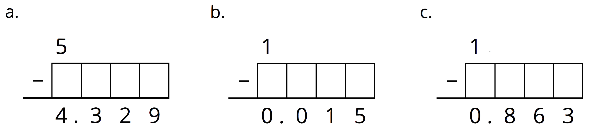
- (From Unit 5, Lesson 4.)
- Use the equation $124⋅15=1,​860$ and what you know about fractions, decimals, and place value to explain how to place the decimal point when you compute $(1.24)⋅(0.15)$.
- (From Unit 5, Lesson 6.)
© CC BY Open Up Resources. Adaptations CC BY IM.

