Unit 2 Lesson 14: Four Representations

1 Which is the Bluest? (Warm up)

Student Task Statement
- Which group of blocks is the bluest?
- 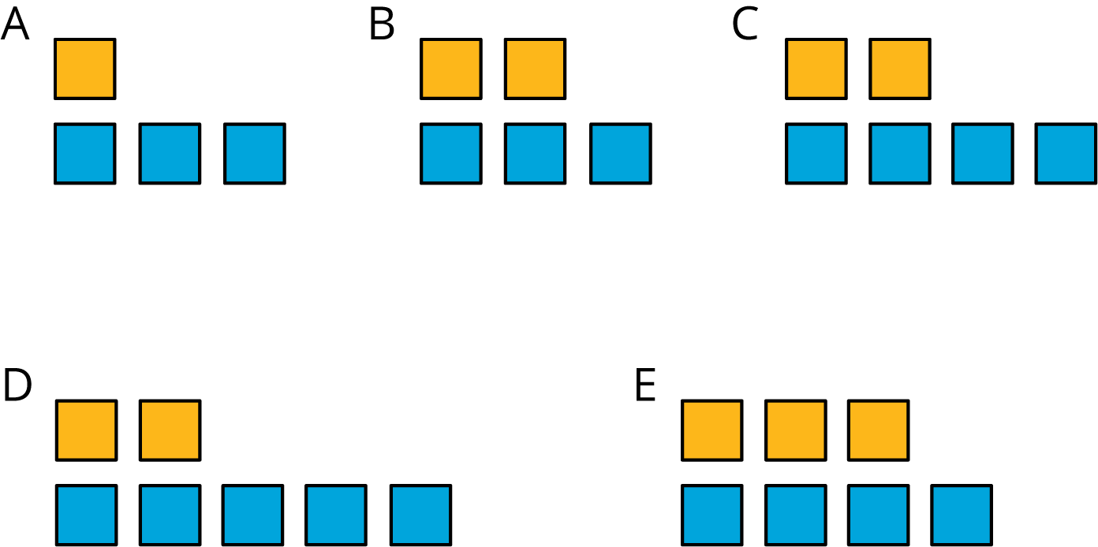
- Order the groups of blocks from least blue to bluest.

2 One Scenario, Four Representations

Student Task Statement
- Select two things from different lists. Make up a situation where there is a proportional relationship between quantities that involve these things.
- creatures
  - starfish
  - centipedes
  - earthworms
  - dinosaurs
- length
  - centimeters
  - cubits
  - kilometers
  - parsecs
- time
  - nanoseconds
  - minutes
  - years
  - millennia
- volume
  - milliliters
  - gallons
  - bushels
  - cubic miles
- body parts
  - legs
  - eyes
  - neurons
  - digits
- area
  - square microns
  - acres
  - hides
  - square light-years
- weight
  - nanograms
  - ounces
  - deben
  - metric tonnes
- substance
  - helium
  - oobleck
  - pitch
  - glue
- Select two other things from the lists, and make up a situation where there is a relationship between quantities that involve these things, but the relationship is not proportional.
- Your teacher will give you two copies of the “One Scenario, Four Representations” sheet. For each of your situations, describe the relationships in detail. If you get stuck, consider asking your teacher for a copy of the sample response.
  - Write one or more sentences describing the relationship between the things you chose.
  - Make a table with titles in each column and at least 6 pairs of numbers relating the two things.
  - Graph the situation and label the axes.
  - Write an equation showing the relationship and explain in your own words what each number and letter in your equation means.
  - Explain how you know whether each relationship is proportional or not proportional. Give as many reasons as you can.

3 Make a Poster (Optional)

Student Task Statement
Create a visual display of your two situations that includes all the information from the previous activity.
© CC BY Open Up Resources. Adaptations CC BY IM.

