Lesson 7: Build with Straws
- Let’s make shapes with straws.

7.1: Compare Length of Straws
Let’s put the straws into 2 groups.
shorter than
longer than

7.3: Introduce Build Shapes, Match the Flat Shape
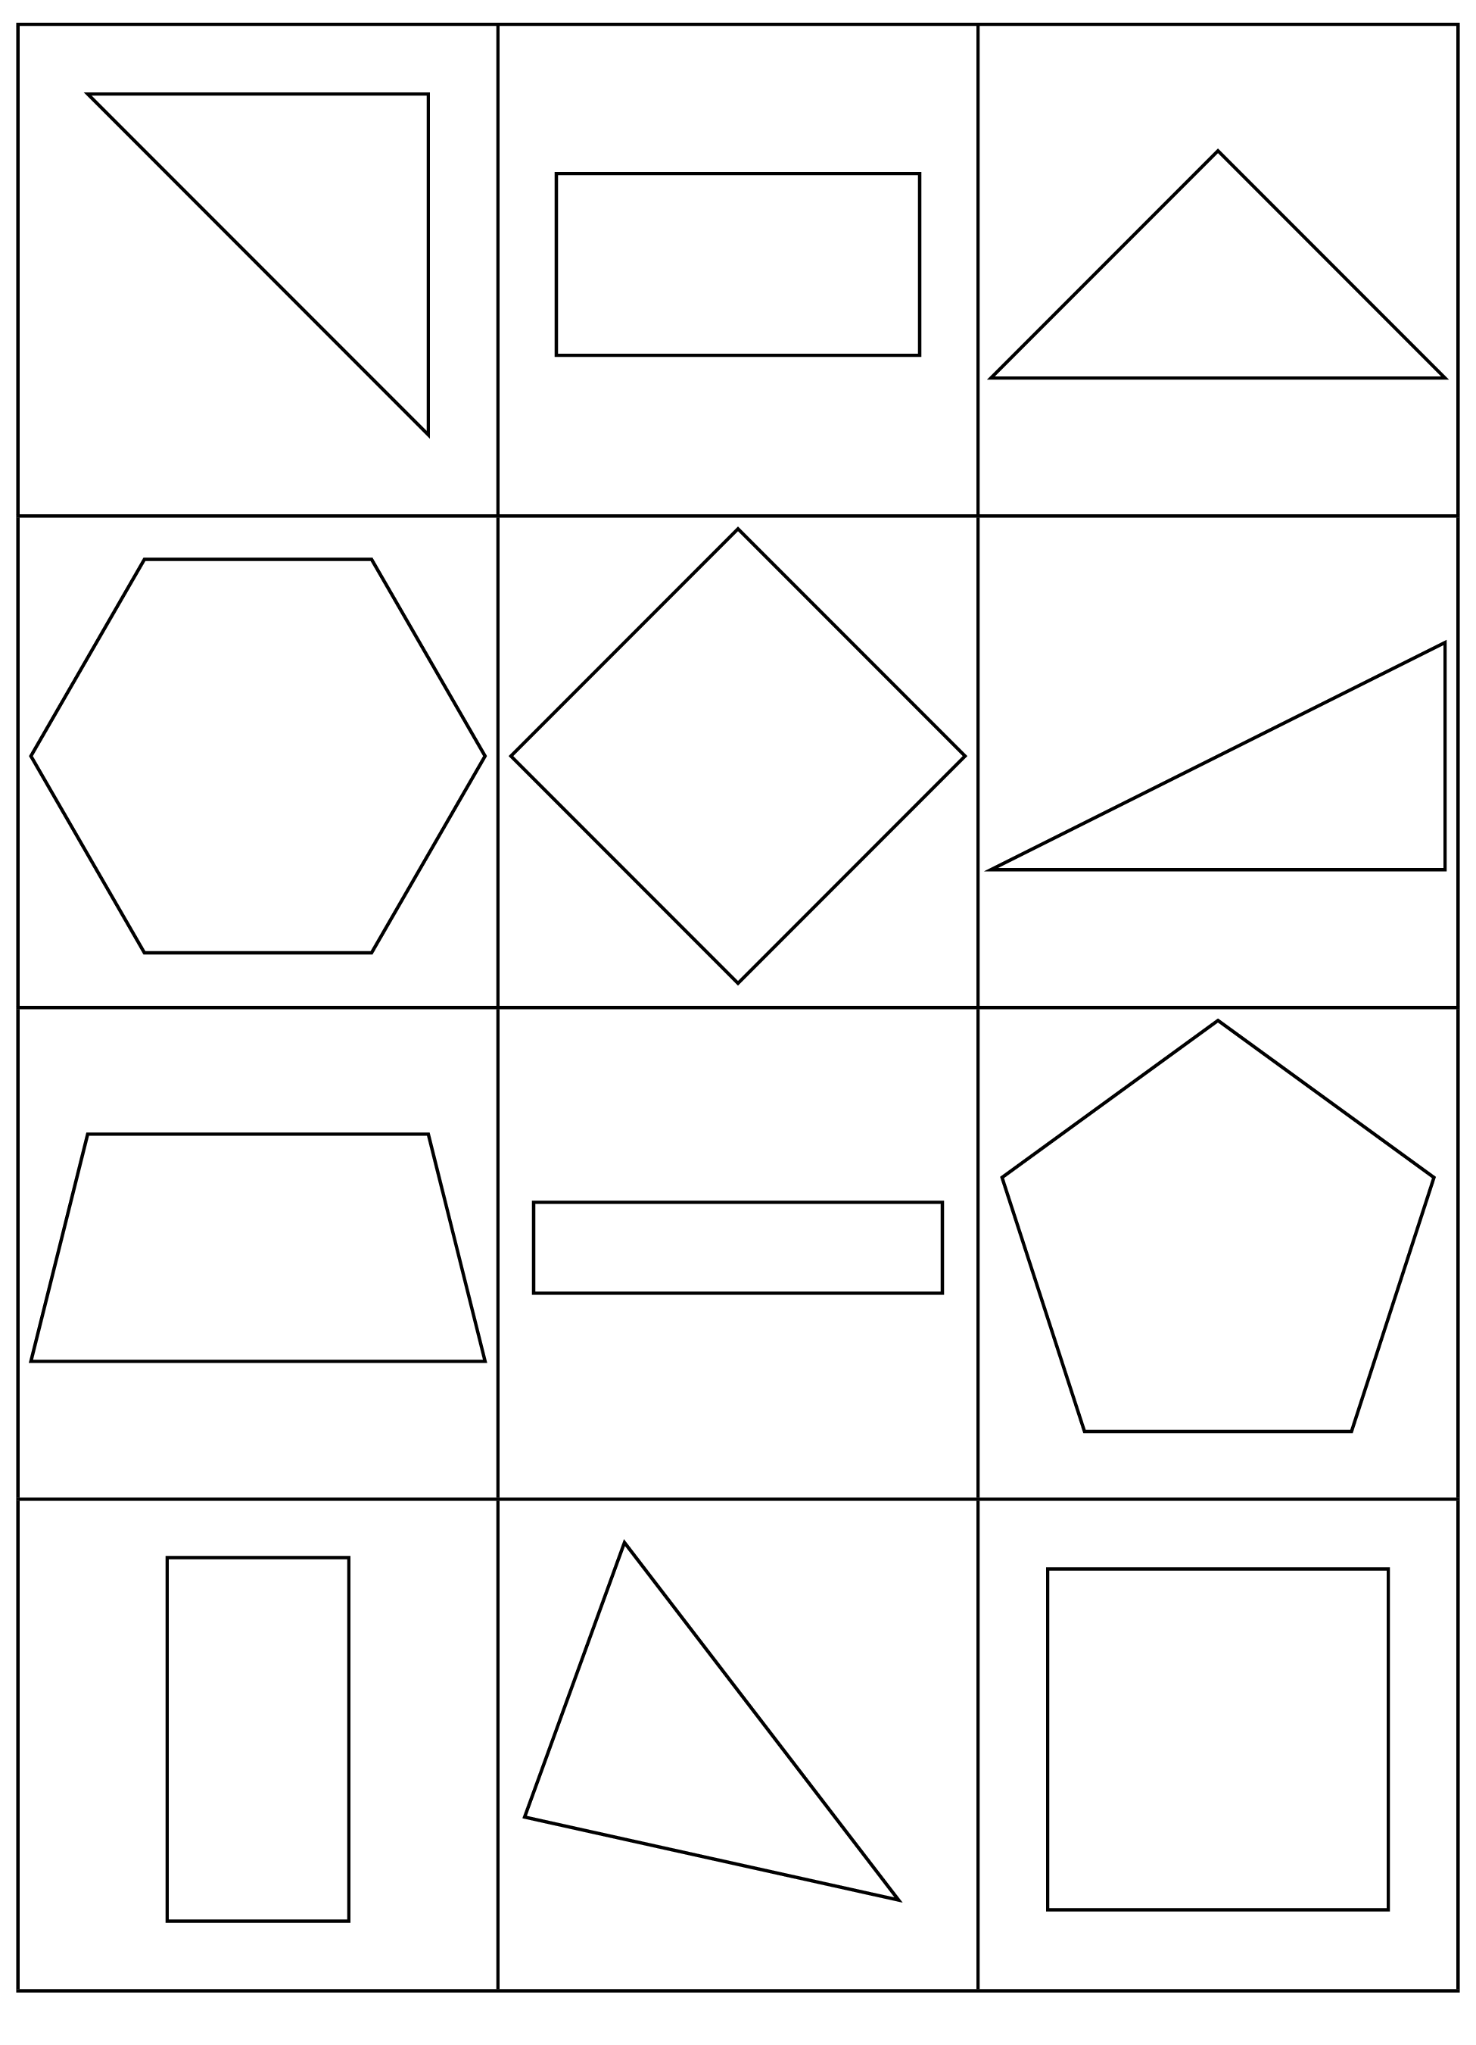
Choose a center.
Build Shapes
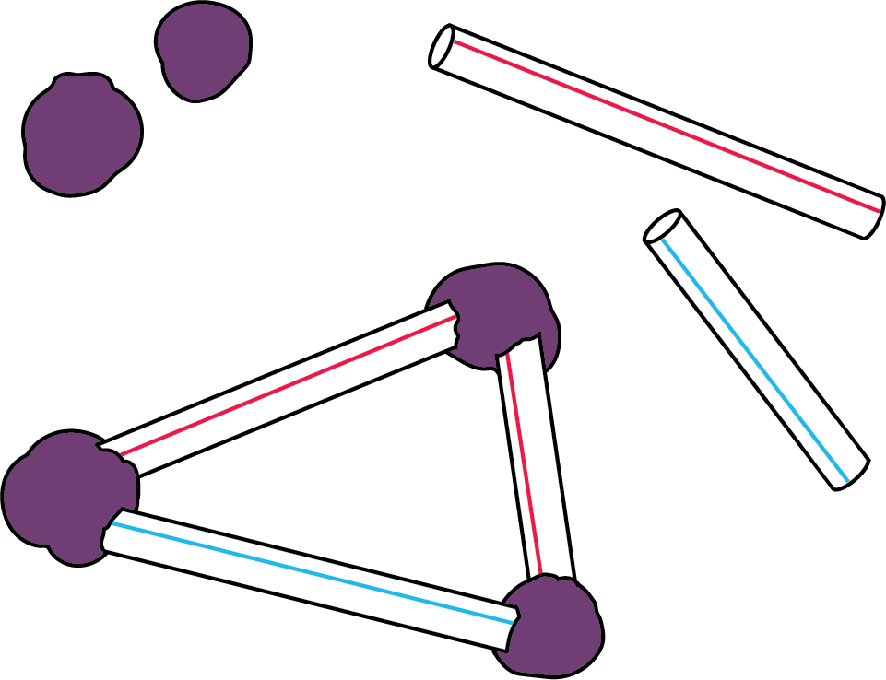
Counting Collections
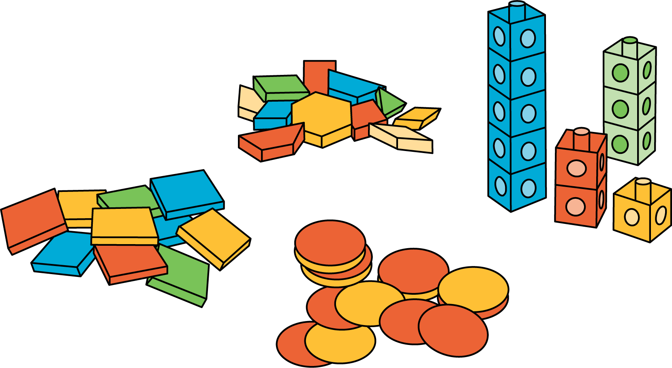
Which One
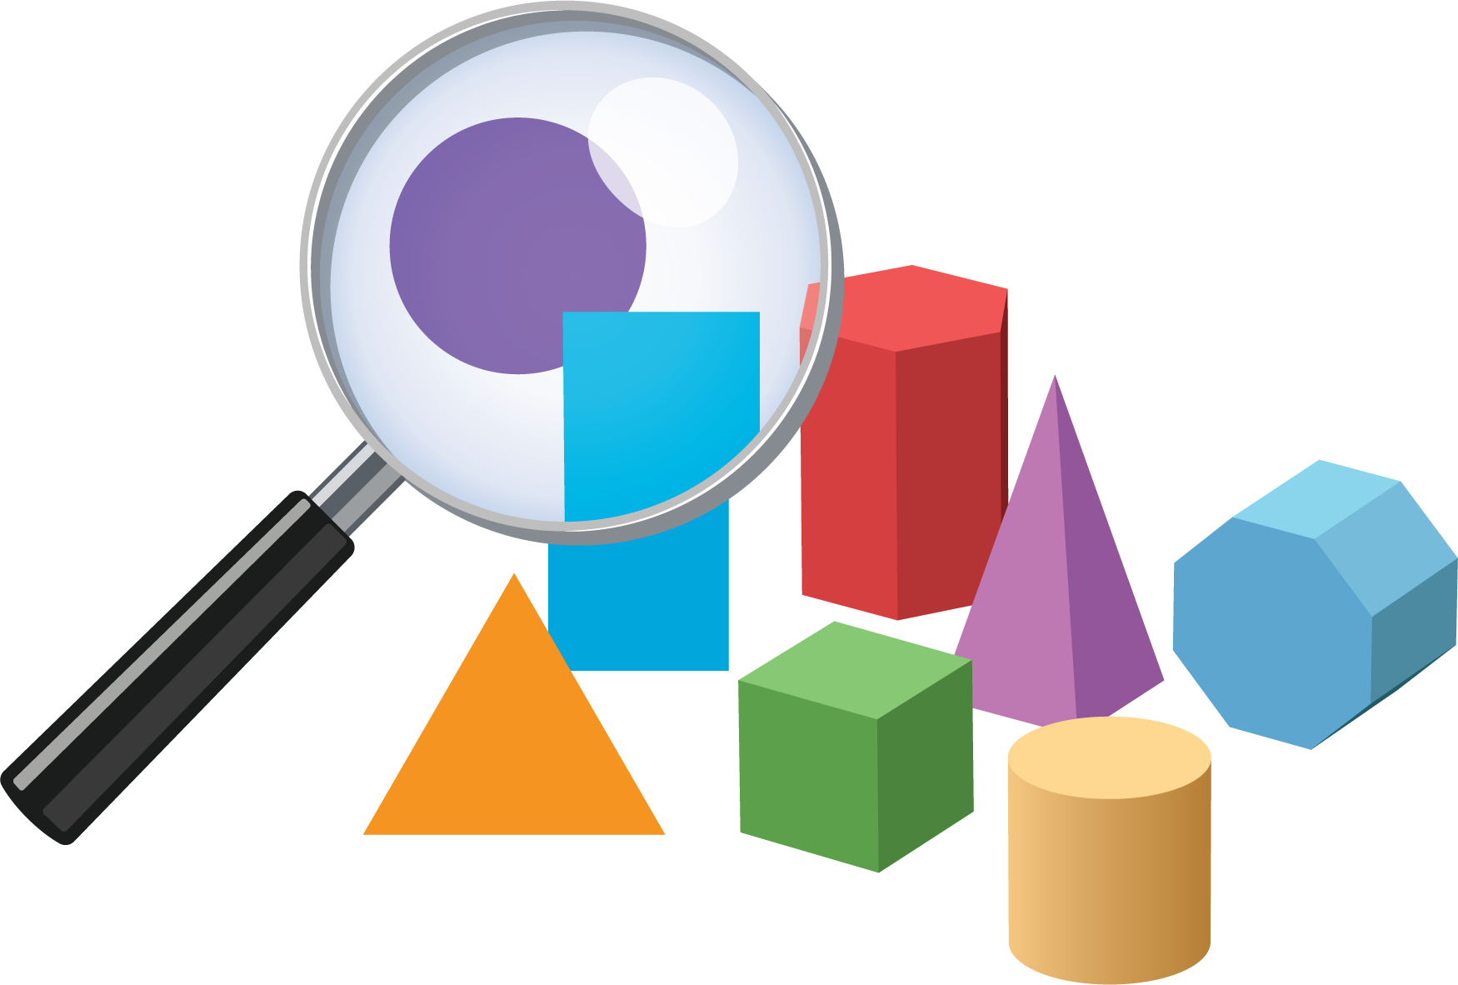
Picture Books
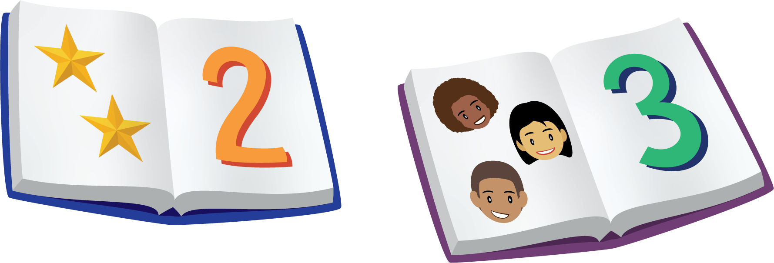
Bingo
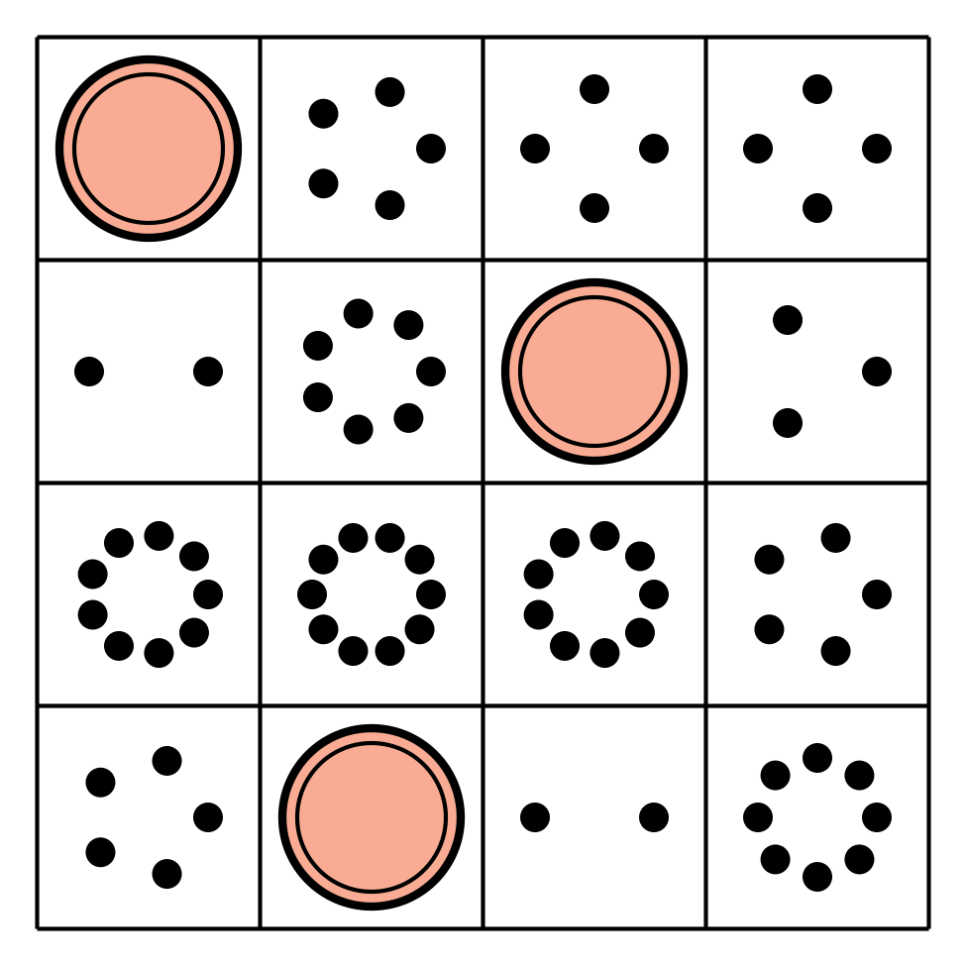
Shake and Spill
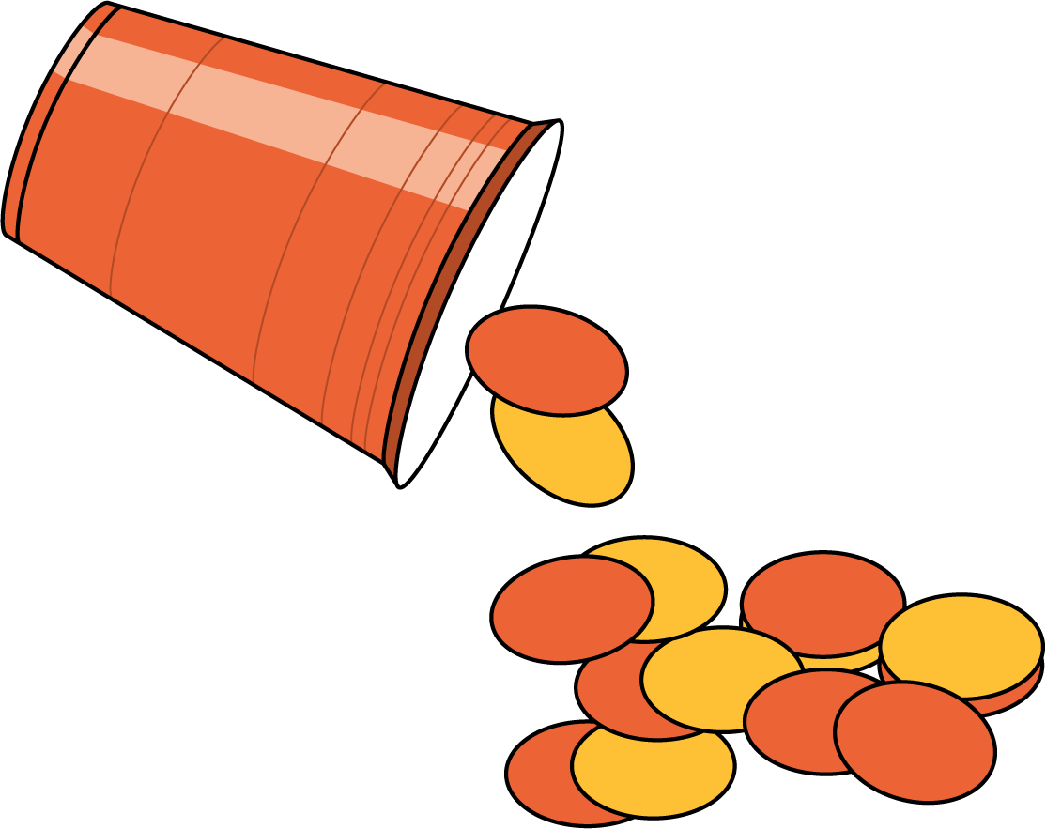
© CC BY 2021 Illustrative Mathematics®

