Lesson 5: Using Function Notation to Describe Rules (Part 2)
Let’s graph and find the values of some functions.

5.1: Make It True
Consider the equation $q=4+0.8p$.
- What value of $q$ would make the equation true when:
  - $p$ is 7?
  - $p$ is 100?
- What value of $p$ would make the equation true when:
  - $q$ is 12?
  - $q$ is 60?
Be prepared to explain or show your reasoning.

5.2: Data Plans
A college student is choosing between two data plans for her new cell phone. Both plans include an allowance of 2 gigabytes of data per month. The monthly cost of each option can be seen as a function and represented with an equation:
- Option A: $A(x)=60$
- Option B: $B(x)=10x+25$
In each function, the input, $x$, represents the gigabytes of data used over the monthly allowance.
- The student decides to find the values of $A(1)$ and $B(1)$ and compare them. What are those values?
- After looking at some of her past phone bills, she decided to compare $A(7.5)$ and $B(7.5)$. What are those values?
- Describe each data plan in words.
- Graph each function on the same coordinate plane. Then, explain which plan you think she should choose.
- ​​​​​
- ​​​​​​
- The student only budgeted $50 a month for her cell phone. She thought, “I wonder how many gigabytes of data I would have for $50 if I go with Option B?” and wrote $B(x)=50$. What is the answer to her question? Explain or show how you know.

Are you ready for more?
Describe a different data plan that, for any amount of data used, would cost no more than one of the given plans and no less than the other given plan. Explain or show how you know this data plan would meet these requirements.

5.3: Function Notation and Graphing Technology
The function $B$ is defined by the equation $B(x)=10x+25$. Use graphing technology to:
- Find the value of each expression:
- $B(6)$
- $B(2.75)$
- $B(1.482)$
- Solve each equation:
- $B(x)=93$
- $B(x)=42.1$
- $B(x)=116.25$

Lesson 5 Summary
Knowing the rule that defines a function can be very useful. It can help us to:
- Find the output when we know the input.
  - If the rule $f(x)=5(x+2)$ defines $f$, we can find $f(100)$ by evaluating $5(100+2)$.
  - If $m(x)=3−\frac{1}{2}x$ defines function $m$, we can find $m(10)$ by evaluating $3−\frac{1}{2}(10)$.
- Create a table of values.
- Here are tables representing functions $f$ and $m$:
- $x$ | - $f(x)=5(x+2)$
- 0 | - 10
- 1 | - 15
- 2 | - 20
- 3 | - 25
- 4 | - 30
- $x$ | - $m(x)=3−\frac{1}{2}x$
- 0 | - 3
- 1 | - $2\frac{1}{2}$
- 2 | - 2
- 3 | - $1\frac{1}{2}$
- 4 | - 1
- Graph the function. The horizontal values represent the input, and the vertical values represent the output.
- For function $f$, the values of $f(x)$ are the vertical values, which are often labeled $y$, so we can write $y=f(x)$. Because $f(x)$ is defined by the expression $5(x+2)$, we can graph $y=5(x+2)$.
- For function $m$, we can write $y=m(x)$ and graph $y=3−\frac{1}{2}x$.
- 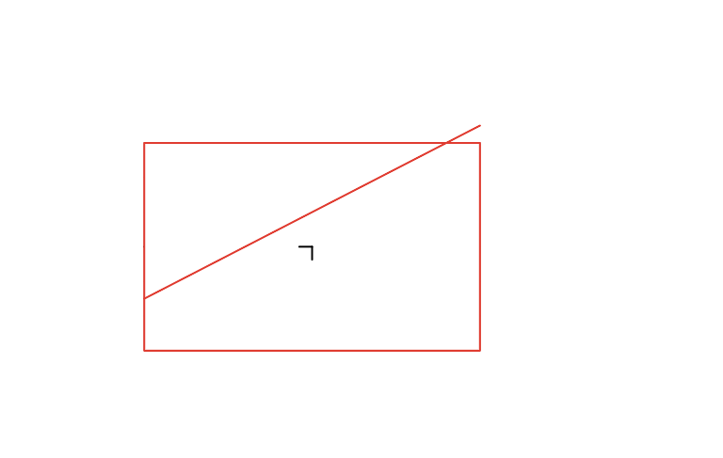
- 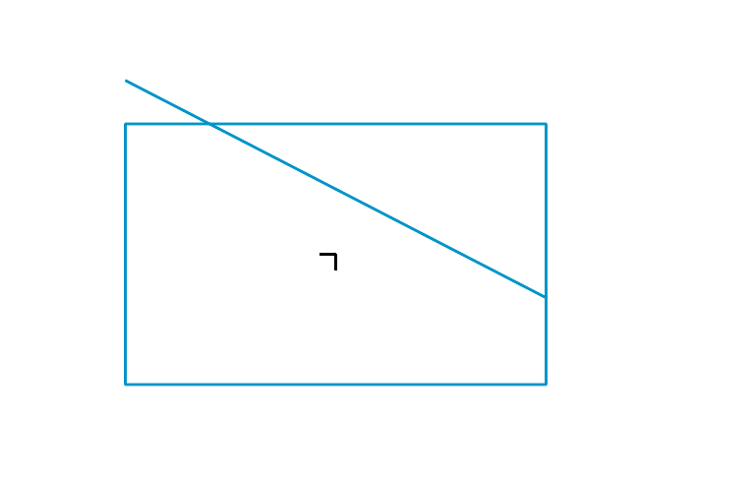
- Find the input when we know the output.
- Suppose the output of function $f$ is 65 at some value of $x$, or $f(x)=65$, and we want to find out what that value is. Because $f(x)$ is equal to $5(x+2)$, we can write $5(x+2)=65$ and solve for $x$.
- $\begin{matrix}5(x+2) & =65 \\ x+2 & =13 \\ x & =11\end{matrix}$
Each function here is a linear function because the value of the function changes by a constant rate and its graph is a line.
© CC BY 2019 by Illustrative Mathematics®

