Lesson 18 Practice Problems
- The figures are congruent. Select all the sequences of transformations that would take Figure 1 to Figure 2.
- 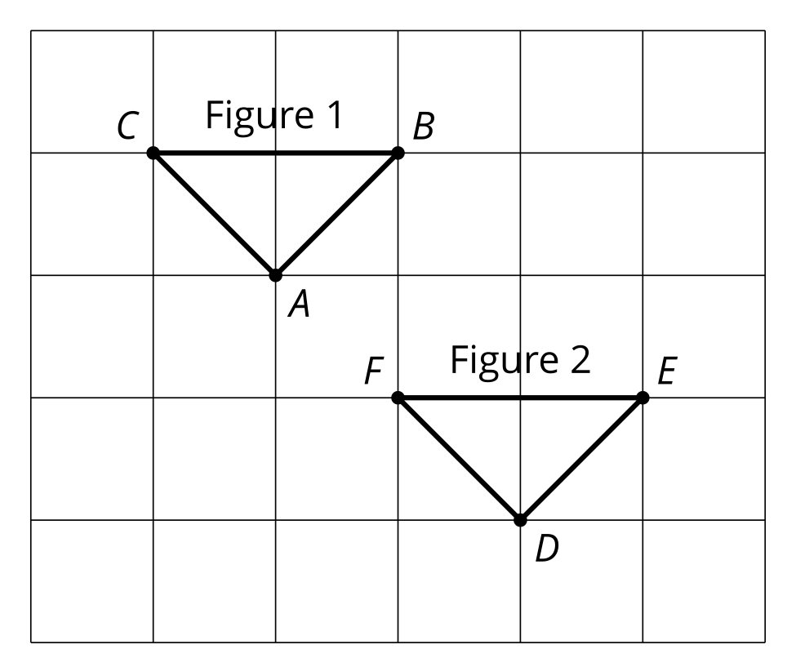
  - Translate by directed line segment $AD$.
  - Rotate 180 degrees around point $E$.
  - Translate by directed line segment $AE$ and reflect across $AC$.
  - Translate by directed line segment $CE$ and rotate 90 degrees counterclockwise around point $E$.
  - Rotate 180 degrees around point $C$, translate by directed line segment $CE$, and reflect across segment $EF$.
  - Reflect across segment $AB$, rotate clockwise by angle $BFE$ using center $F$, then reflect across segment $EF$.

  - Draw the image of figure $ACTS$ after a clockwise rotation around point $T$ using angle $CTS$ and then a translation by directed line segment $CT$.
  - Describe another sequence of transformations that will result in the same image.
- 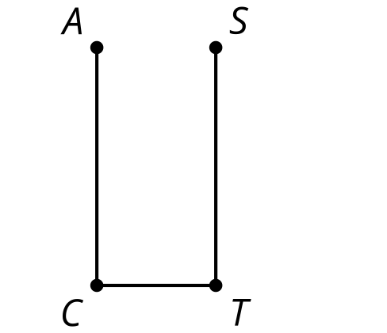
- Draw the image of triangle $ABC$ after this sequence of rigid transformations.
  - Reflect across line segment $AB$.
  - Translate by directed line segment $u$.
- 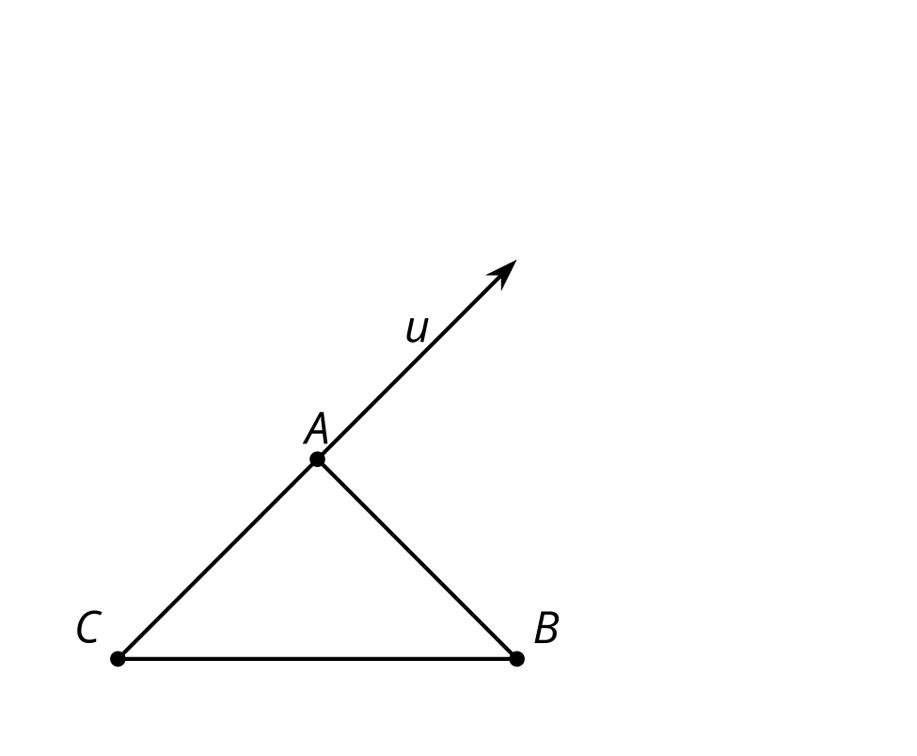
- Describe a transformation that takes any point $A$ to any point $B$.
- (From Unit 1, Lesson 17.)
- Triangle $ABC$ is congruent to triangle $A^{′}B^{′}C^{′}$. Describe a sequence of rigid motions that takes $A$ to $A^{′}$, $B$ to $B^{′}$, and $C$ to $C^{′}$.
- 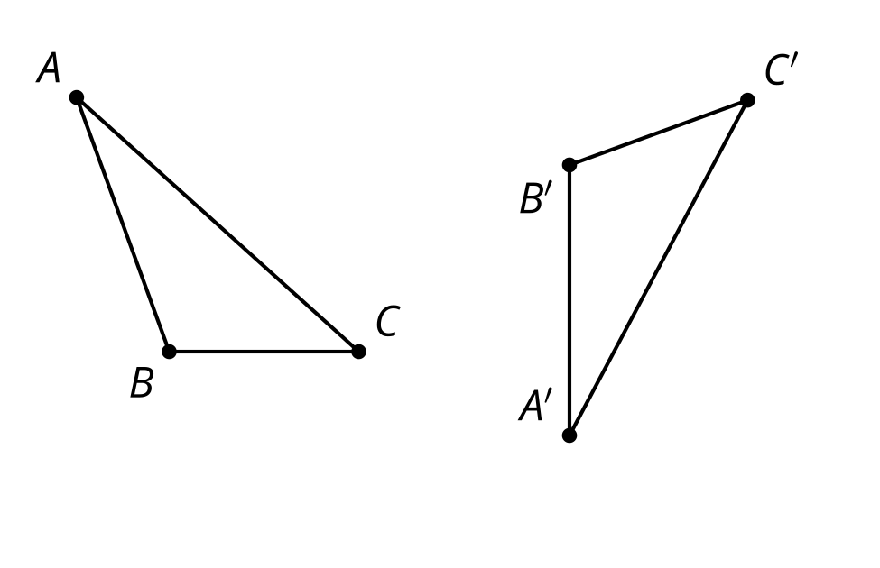
- (From Unit 1, Lesson 17.)
- A quadrilateral has rotation symmetry that can take any of its vertices to any of its other vertices. Select all conclusions that we can reach from this.
  - All sides of the quadrilateral have the same length.
  - All angles of the quadrilateral have the same measure.
  - All rotations take one half of the quadrilateral to the other half of the quadrilateral.
- (From Unit 1, Lesson 16.)
- A quadrilateral has a line of symmetry. Select all conclusions that must be true.
  - All sides of the quadrilateral have the same length.
  - All angles of the quadrilateral have the same measure.
  - Two sides of the quadrilateral have the same length.
  - Two angles of the quadrilateral have the same measure.
  - No sides of the quadrilateral have the same length.
  - No angles of the quadrilateral have the same measure.
- (From Unit 1, Lesson 15.)
- Which segment is the image of $FG$ when rotated ${90}^{∘}$ clockwise around point $P$?
- 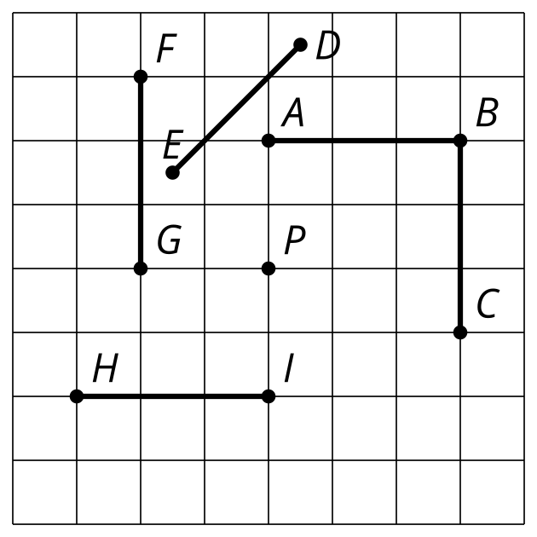
- (From Unit 1, Lesson 14.)
- Which statement is true about a translation?
  - A translation rotates a line.
  - A translation takes a line to a parallel line or itself.
  - A translation takes a line to a perpendicular line.
  - A translation dilates a line.
- (From Unit 1, Lesson 12.)
© CC BY 2019 by Illustrative Mathematics®

