Unit 2 Lesson 15: The Remainder Theorem

1 Notice and Wonder: Division Leftovers (Warm up)

Student Task Statement
What do you notice? What do you wonder?
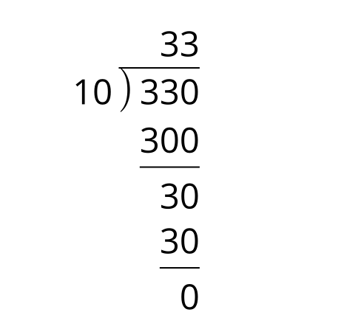
A. $330=33\left(10\right)+0$
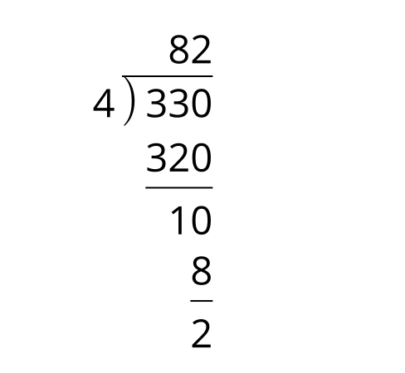
B. $330=4\left(82\right)+2$
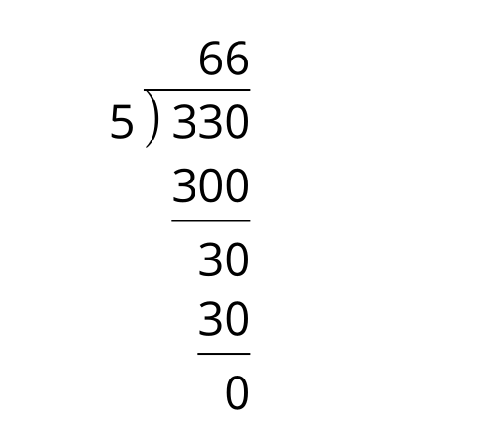
C. $330=5\left(66\right)+0$

2 The Unknown Coefficient

Student Task Statement
Consider the polynomial function $f\left(x\right)=x^{4}−ux^{3}+24x^{2}−32x+16$ where $u$ is an unknown real number. If $x−2$ is a factor, what is the value of $u$? Explain how you know.

3 A Study of Remainders

Student Task Statement
- Which of these polynomials could have $\left(x−2\right)$ as a factor?
  - $A\left(x\right)=6x^{2}−7x−5$
  - $B\left(x\right)=3x^{2}+15x−42$
  - $C\left(x\right)=2x^{3}+13x^{2}+16x+5$
  - $D\left(x\right)=3x^{3}−2x^{2}−15x+14$
  - $E\left(x\right)=8x^{4}−41x^{3}−18x^{2}+101x+70$
  - $F\left(x\right)=x^{4}+5x^{3}−27x^{2}−101x−70$
- Select one of the polynomials that you said doesn’t have $\left(x−2\right)$ as a factor.
  - Explain how you know $\left(x−2\right)$ is not a factor.
  - If you have not already done so, divide the polynomial by $\left(x−2\right)$. What is the remainder?
- List the remainders for each of the polynomials when divided by $\left(x−2\right)$. How do these values compare to the value of the functions at $x=2$?
© CC BY 2019 by Illustrative Mathematics®

