Lesson 4: Use Layers to Determine Volume
- Let's relate multiplication to how we use layers to find volume.

Warm-up: Estimation Exploration: How Many Cubes?
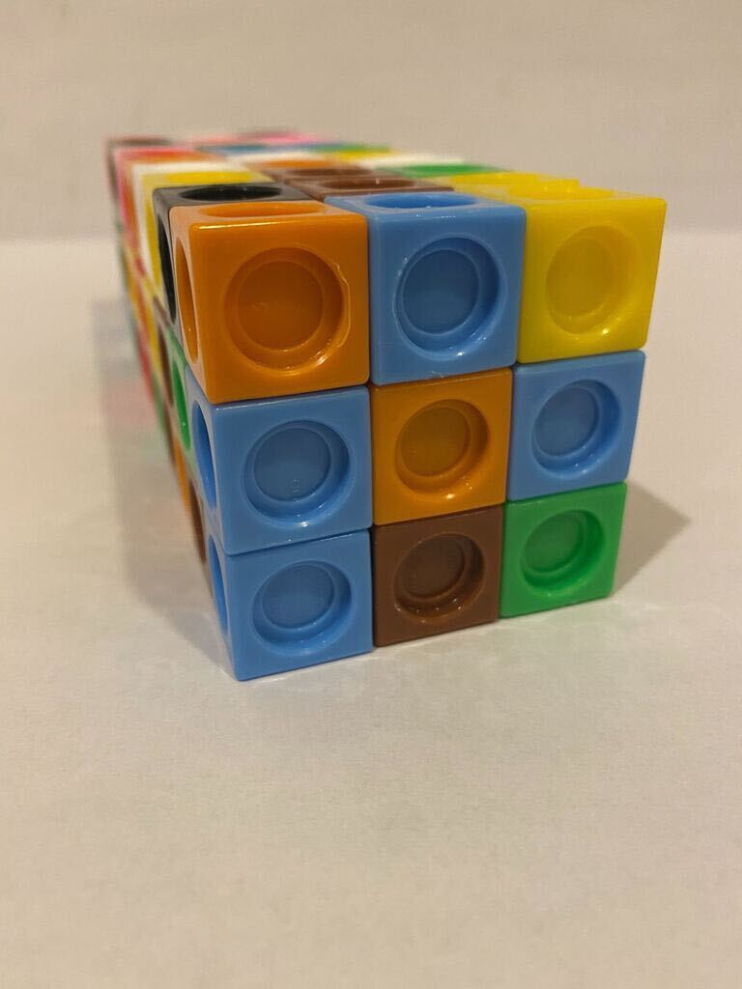
About how many cubes were used to build this prism?
Record an estimate that is:
too low | about right | too high

4.1: Layers in Rectangular Prisms
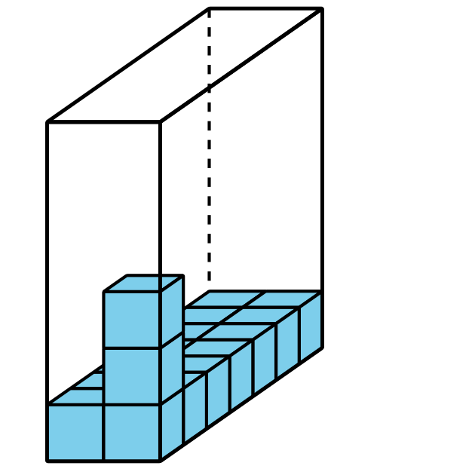
- Complete the table. Be prepared to explain your reasoning.
- prism | - number of cubes in one layer | - number of layers | - volume
- A
- B
- C
- D

- Prism A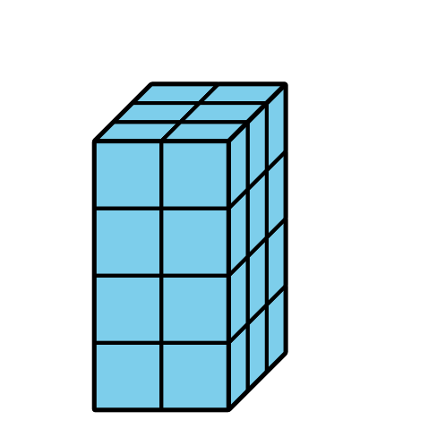
- Prism B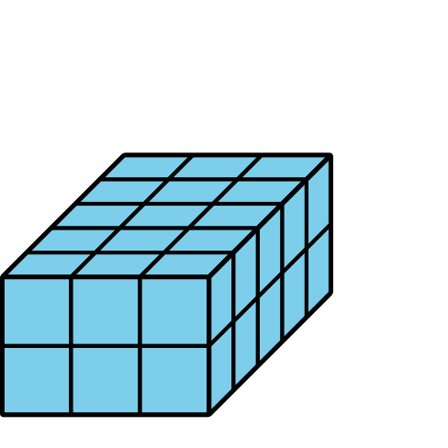
- Prism C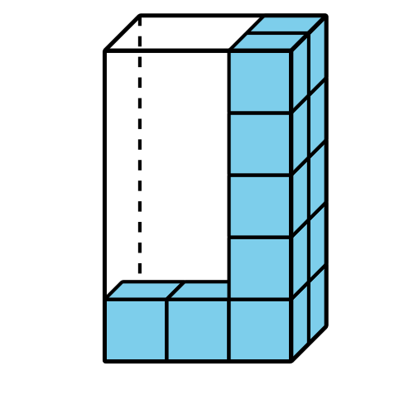
- Prism D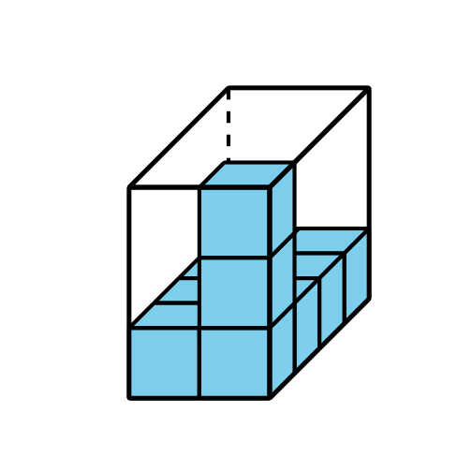
- Find the volume of each prism. Explain or show your reasoning.
- Prism E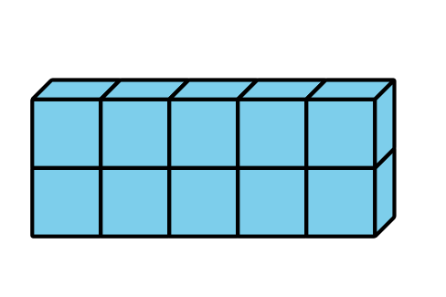

- Prism F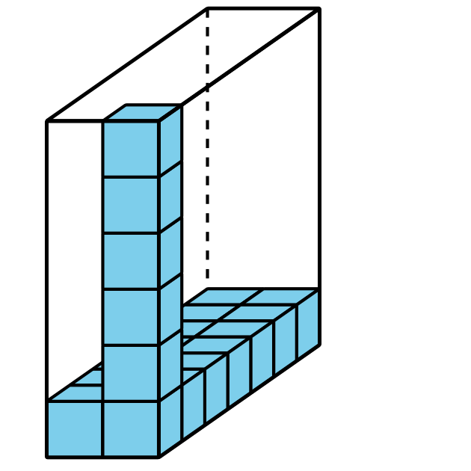
- How can you find the volume of any rectangular prism?

4.2: Finding Volume in Different Ways
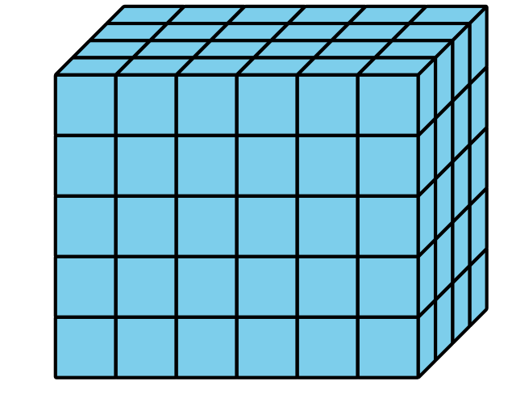
- Explain or show how the expression $5×24$ represents the volume of this rectangular prism.
- Explain or show how the expression $6×20$ represents the volume of this rectangular prism.
- Find a different way to calculate the volume of this rectangular prism. Explain or show your thinking.
- Write an expression to represent the way you calculated the volume.

Section Summary
Section Summary
We call the amount of space an object takes up volume. This prism has a volume of 120 cubes.
To find the volume of any prism, we can find the number of cubes in one layer and multiply that number by the number of layers. We can describe this prism as having 6 layers of 20 cubes, 4 layers of 30 cubes, or 5 layers of 24 cubes. We can use all of these expressions to represent the volume of the prism:
$5×24$, $5×\left(6×4\right)$
$6×20$, $6×\left(5×4\right)$
$4×30$, $4×\left(5×6\right)$
© CC BY 2021 Illustrative Mathematics®

