Lesson 15 Practice Problems
- For the polynomial function $f(x)=x^{3}−2x^{2}−5x+6$, we have $f(0)=6,f(2)=\text{-}4,f(\text{-}2)=0,f(3)=0,f(\text{-}1)=8,f(1)=0$. Rewrite $f(x)$ as a product of linear factors.
- Select all the polynomials that have $(x−4)$ as a factor.
  - $x^{3}−13x−12$
  - $x^{3}+8x^{2}+19x+12$
  - $x^{3}+6x+5x−12$
  - $x^{3}−x^{2}−10x−8$
  - $x^{2}−4$
- Write a polynomial function, $p(x)$, with degree 3 that has $p(7)=0$.
- Long division was used here to divide the polynomial function $p(x)=x^{3}+7x^{2}−20x−110$ by $(x−5)$ and to divide it by $(x+5)$.
- x2+12x+40x−5x3+7x2−20x−110−x3+5x2_−20x−11012x2−20x−110−12x2+60x_−11040x−110−40x+200_90
- x2+2x−30x+5x3+7x2−20x−110−x3−5x2_−20x−1102x2−20x−110−2x2−10x_−110-30x−11030x+150_40
  - What is $p(\text{-}5)$?
  - What is $p(5)$?
- Which polynomial function has zeros when $x=5,\frac{2}{3},\text{-}7$?
  - $f(x)=(x+5)(2x+3)(x−7)$
  - $f(x)=(x+5)(3x+2)(x−7)$
  - $f(x)=(x−5)(2x−3)(x+7)$
  - $f(x)=(x−5)(3x−2)(x+7)$
- (From Unit 2, Lesson 5.)
- The polynomial function $q(x)=3x^{4}+8x^{3}−13x^{2}−22x+24$ has known factors $(x+3)$ and $(x+2)$. Rewrite $q(x)$ as the product of linear factors.
- (From Unit 2, Lesson 12.)
- We know these things about a polynomial function $f(x)$: it has degree 3, the leading coefficient is negative, and it has zeros at $x=\text{-}5,\text{-}1,3$. Sketch a graph of $f(x)$ given this information.
- 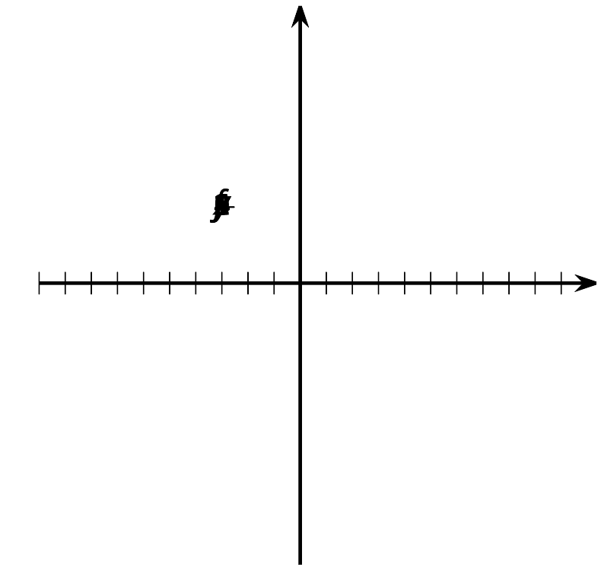
- (From Unit 2, Lesson 14.)
© CC BY 2019 by Illustrative Mathematics®

