Lesson 8: Estimate and Measure Liquid Volume
- Let’s measure and estimate liquid volume.

Warm-up: Number Talk: Divide by 3
Find the value of each expression mentally.
- $30÷3$
- $60÷3$
- $63÷3$
- $54÷3$

8.1: Estimate Liquid Volume
- Clare says the bathtub holds about 2 liters.
- Jada says the bathtub holds about 20 liters.
- Kiran says the bathtub holds about 200 liters.
- 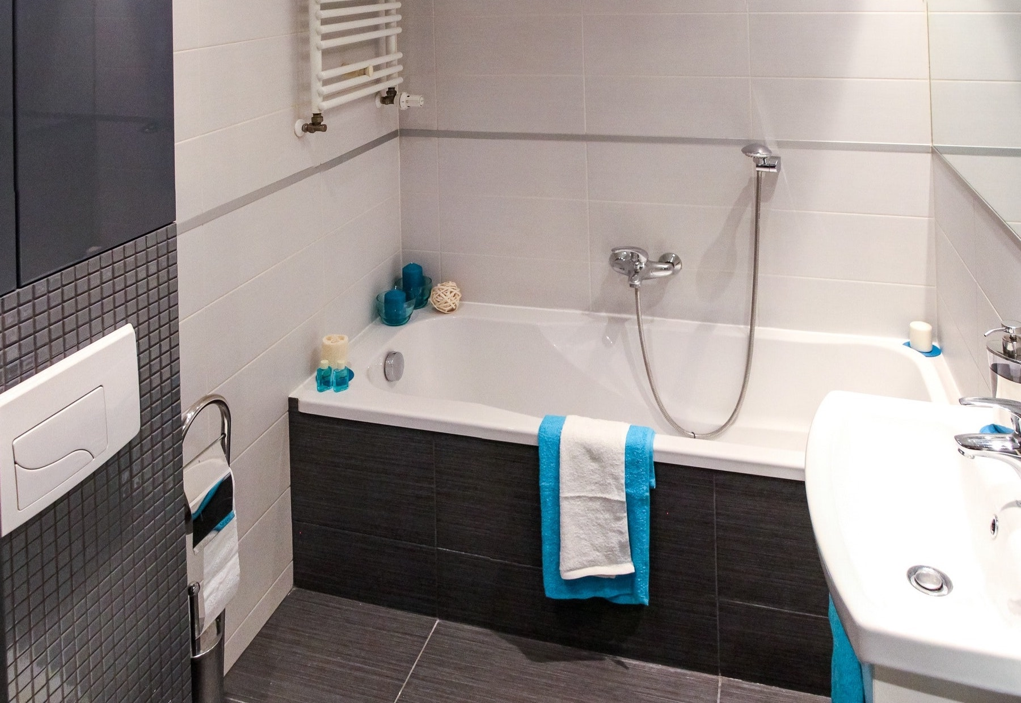
- Whom do you agree with? Explain or show your reasoning.
- Would the bucket and the bottle hold 2 liters, 20 liters, or 200 liters? Explain how you know.
- 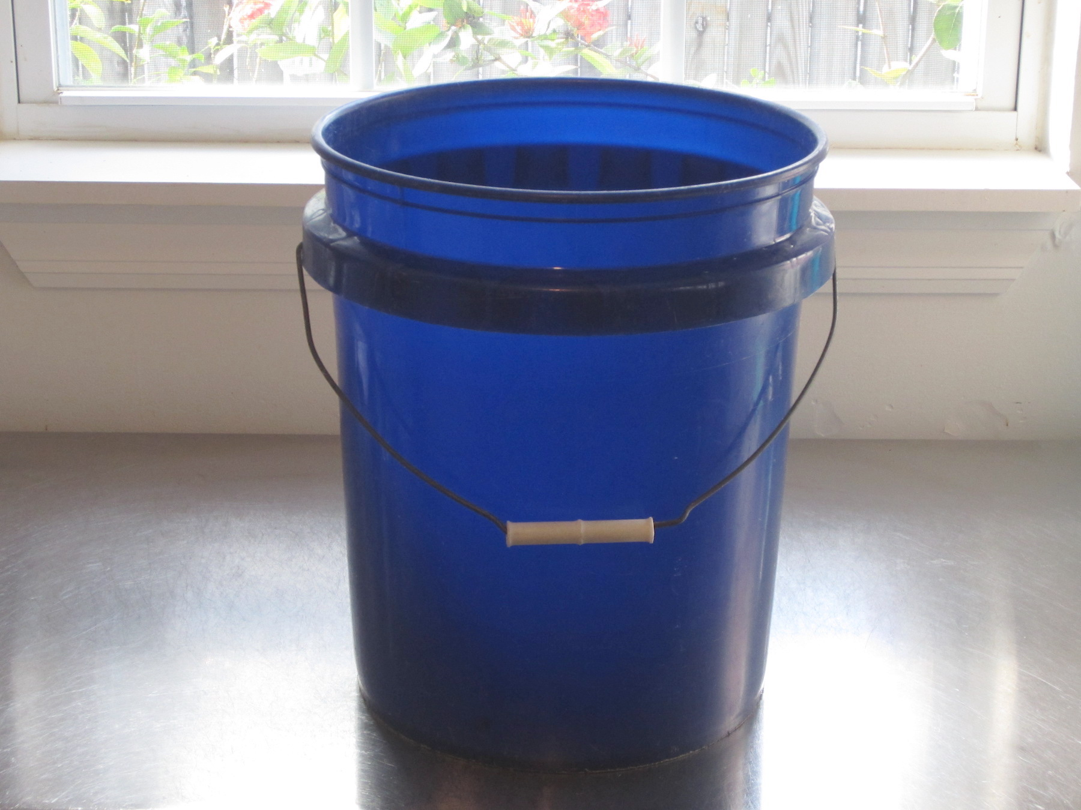
- 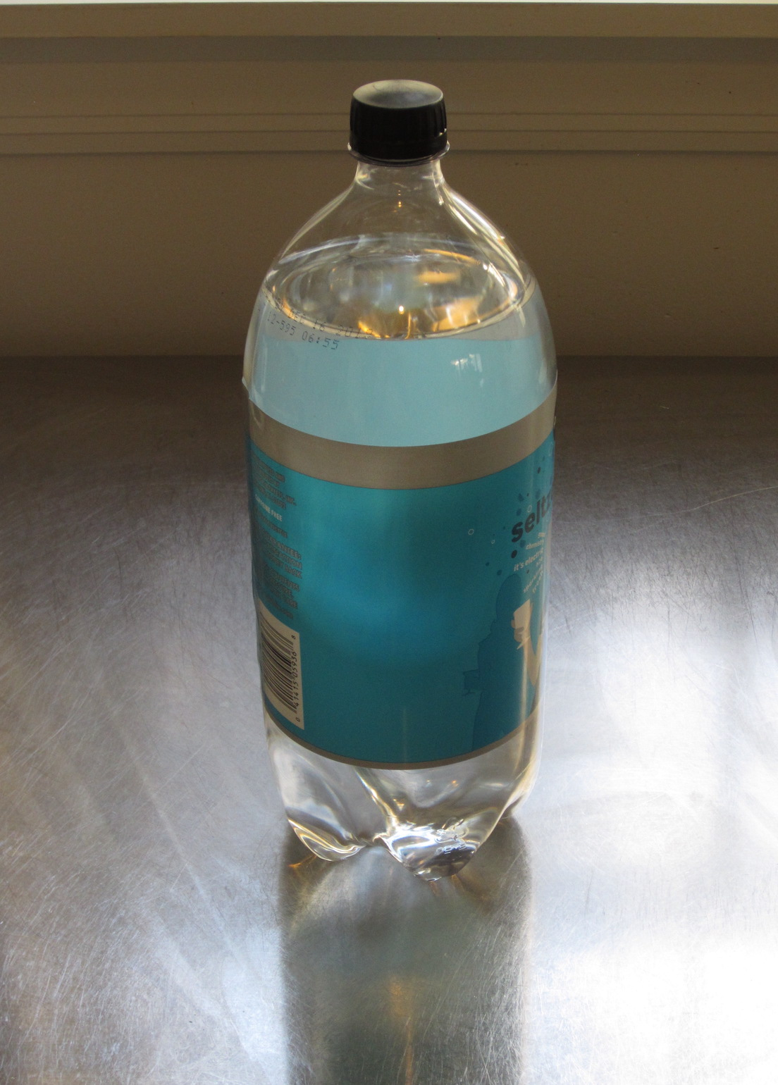
- Match the containers to the number of liters they could hold. Be ready to explain your reasoning.
- item
  - sink
  - 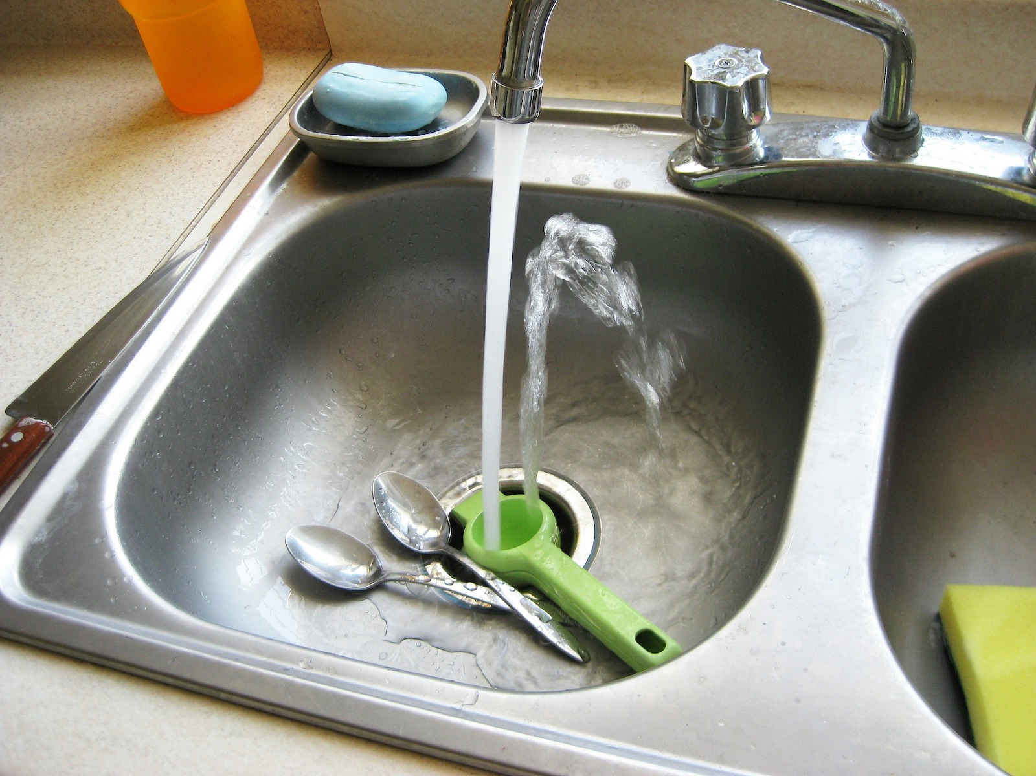
  - kiddie pool
  - 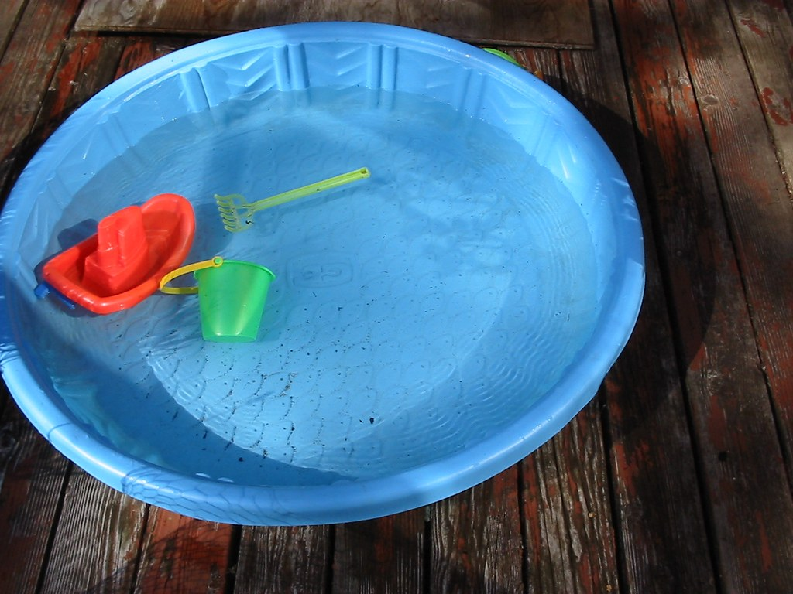
  - pot
  - 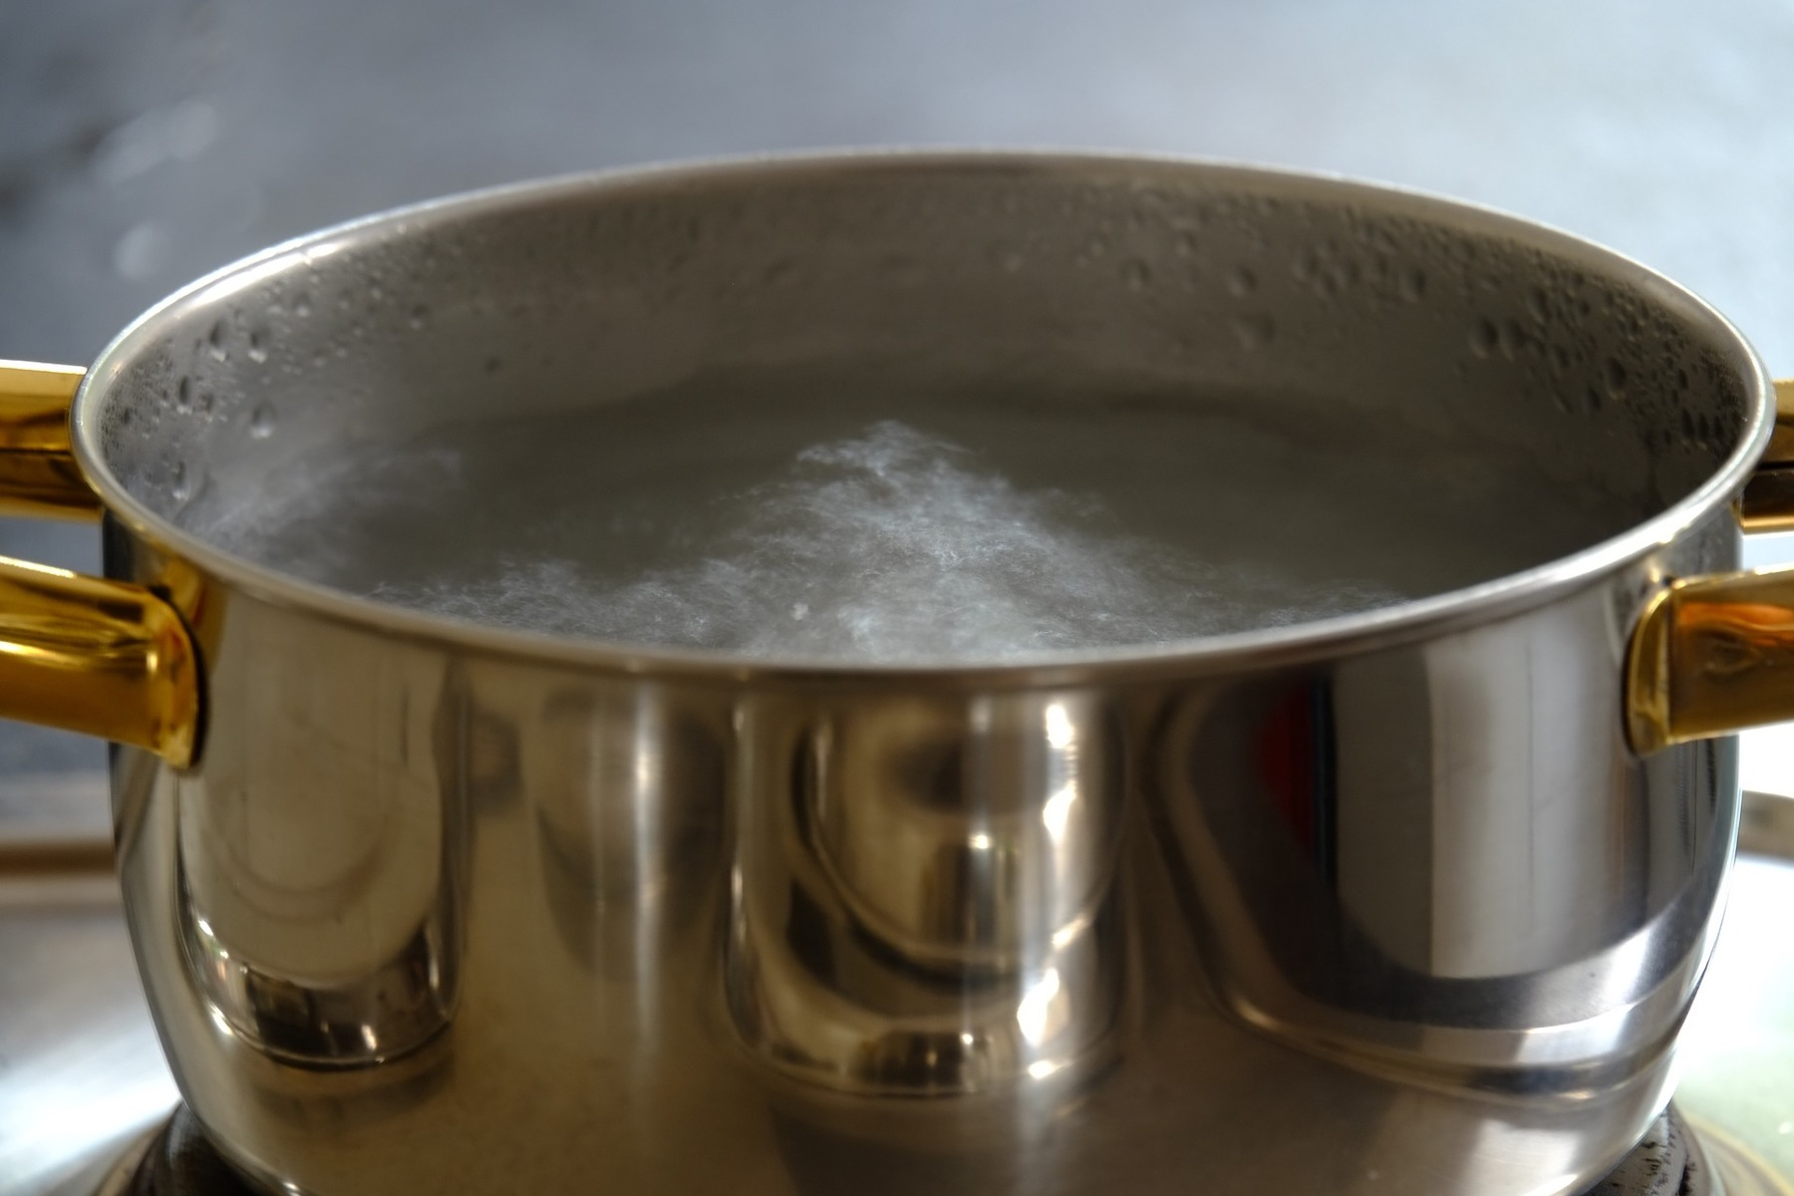
  - toilet tank
  - 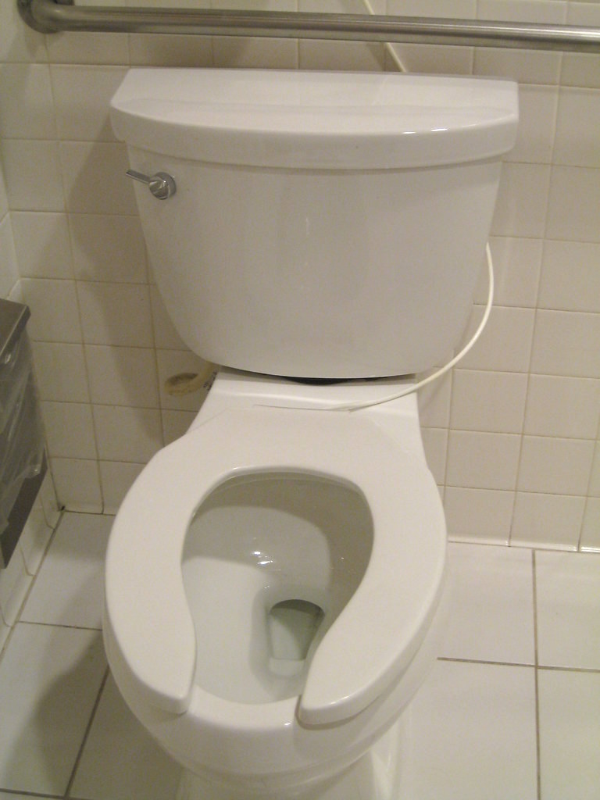
- number of liters
  - 4 liters
  - 6 liters
  - 500 liters
  - 10 liters

8.2: Measure Liquid Volume
What do you notice? What do you wonder?
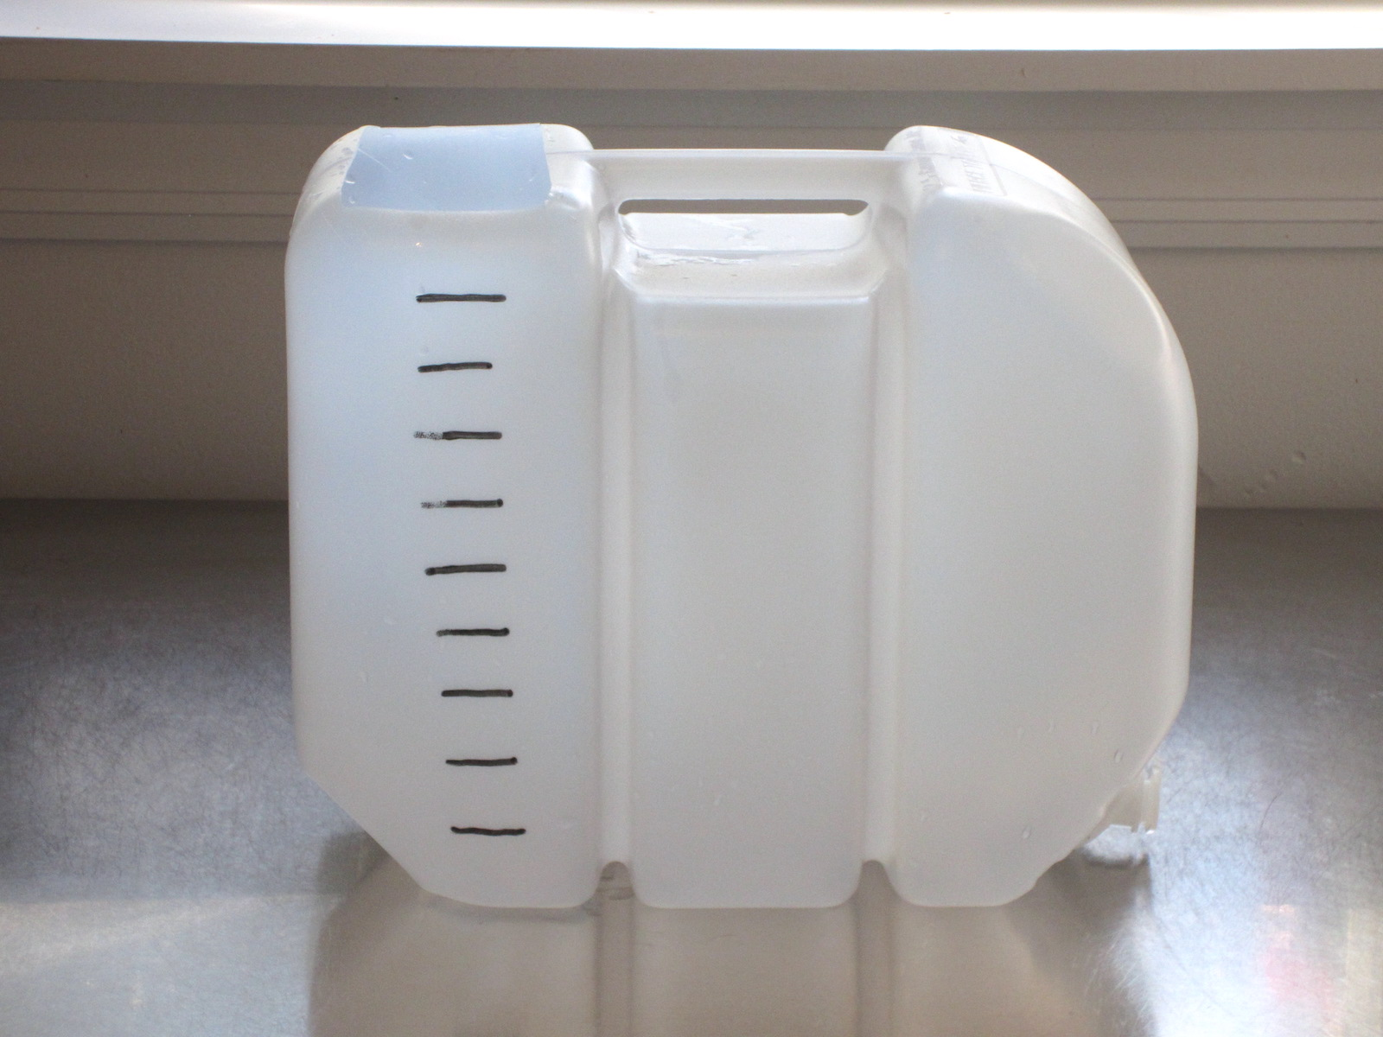
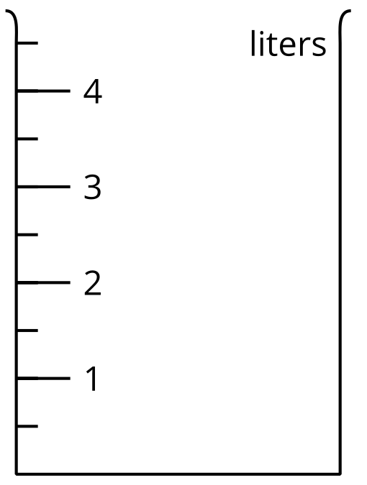
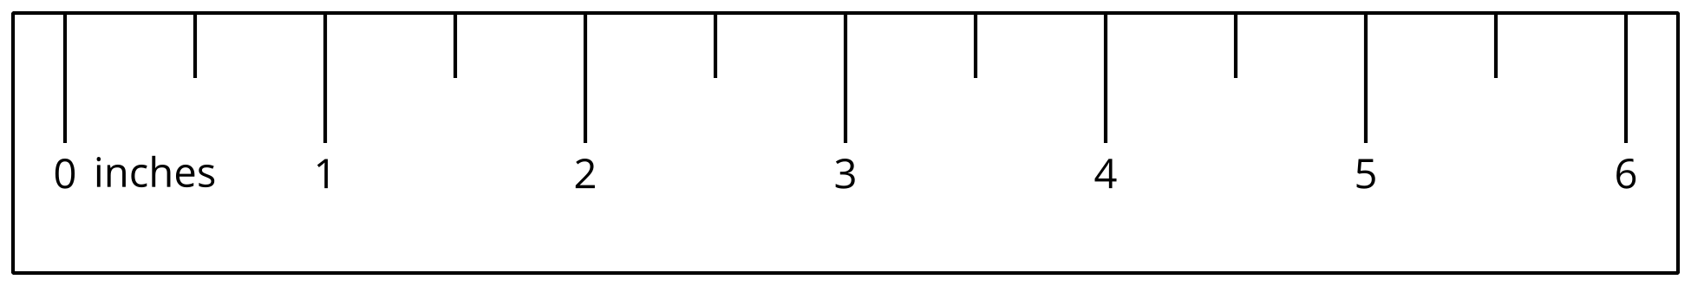
- The container in each image is marked in liters. Find the volume of the liquid.
- A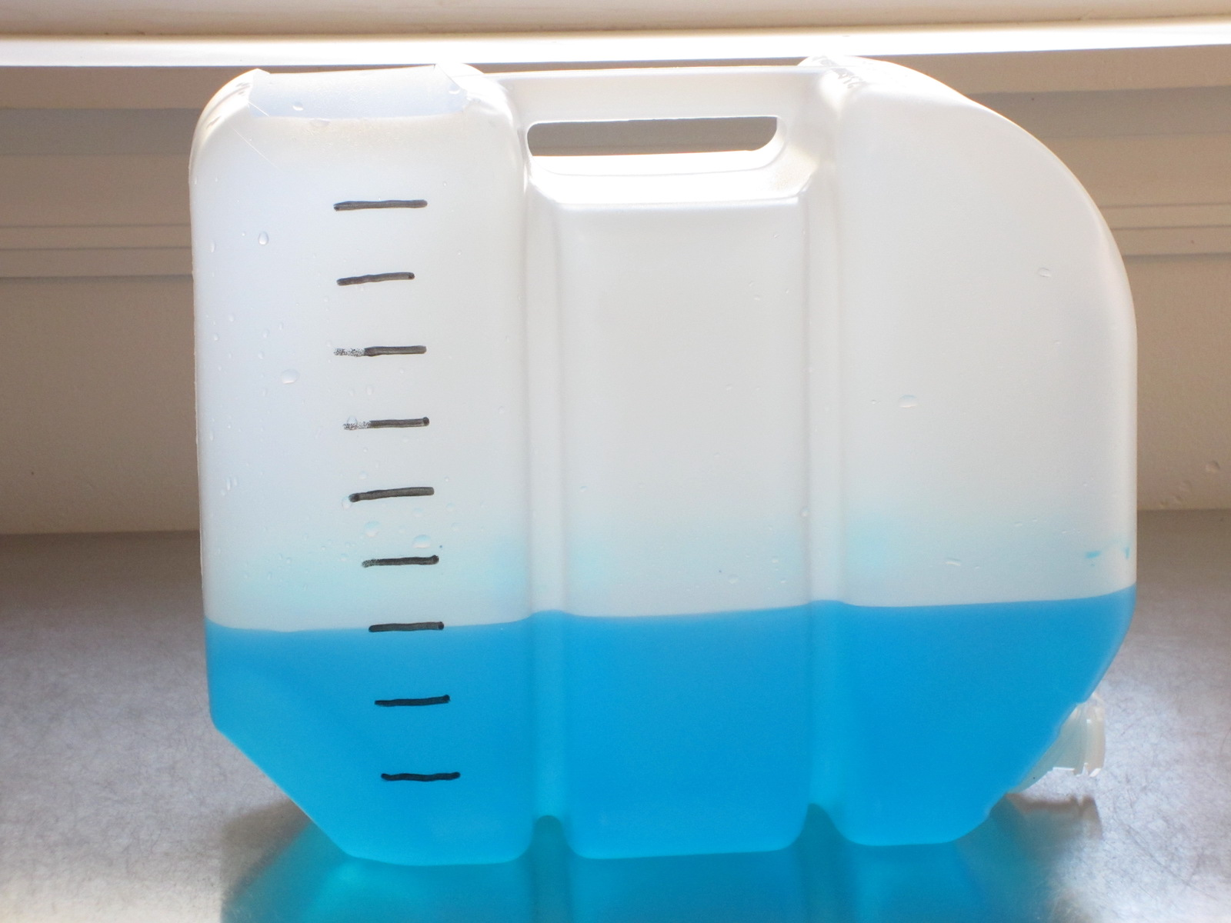
- B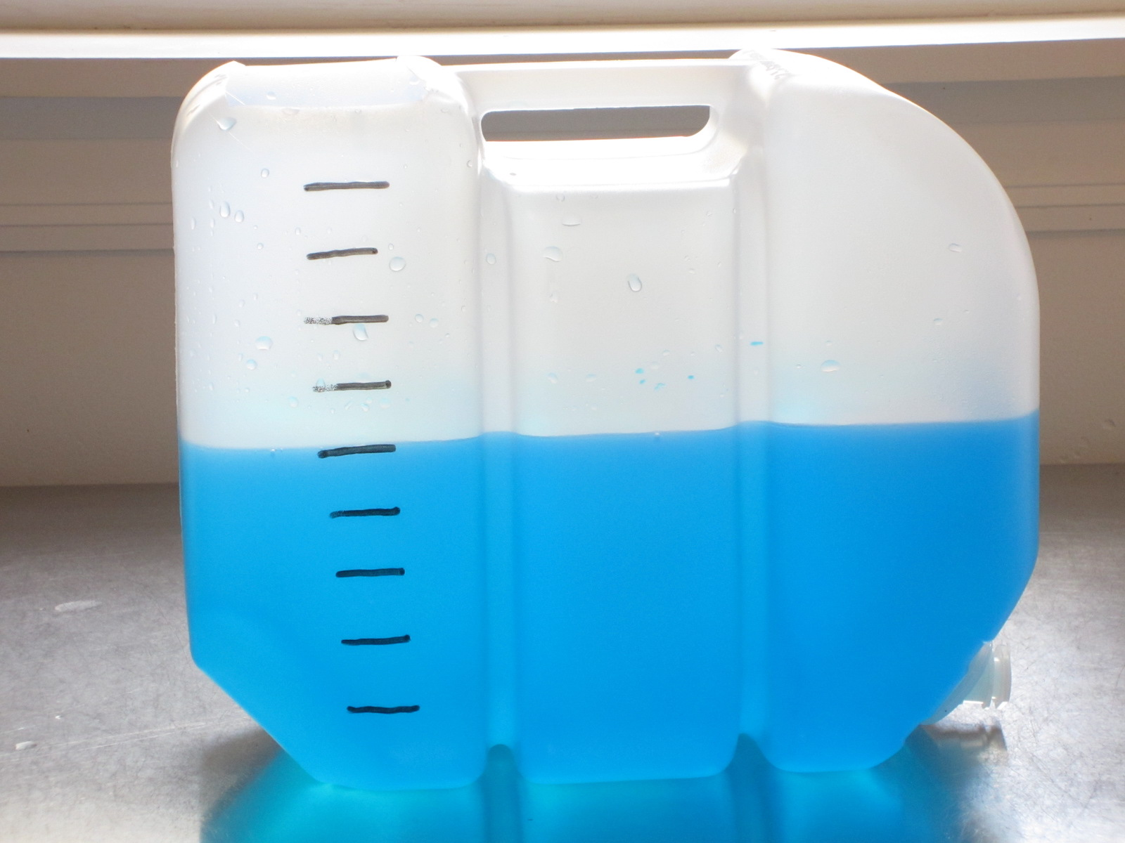
- C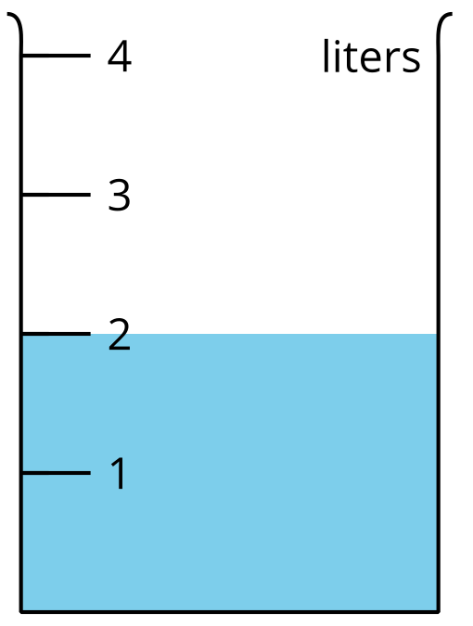
- D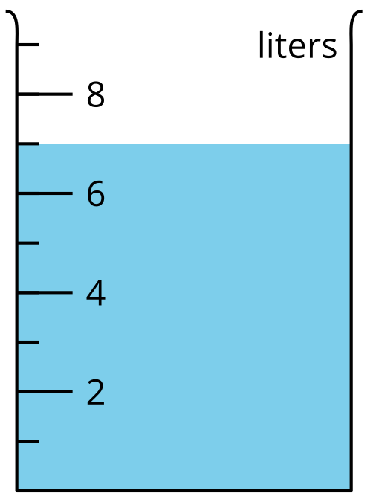
- E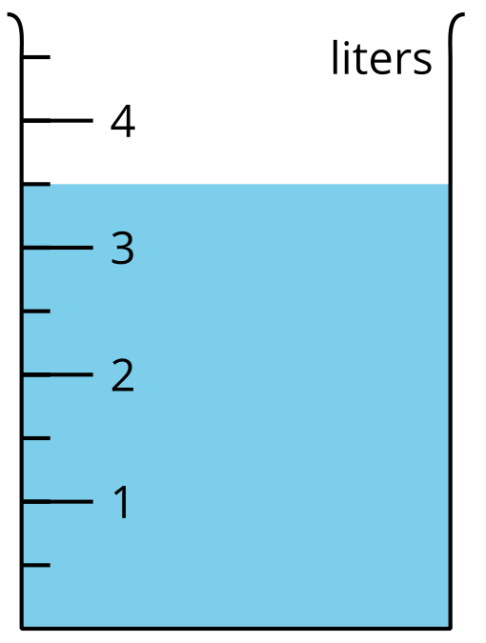
- F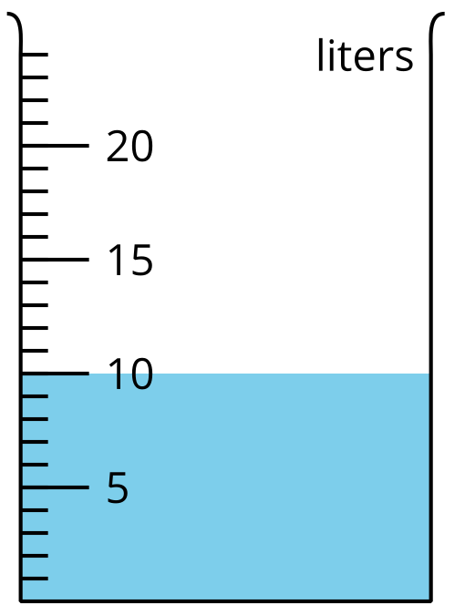
- G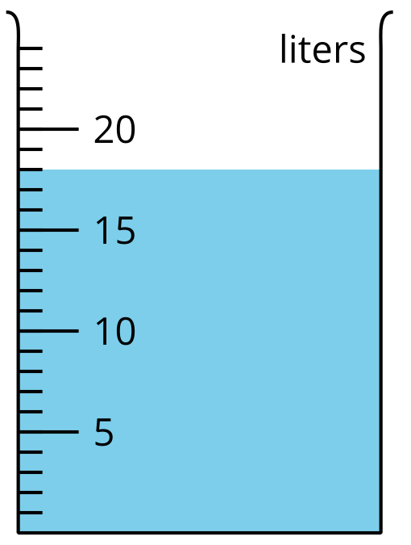
- H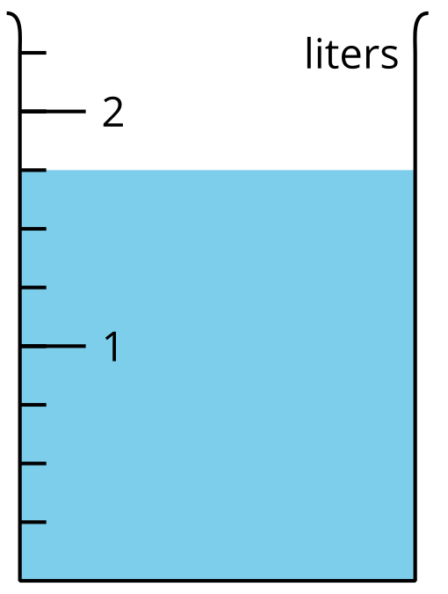
- Shade the images of the empty containers to show the liquid volume.
- P: 1 liter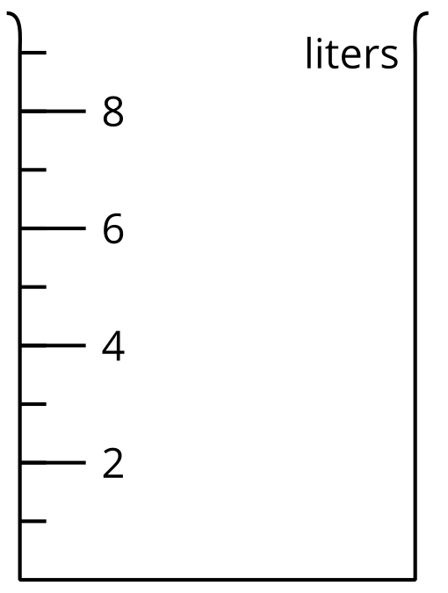
- Q: 8 liters
- R: 7 liters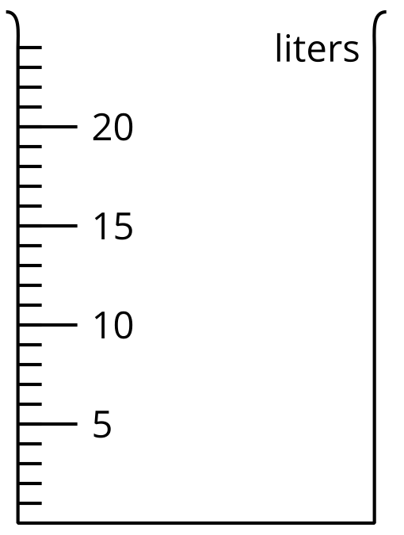
- S: $2\frac{1}{2}$ liters
- T: 23 liters
- If you have time: Of all the containers in this activity, which two containers have the most liquid? How many liters would you have if you combined the liquid in them? Explain or show your reasoning.

Section Summary
Section Summary
In this section, we learned how to measure and estimate weight in grams and kilograms.
This paper clip weighs about 1 gram.
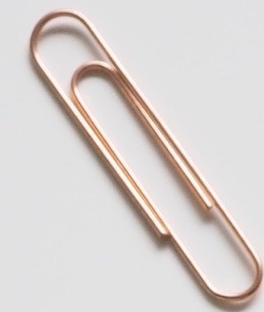
This basket of apples weighs about 1 kilogram.
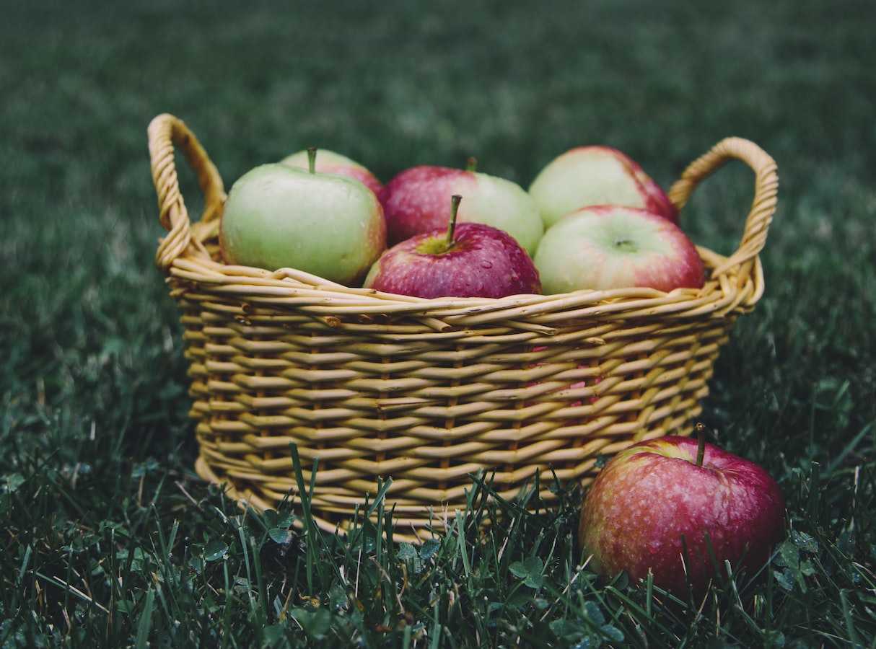
We also learned how to measure and estimate liquid volume in liters.
© CC BY 2021 Illustrative Mathematics®

