Unit 8 Lesson 14: Estimation Exploration

WU Estimation Exploration: Fractional Measurement (Warm up)

Student Task Statement
What is the length of this earthworm?
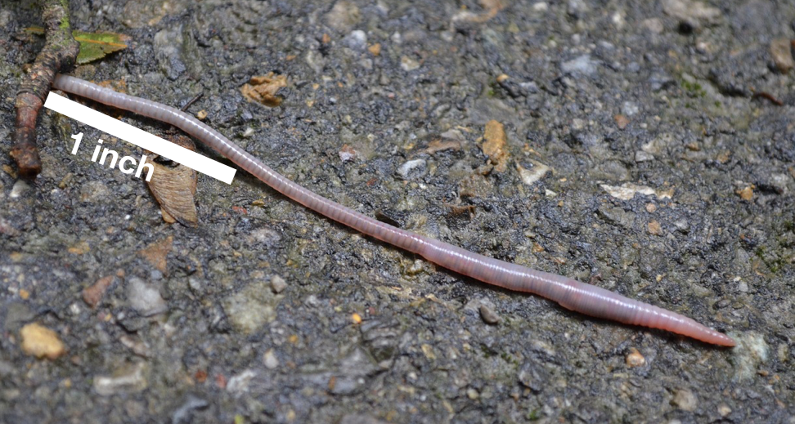
Record an estimate that is:
too low | about right | too high

1 Design Your Estimation Exploration

Student Task Statement
- Find an object or an image that would make an interesting estimation problem. Write a question that would encourage others to answer with a length estimated to the nearest half or fourth of an inch.
- Think about possible estimates others might make for the length of the object or image.
- Record an estimate that is:
- too low | - about right | - too high
- Measure the length of the object or image to make sure your estimates make sense. If needed, revise your estimates.

2 Facilitate Your Estimation Exploration

Student Task Statement
- Display your image for your classmates.
- Ask them, “What is an estimate that’s too high? Too low? About right?”
- Give them a minute of quiet think time.
- Give them a minute to discuss together.
- Ask them to share their estimates.
- Record their ideas.
© CC BY 2021 Illustrative Mathematics®

