Lesson 15 Practice Problems
- Here is a graph of a trigonometric function. Which equation could define this function?
  - $y=1.5\text{sin}(x)−4$
  - $y=1.5\text{cos}(x)−4$
  - $y=\text{-}4\text{sin}(1.5x)$
  - $y=\text{-}4\text{cos}(1.5x)$
- Select all the functions that have period $π$.
  - $y=\text{cos}\left(\frac{x}{2}\right)$
  - $y=\text{sin}\left(\frac{x}{2}\right)$
  - $y=\text{cos}(x)$
  - $y=\text{cos}(2x)$
  - $y=\text{sin}(2x)$
  - Sketch a graph of $a(θ)=\text{cos}(3θ)$.
  - Compare the graph of $a$ to the graph of $b(θ)=\text{cos}(θ)$. How are the two graphs alike? How are they different?
- 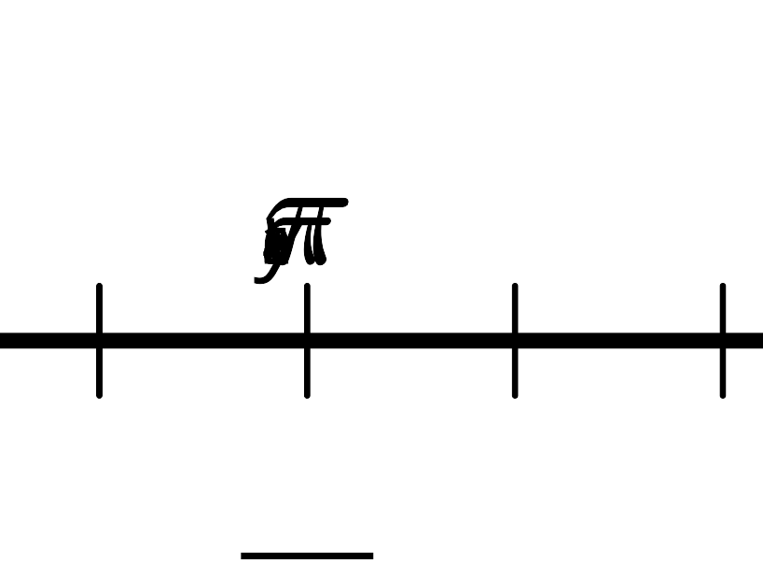
- The functions $f$ and $g$ are given by $f(x)=\text{cos}(x)$ and $g(x)=\text{cos}(5x)$. How are the graphs of $f$ and $g$ related?
- Here is a point at the tip of a windmill blade. The center of the windmill is 6 feet off the ground and the blades are 1.5 feet long.
- Write an equation giving the height $h$ of the point $P$ after the windmill blade rotates by an angle of $a$. Point $P$ is currently rotated $\frac{π}{4}$ radians from the point directly to the right of the center of the windmill.
- (From Unit 6, Lesson 14.)
- The coordinates of $P$ are $(1,0)$.
  - If the wheel makes a $\frac{1}{3}$ rotation counterclockwise around its center, what radian angle does $P$ rotate through?
  - If the wheel makes a $1\frac{1}{4}$ rotation counterclockwise around its center, what radian angle does $P$ rotate through?
- (From Unit 6, Lesson 3.)
- A Ferris wheel has a radius of 95 feet and its center is 105 feet above the ground. Which statement is true about a point on the Ferris wheel as it goes around in a circle?
  - It is 85 feet off the ground once in quadrant 1 and once in quadrant 2.
  - It is is 85 feet off the ground once in quadrant 2 and once in quadrant 3.
  - It is 85 feet off the ground once in quadrant 3 and once in quadrant 4.
  - It is 85 feet off the ground once in quadrant 4 and once in quadrant 1.
- (From Unit 6, Lesson 7.)
© CC BY 2019 by Illustrative Mathematics®

