Teacher Presentation Materials

Unit 6 Lesson 18: More Relationships

1 Which One Doesn’t Belong: Graphs (Warm up)

Student Task Statement
Which one doesn’t belong?
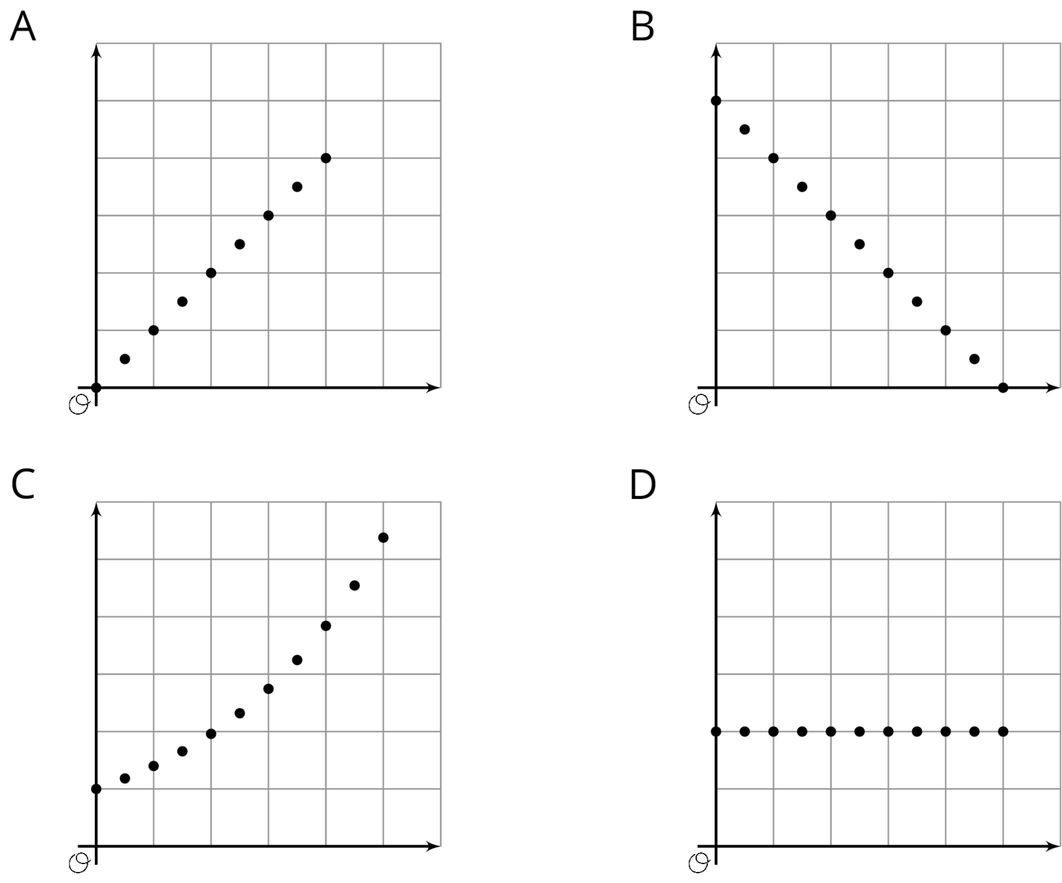

2 Making a Banner (Optional)

Student Task Statement
Mai is creating a rectangular banner to advertise the school play. The material for the banner is sold by the square foot. Mai has enough money to buy 36 square feet of material. She is trying to decide on the length and width of the banner.
- If the length is 6 feet, what is the width?
- If the length is 4 feet, what is the width?
- If the length is 9 feet, what is the width?
- To find different combinations of length and width that give an area of 36 square feet, Mai uses the equation $w=\frac{36}{ℓ}$, where $w$ is the width and $ℓ$ is the length. Compare your strategy and Mai's method for finding the width. How were they the same or different?
- Use several combinations of length and width to create a graph that shows the relationship between the side lengths of various rectangles with area 36 square feet.
- 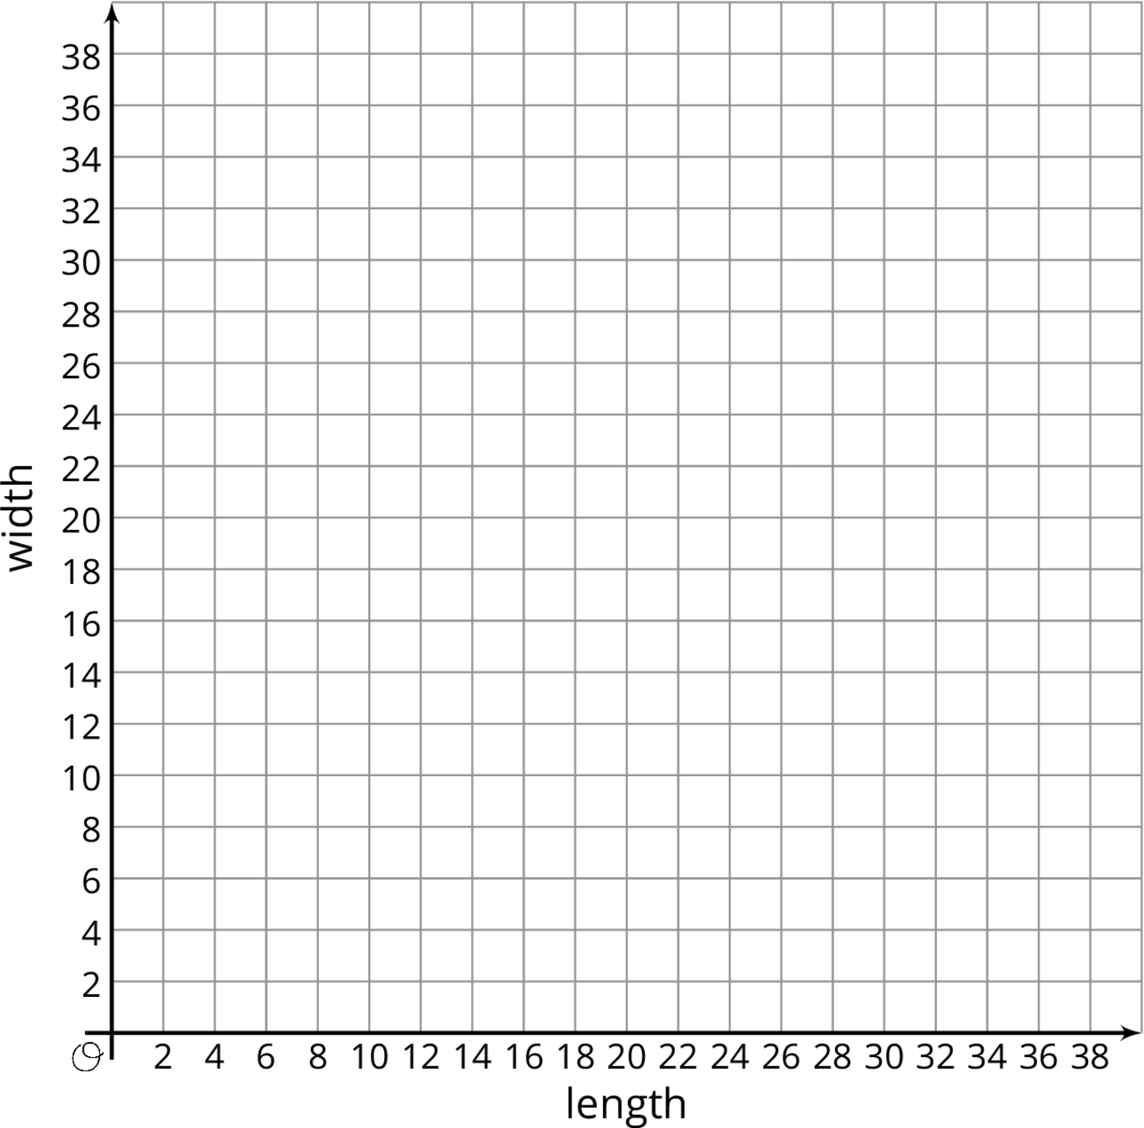
- Explain how the graph describes the relationship between length and width for different rectangles with area 36.
- Suppose Mai used the equation $ℓ=\frac{36}{w}$ to find the length for different values of the width. Would the graph be different if she graphed length on the vertical axis and width on the horizontal axis? Explain how you know.

3 Cereal Boxes (Optional)

Student Task Statement
A cereal manufacturer needs to design a cereal box that has a volume of 225 cubic inches and a height that is no more than 15 inches.
- The designers know that the volume of a rectangular prism can be calculated by multiplying the area of its base and its height. Complete the table with pairs of values that will make the volume 225 in³.
- height (in) |  | - 5 | - 9 | - 12 |  | - $7\frac{1}{2}$
- area of base (in²) | - 75 |  |  |  | - 15
- Describe how you found the missing values for the table.
- Write an equation that shows how the area of the base, $A$, is affected by changes in the height, $h$, for different rectangular prisms with volume 225 in³.
- Plot the ordered pairs from the table on the graph to show the relationship between the area of the base and the height for different boxes box with volume 225 in³.
- 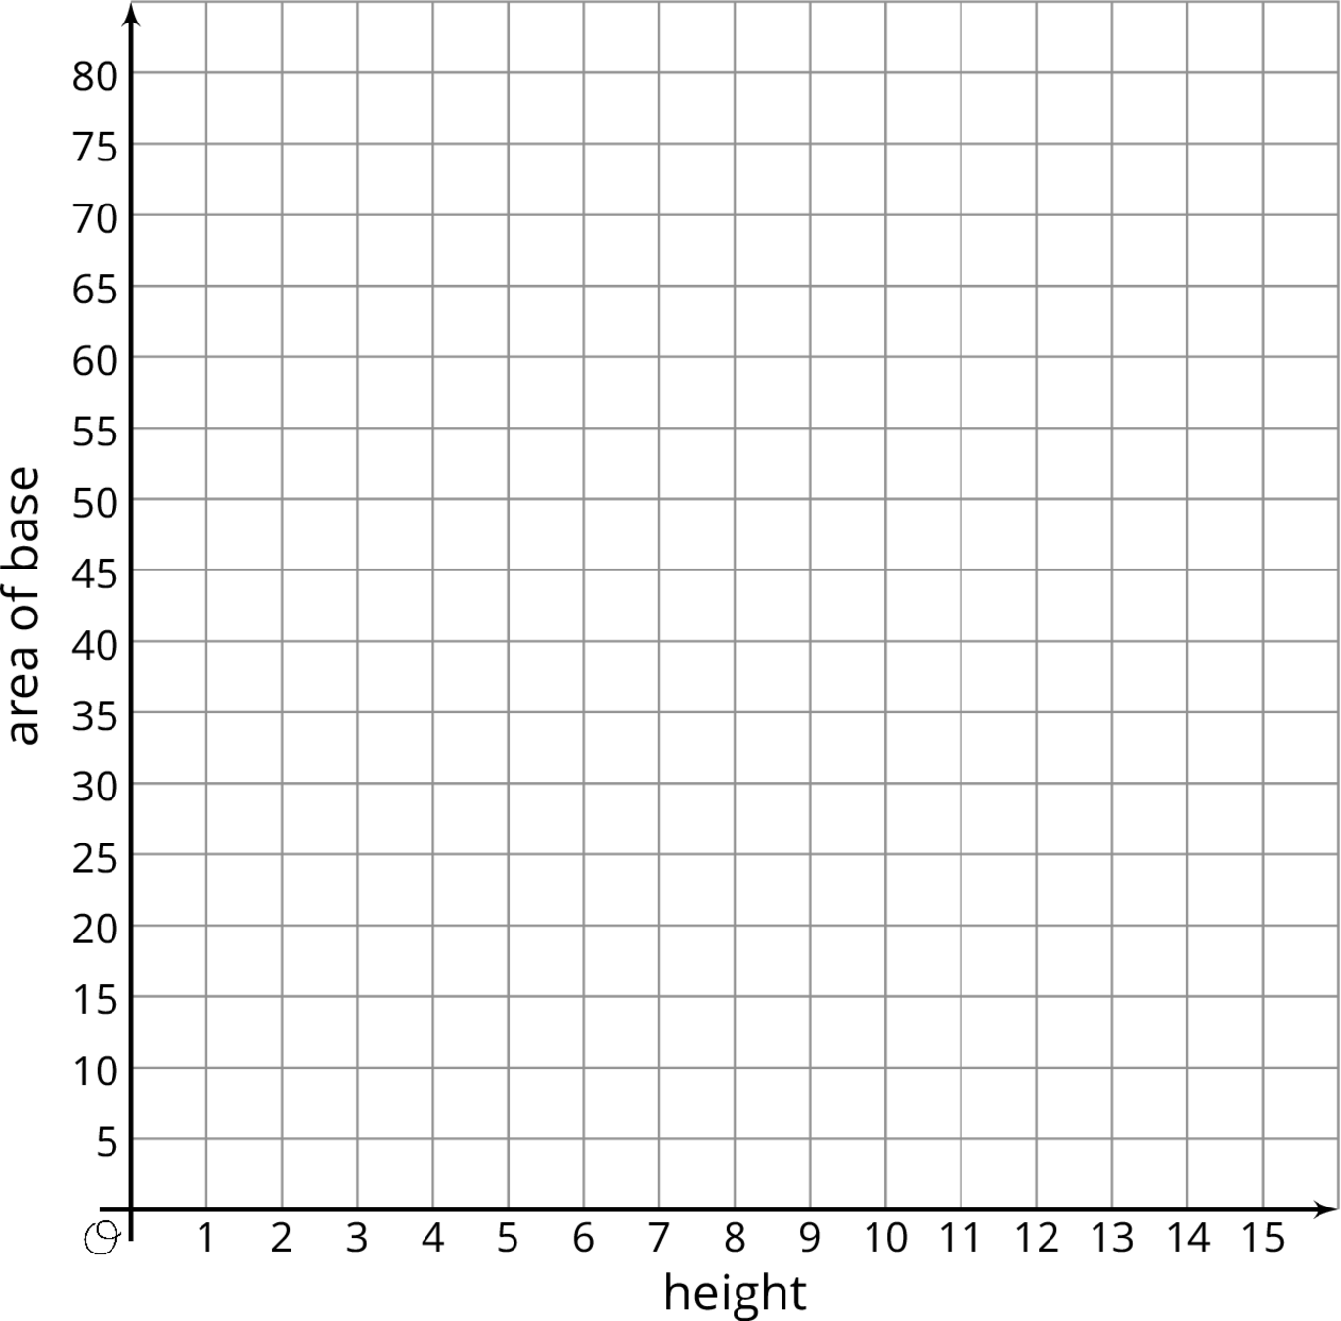

4 Multiplying Mosquitoes (Optional)

Student Task Statement
A researcher who is studying mosquito populations collects the following data:
day in  the study $(d)$ | number of  mosquitoes $(n)$
1 | 2
2 | 4
3 | 8
4 | 16
5 | 32
- The researcher said that, for these five days, the number of mosquitoes, $n$, can be found with the equation $n=2^{d}$ where $d$ is the day in the study. Explain why this equation matches the data.
- Use the ordered pairs in the table to graph the relationship between number of mosquitoes and day in the study for these five days.
- 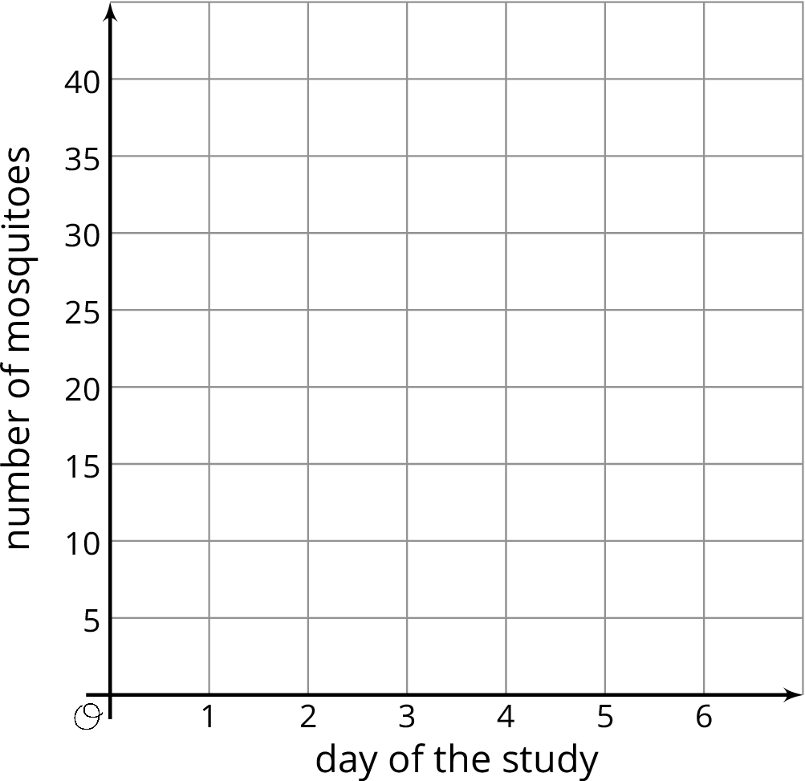
- Describe the graph. Compare how the data, equation, and graph illustrate the relationship between the day in the study and the number of mosquitoes.
- If the pattern continues, how many mosquitoes will there be on day 6?
© CC BY Open Up Resources. Adaptations CC BY IM.

