Lesson 1 Practice Problems
- Priya jogs at a constant speed. The relationship between her distance and time is shown on the graph. Diego bikes at a constant speed twice as fast as Priya. Sketch a graph showing the relationship between Diego’s distance and time.
- 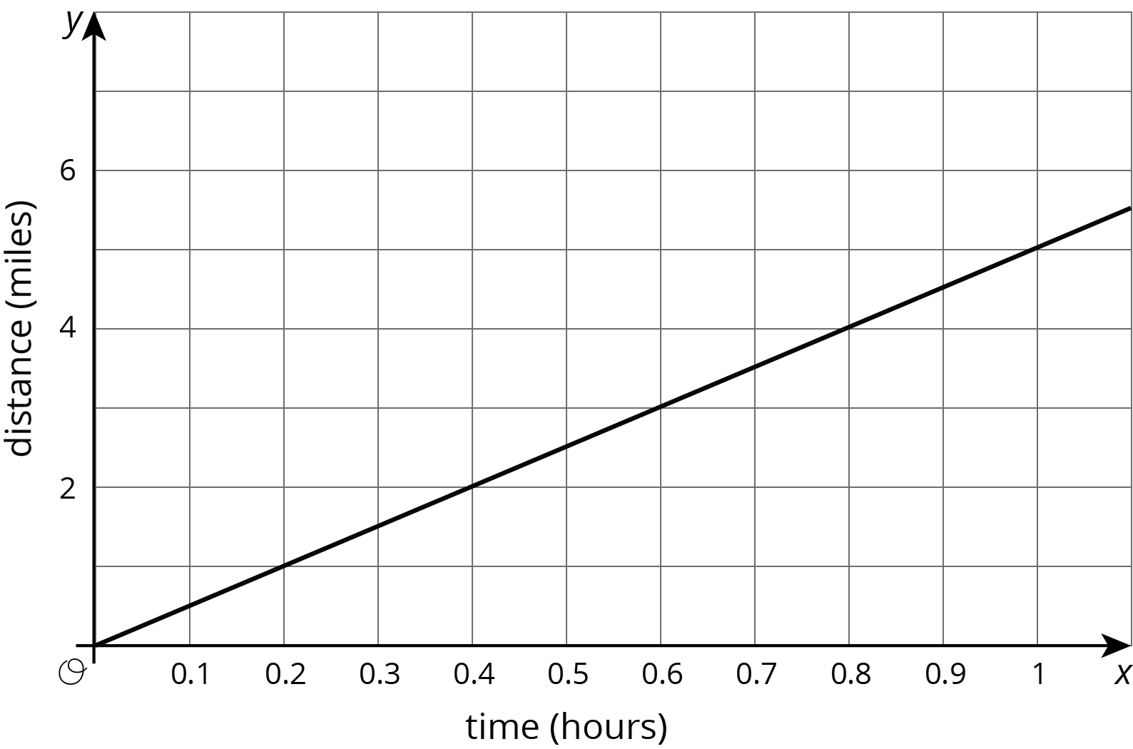
- A you-pick blueberry farm offers 6 lbs of blueberries for $16.50.
- Sketch a graph of the relationship between cost and pounds of blueberries.
- 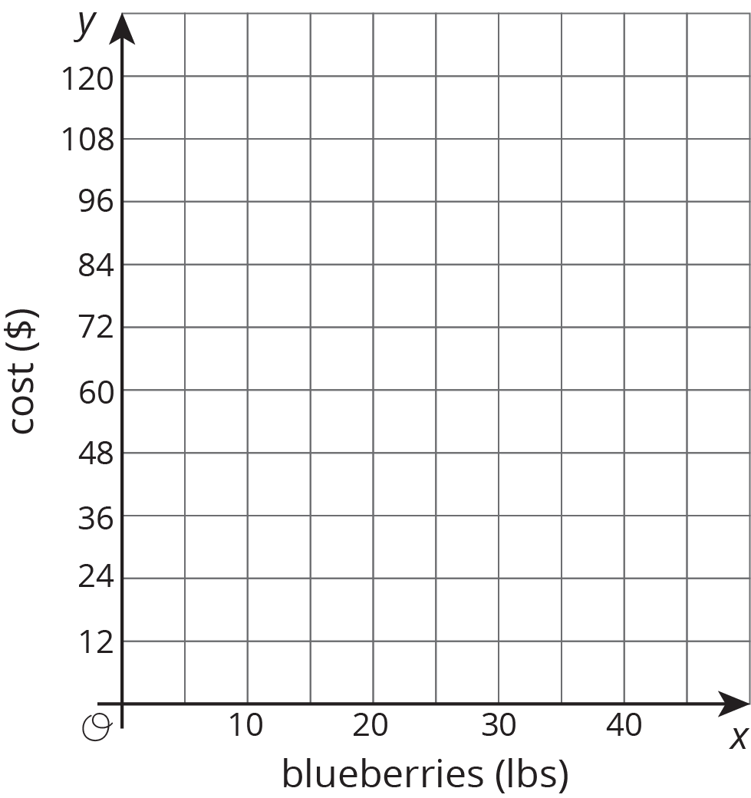
- A line contains the points $\left(\text{-}4,1\right)$ and $\left(4,6\right)$. Decide whether or not each of these points is also on the line:
  - $\left(0,3.5\right)$
  - $\left(12,11\right)$
  - $\left(80,50\right)$
  - $\left(\text{-}1,2.875\right)$
- (From Unit 2, Lesson 17.)
- Select all the inequalities that have the same solutions as $\text{-}4x<20$.
  - $\text{-}x<5$
  - $4x>\text{-}20$
  - $4x<\text{-}20$
  - $x<\text{-}5$
  - $x>5$
  - $x>\text{-}5$
- (From Unit 4, Lesson 3.)
© CC BY Open Up Resources. Adaptations CC BY IM.

