Lesson 12: The Number $e$
- Let’s learn about the number $e$.

12.1: Matching Situations and Equations
Match each equation to a situation it represents. Be prepared to explain how you know. Not all equations have a match.
$f\left(t\right)=400⋅{\left(0.5\right)}^{0.1t}$
$g\left(t\right)=400⋅{\left(1.25\right)}^{0.1t}$
$h\left(t\right)=400⋅{\left(0.75\right)}^{0.1t}$
$j\left(t\right)=400⋅{\left(2\right)}^{10t}$
$k\left(t\right)=400⋅{\left(2\right)}^{0.1t}$
- A scientist begins an experiment with 400 bacteria in a petri dish. The population doubles every 10 hours. The function gives the number of bacteria $t$ hours since the experiment began.
- A patient takes 400 mg of a medicine. The amount of medicine in her bloodstream decreases by 25% every 10 hours. The function gives the amount of medicine left in her bloodstream after $t$ hours of taking the medicine.
- The half-life of a radioactive element is 10 years. There are 400 g of the element in a sample when it is first studied. The function gives the amount of the element remaining $t$ years later.
- In a lake, the population of a species of fish is 400. The population is expected to grow by 25% in the next decade. The function gives the number of fish in the lake $t$ years after it was 400.

12.2: Notice and Wonder: Moldy Growth
A spot of mold is found on a basement wall. Its area is about 10 square centimeters. Here are three representations of a function that models how the mold is growing.
time (weeks) | area of mold (sq cm)
0 | 10
1 | 27
2 | 74
3 | 201
4 | 546
$a\left(t\right)=10⋅e^{t}$
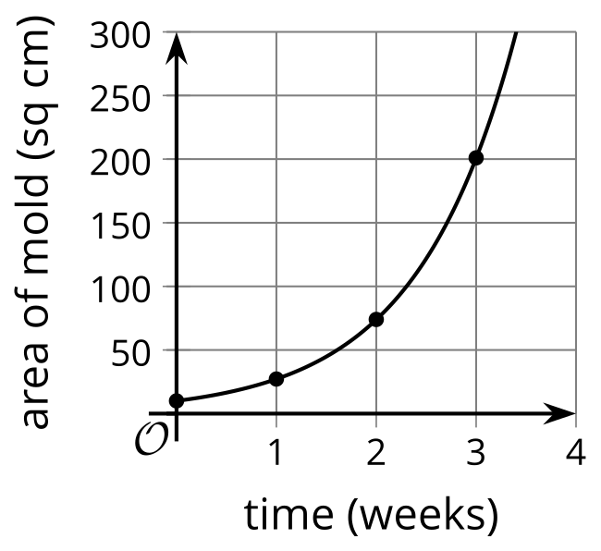
What do you notice? What do you wonder?

12.3: ${\left(1+\text{tiny}\right)}^{\text{huge}}$
- Here are some functions. For each function, describe, in words, the outputs for very tiny, positive values of $x$ and for very large values of $x$.
- $a\left(x\right)=1^{x}$
- $b\left(x\right)=\text{-}x$
- $d\left(x\right)=\frac{1}{x}$
- $f\left(x\right)={\left(\frac{1}{x}\right)}^{x}$
- $g\left(x\right)={\left(1+\frac{1}{x}\right)}^{x}$
- $h\left(x\right)=e^{x}$
- $k\left(x\right)=1+x$

- Remember that $e≈2.718$. What does the function $g$ have to do with the number $e$?
- What do you notice about the relationship between $h$ and $k$ for very small, positive values of $x$?

Are you ready for more?
Complete the table to show the value of each expression to the nearest hundred-thousandth. Two entries have already been completed as an example.
$x$ | $2^{x}$ | $e^{x}$ | $3^{x}$
0.1 | 1.07177 | 1.10517 | 1.11612
0.01
0.001
0.0001
What do you notice about the values in the table?

Lesson 12 Summary
Scientists, economists, engineers, and others often use the number $e$ in their mathematical models. What is $e$?
$e$ is an important constant in mathematics, just like the constant $π$, which is important in geometry. The value of $e$ is approximately 2.718. Just like $π$, the number $e$ is irrational, so it can’t be represented as a fraction, and its decimal representation never repeats or terminates. The number is named after the 18th-century mathematician Leonhard Euler and is sometimes called Euler’s number.
$e$ has many useful properties and it arises in situations involving exponential growth or decay, so $e$ often appears in exponential functions. In upcoming lessons, we will work with functions that are expressed using $e$.
© CC BY 2019 by Illustrative Mathematics®

