Lesson 7 Practice Problems
- Select all the values for $r$ that indicate a positive slope for the line of best fit.
  - 1
  - -1
  - 0.5
  - -0.5
  - 0
  - 0.8
  - -0.8
- The correlation coefficient, $r$, is given for several different data sets. Which value for $r$ indicates the strongest correlation?
  - 0.01
  - -0.34
  - -0.82
  - -0.95
- Which of the values is the best estimate of the correlation coefficient for the line of best fit shown in the scatter plot?
- 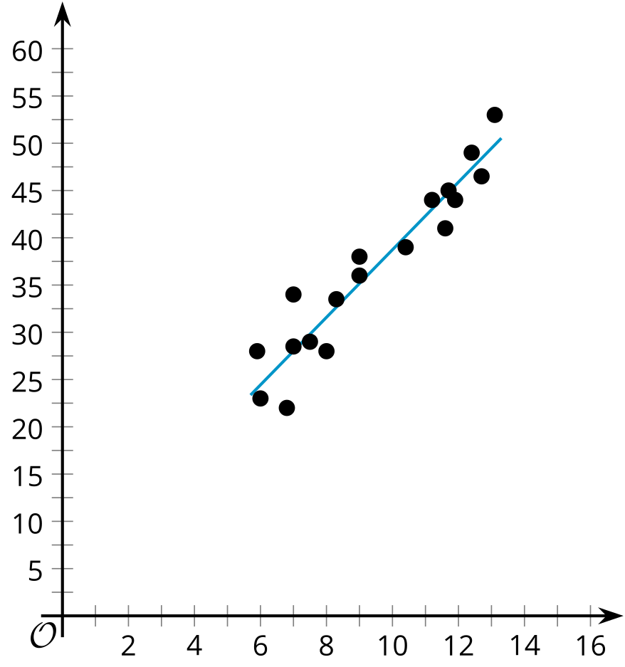
  - -0.9
  - -0.4
  - 0.4
  - 0.9
- Technology required.
- A study investigated the relationship between the amount of daily food waste measured in pounds and the number of people in a household. The data in the table displays the results of the study.
- number of people in household, $x$ | - food waste (pounds), $y$
- 2 | - 3.4
- 3 | - 2.5
- 4 | - 8.9
- 4 | - 4.7
- 4 | - 3.5
- 4 | - 4
- 5 | - 5.3
- 5 | - 4.6
- 5 | - 7.8
- 6 | - 3.2
- 8 | - 12
- Use graphing technology to create the line of best fit for the data in the table.
  - What is the equation of the line of best fit for this data? Round numbers to two decimal places.
  - What is the slope of the line of best fit? What does it mean in this situation? Is this realistic?
  - What is the $y$-intercept of the line of best fit? What does it mean in this situation? Is this realistic?
- (From Unit 3, Lesson 5.)
- A table of values and the plot of the residuals for the line of best fit are shown.
- $x$ | - $y$
- 1 | - 10
- 2 | - 8
- 2.5 | - 9.5
- 4 | - 8
- 5 | - 8
- 6 | - 7.5
- 7.2 | - 7
- 8.5 | - 6
- 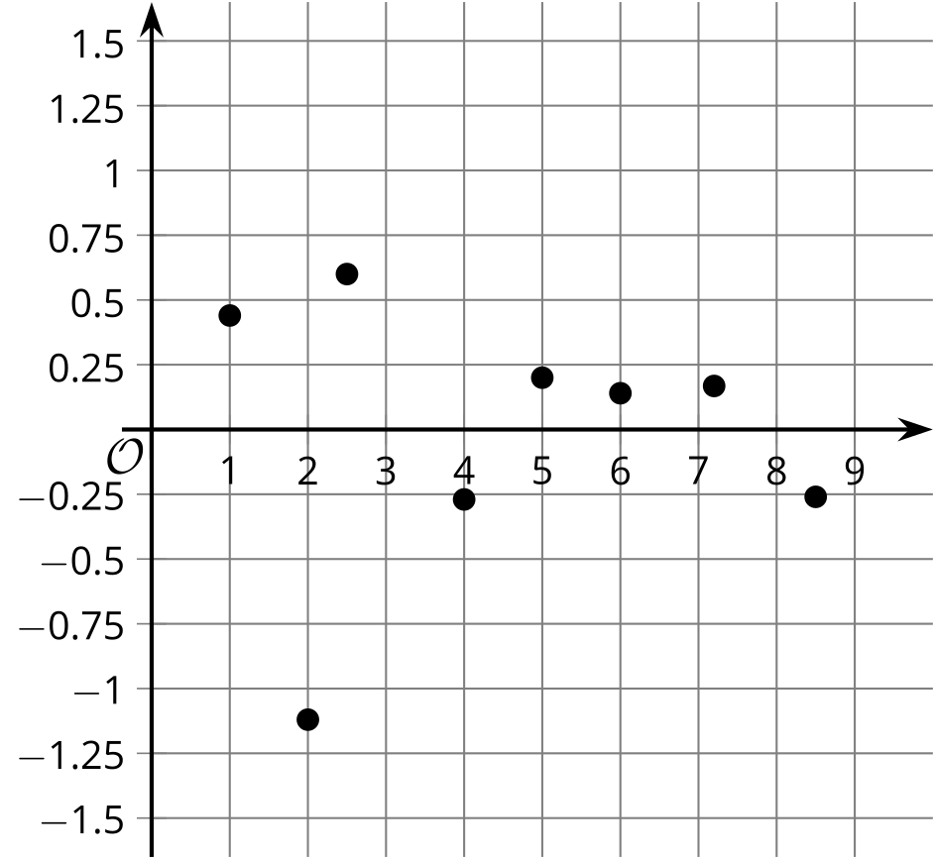
  - Which point does the line estimate the best?
  - Which point does the line estimate the worst?
- (From Unit 3, Lesson 6.)
- Tyler creates a scatter plot that displays the relationship between the grams of food a hamster eats, $x$, and the total number of rotations that the hamster’s wheel makes, $y$. Tyler creates a line of best fit and finds that the residual for the point $\left(1.4,1250\right)$ is -132. The point $\left(1.2,1364\right)$ has a residual of 117. Interpret the meaning of 117 in the context of the problem.
- (From Unit 3, Lesson 6.)
© CC BY 2019 by Illustrative Mathematics®

