Lesson 2 Practice Problems
- Find the lengths of the legs.
- 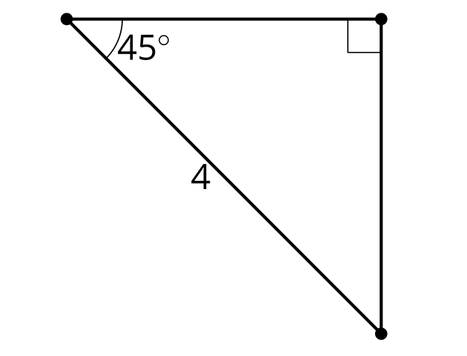
  - $4\sqrt{2}$ units
  - $\frac{4}{\sqrt{2}}$ units
  - 4 units
  - Not enough information
- What is the length of the diagonal?
- 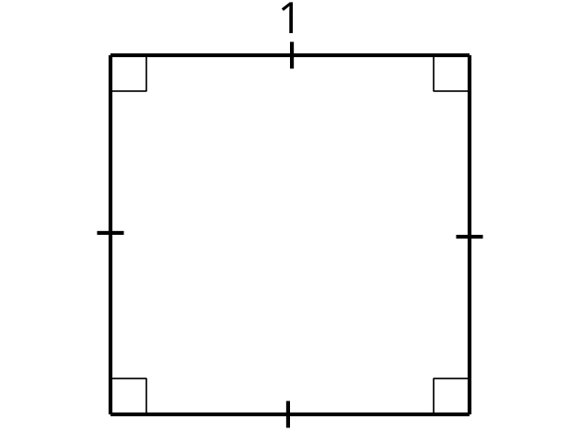
- A square has a diagonal of length 5 cm. What is the area of the square?
- Priya is teaching her younger cousin to ride a bike. She wants to stay on roads that are not too steep and easy enough for a new bike rider. She has decided the roads must have an angle less than or equal to 7 degrees. A 7 degree angle in a right triangle has a $3:25$ ratio for the legs. List the legs of 2 right triangles that would be safe for a new bike rider.
- (From Unit 4, Lesson 1.)
- Clare and Han are discussing how to find the missing lengths. Clare says she is using similarity. Han says he is using the Pythagorean Theorem.
  - Do you agree with either of them? Show or explain your reasoning.
  - Find the missing sides.
- 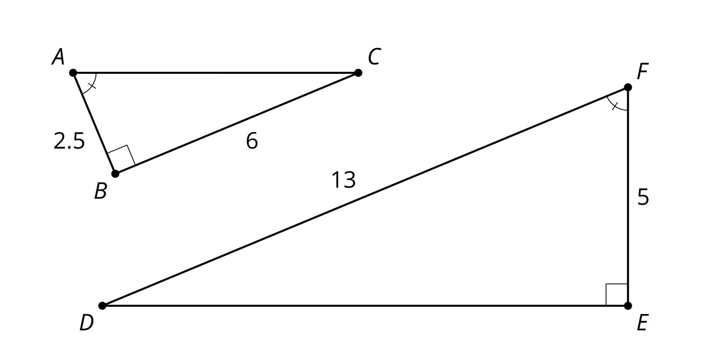
- (From Unit 4, Lesson 1.)
- In right triangle $ABC$, angle $C$ is a right angle, $AB$ is 25 units long, and $BC$ is 24 units long. What is the length of $AC$?
  - 1
  - 2
  - 7
  - 49
- (From Unit 3, Lesson 15.)

  - Find the length of $EF$.
  - Find the measure of angle $E$.
- 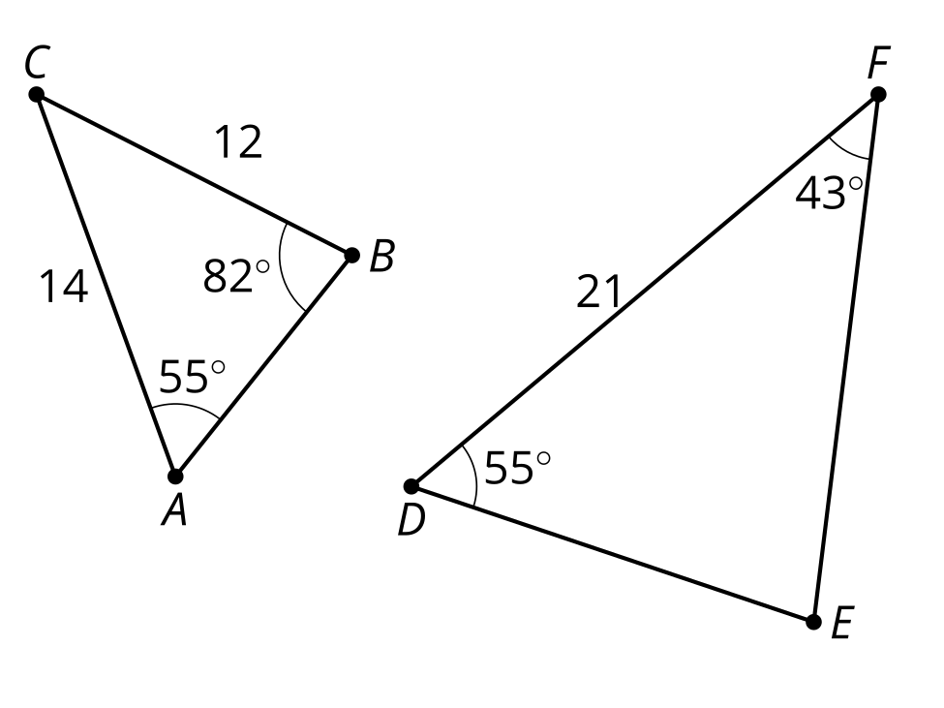
- (From Unit 3, Lesson 10.)
- Determine if each statement must be true, could possibly be true, or definitely can't be true. Explain or show your reasoning.
  - Isosceles triangles are similar.
  - Equilateral triangles are similar.
- (From Unit 3, Lesson 7.)
© CC BY 2019 by Illustrative Mathematics®

