Unit 2 Lesson 16: Minimizing Surface Area

1 The Least Material (Warm up)

Student Task Statement
Here are four cylinders that have the same volume.
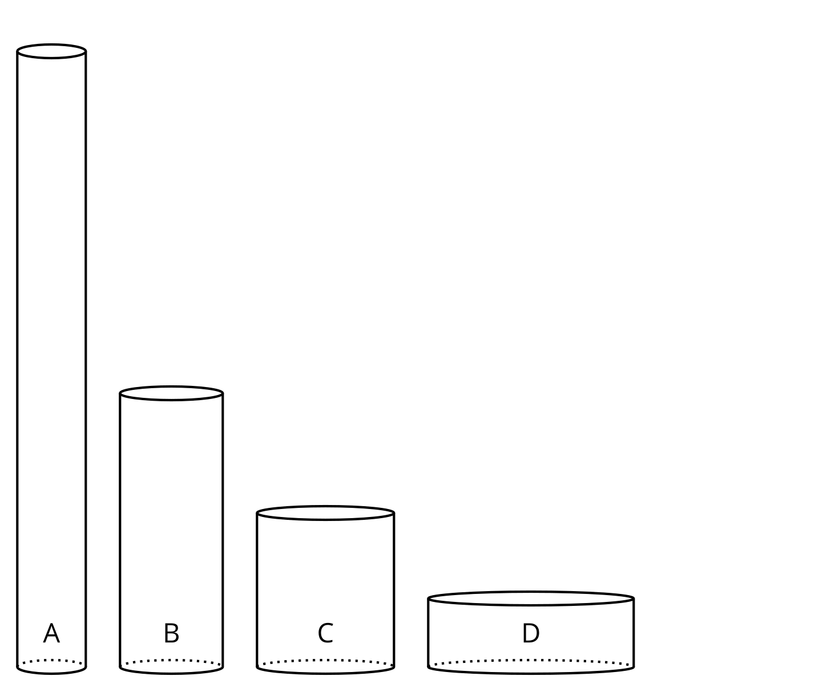
- Which cylinder needs the least material to build?
- What information would be useful to know to determine which cylinder takes the least material to build?

2 Figuring Out Cylinder Dimensions

Student Task Statement
There are many cylinders with volume 452 cm³. Let $r$ represent the radius and $h$ represent the height of these cylinders in centimeters.
- Complete the table.
- volume (cm³) | - radius (cm) | - height (cm)
- 452 | - 1
- 452 | - 2
- 452 | - 3
- 452 | - 4
- 452 | - 5
- 452 | - 6
- 452 | - 7
- 452 | - 8
- 452 | - 9
- 452 | - 10
- 452 | - $r$
- Use graphing technology to plot the pairs $\left(r,h\right)$ from the table on the coordinate plane.
- What do you notice about the graph?

3 Calculating Surface Area

Student Task Statement
There are many cylinders with volume 452 cm³. Let $r$ represent the radius of these cylinders, $h$ represent the height, and $S$ represent the surface area.
- Use the table to explore how the value of $r$ affects the surface area of the cylinder.
- radius (cm) | - height (cm) | - surface area (cm²)
- Use graphing technology to plot the pairs $\left(r,S\right)$ on the coordinate plane.
- What do you notice about the graph?
- Write an equation for $S$ as a function of $r$ when the volume of the cylinder is 452 cm³.
© CC BY 2019 by Illustrative Mathematics®

