Lesson 5: Side Lengths of Rectangular Prisms
- Let’s describe the side lengths of a prism and find the volume.

Warm-up: Notice and Wonder: Prism Print
What do you notice? What do you wonder?
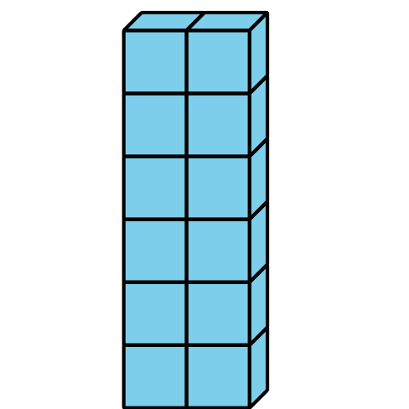
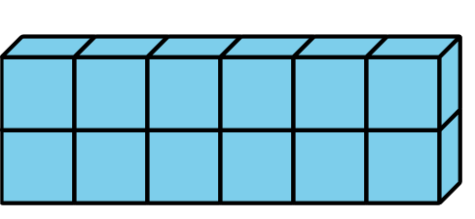
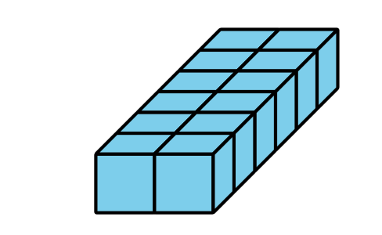
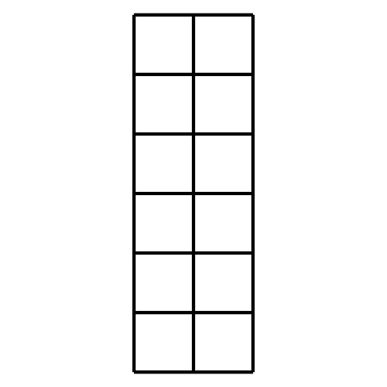

5.1: All About That Base
Here are 3 rectangular prisms.
1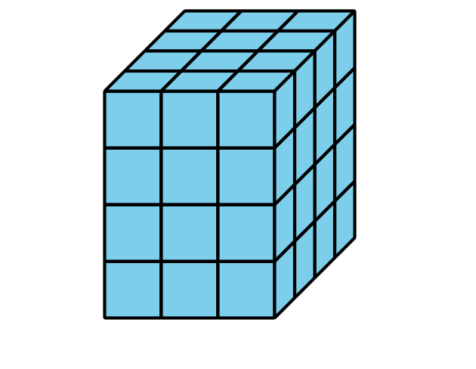
2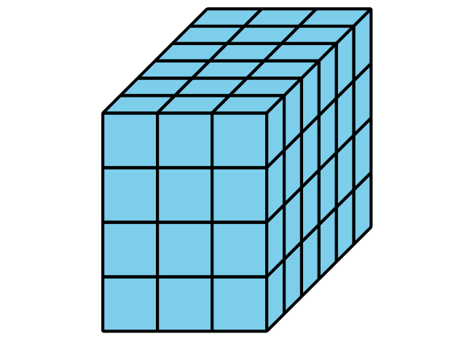
3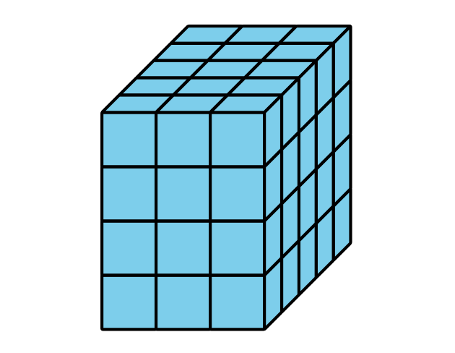
These rectangles represent bases of the prisms.
A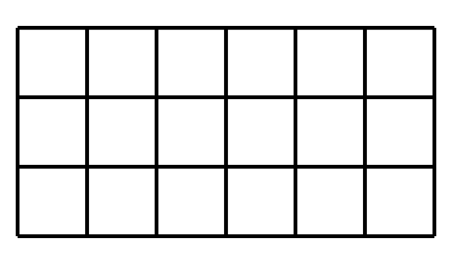
B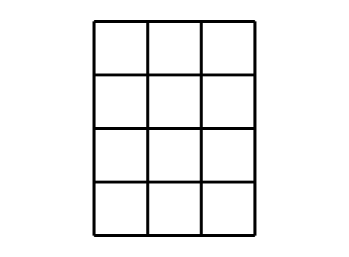
C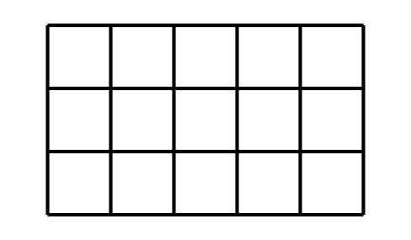
- Match each prism with a rectangle that represents its base. Note: Some prisms may match more than 1 rectangular base.
- Find the volume of each prism. Explain or show your reasoning.

5.2: Growing Prism
Here is a base of a rectangular prism.
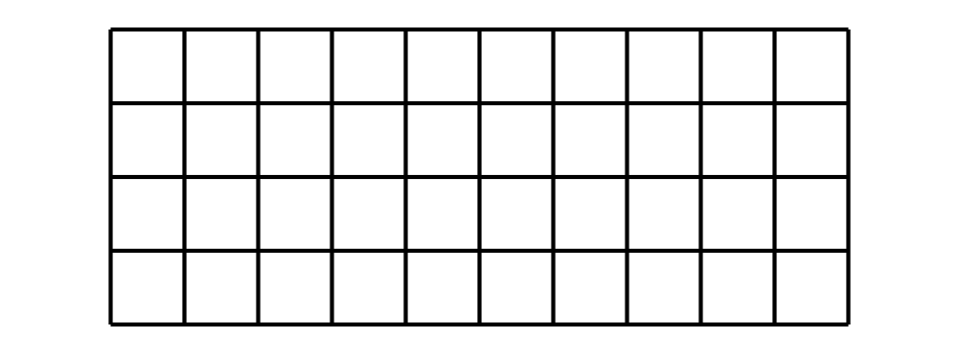
- Fill out the table for the volumes of rectangular prisms with this base and different heights.
- height | - multiplication expression to represent the volume | - volume
- 1
- 2
- 3
- 10
- 25

5.3: What is the Question?
This is the base of a rectangular prism that has a height of 5 cubes.
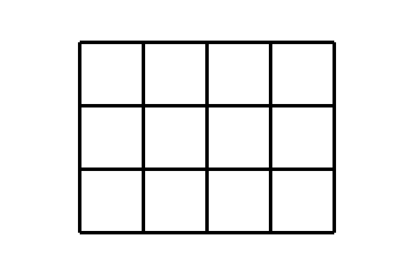
These are answers to questions about the prism. Read each answer and determine what question it is answering about the prism.
- 3 is the answer. What is the question?
- 5 is the answer. What is the question?
- $3×4=12$. The answer is 12. What is the question?
- $12×5=60$. The answer is 60 cubes. What is the question?
- 3 by 4 by 5 is the answer. What is the question?
© CC BY 2021 Illustrative Mathematics®

