Lesson 5: Expanded Form of Numbers
- Let’s represent three-digit numbers as a sum of the value of each digit.

Warm-up: True or False: Value of Digits
Decide if each statement is true or false. Be prepared to explain your reasoning.
- $800+90+7=897$
- $156=50+100+6$
- $407=70+400$
- $632=22+10+600$

5.1: Expressions and Three-digit Numbers
- Andre has 3 hundreds. Tyler has 5 tens. Mai has 7 ones. They want to represent the amount they have using an equation.
- 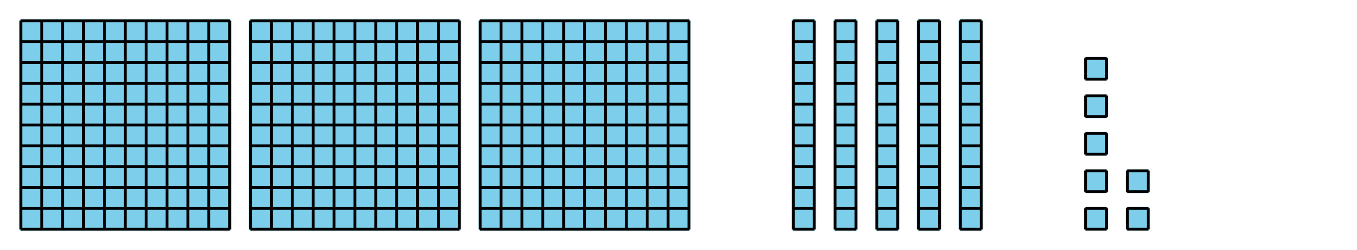
- Write an expression to represent the sum of their values.
- __________ + __________ + __________
- Write the total value as a three-digit number:
- _______________
- Write each number as the sum of hundreds, tens, and ones, and as a three-digit number.
- 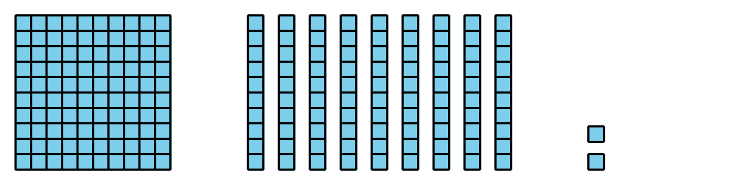
- Expanded form: _________________________
- Three-digit number: _________________________
- 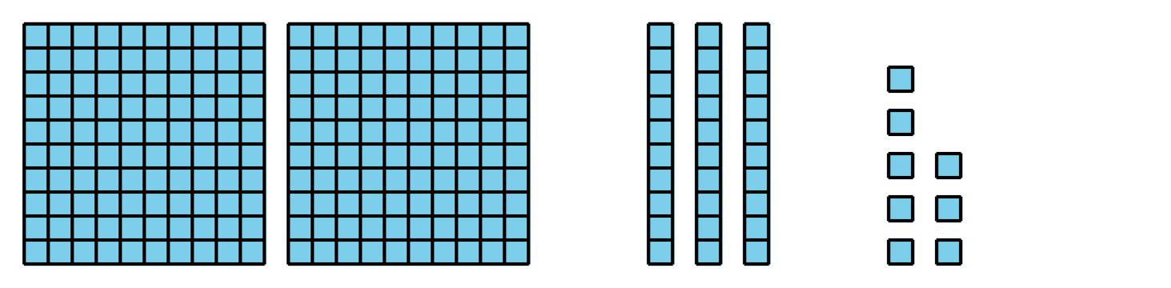
- Expanded form: _________________________
- Three-digit number: _________________________
- 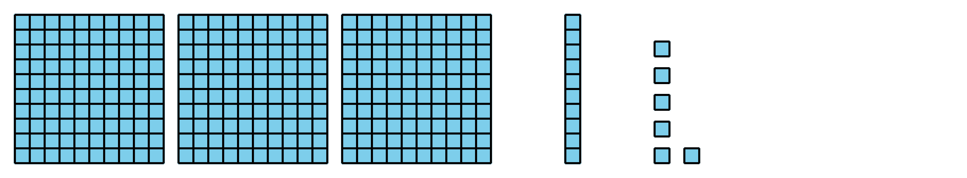
- Expanded form: _________________________
- Three-digit number: _________________________
- 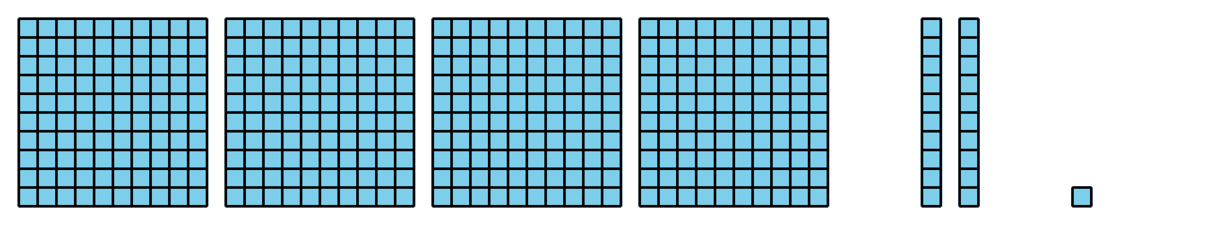
- Expanded form: _________________________
- Three-digit number: _________________________

5.2: Make It and Expand It
- Roll the number cubes.
- Make the largest number possible.
- Write it as a three-digit number. ___________
- Write it in expanded form.
- Roll the number cubes.
- Make the smallest number possible.
- Write it as a three-digit number. ___________
- Write it in expanded form.
- Roll the number cubes.
- Using the same digits, make a number different from your partner’s.
- Write it in expanded form.
- Write it as a three-digit number. ___________
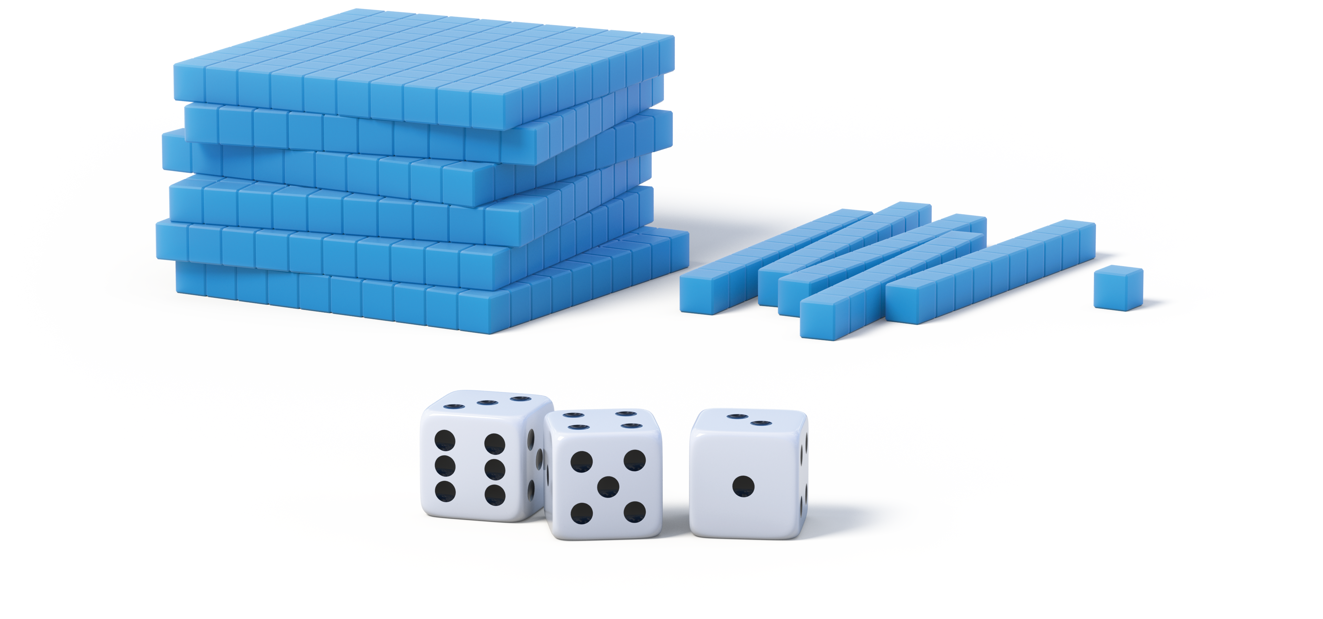
© CC BY 2021 Illustrative Mathematics®

