Unit 6 Lesson 8: Are All Pieces Created Equal?

WU Number Talk: 5 Ones (Warm up)

Student Task Statement
Find the value of each expression mentally.
- $25−15$
- $40−15$
- $65−25$
- $60−35$

1 Make Quarters and Halves

Student Task Statement
Lin wanted to partition this square into quarters. She started by splitting the square into halves.
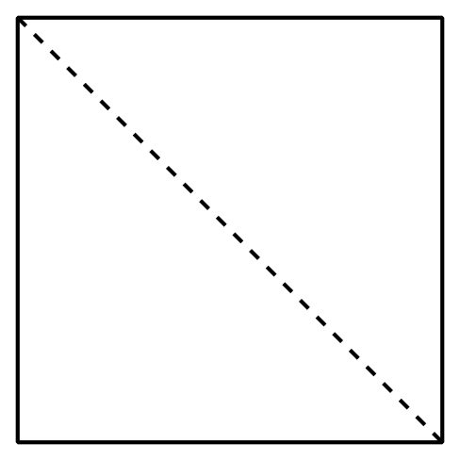
After she drew the first line, she tried 3 different ways to make fourths.
- Which of these shows fourths or quarters? Explain and share with your partner.
- A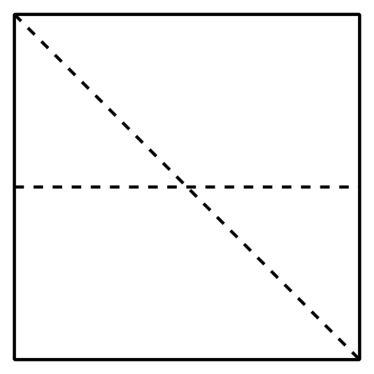
- B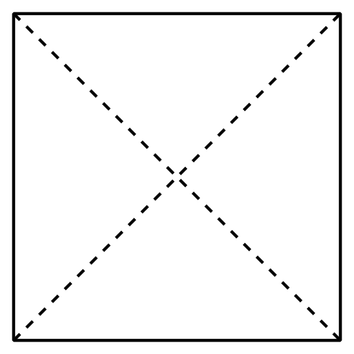
- C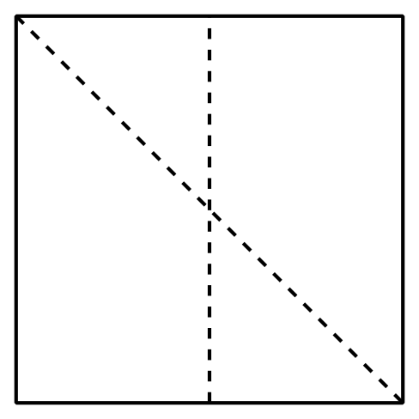
- Name the shaded piece.
- A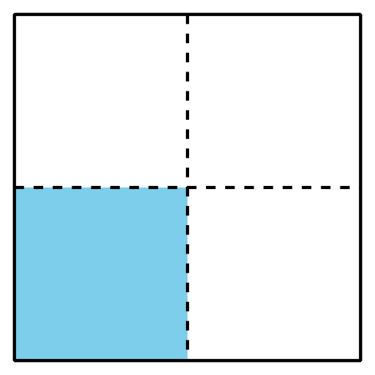
- Shape A has a ________________ shaded.
- B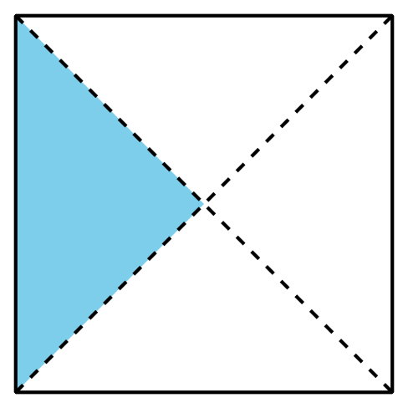
- Shape B has a ________________ shaded.
- Show 2 different ways to partition the rectangle into quarters or fourths. Shade in a fourth of each rectangle.
- Show 2 different ways to partition the square into halves.
Shade in a half of each square.

2 Make Equal Pieces

Student Task Statement
- Lin, Mai, and Andre were asked to shade in a third of a shape.
- Lin
- 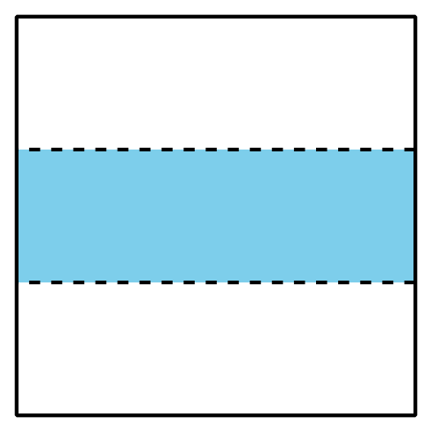
- Mai
- 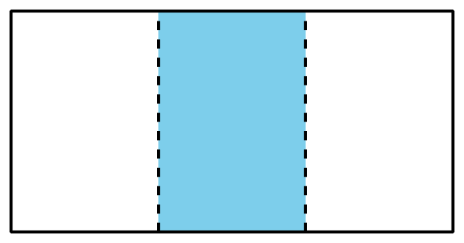
- Andre
- 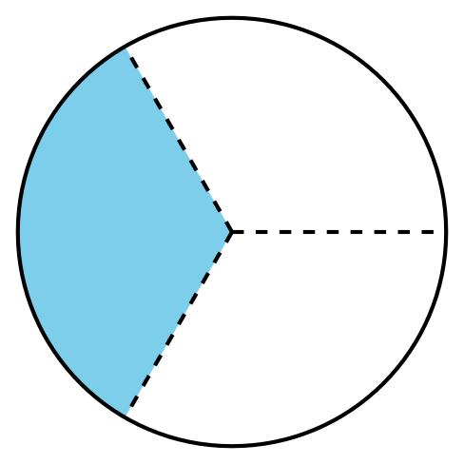
- Do all their shapes show a third shaded? Explain and share with a partner.
- Partition the rectangle into thirds and shade a third of the shape.
- Diego’s dad made 2 square pans of cornbread and sliced them up for the family.
- Diego’s Brother
- Diego’s
- 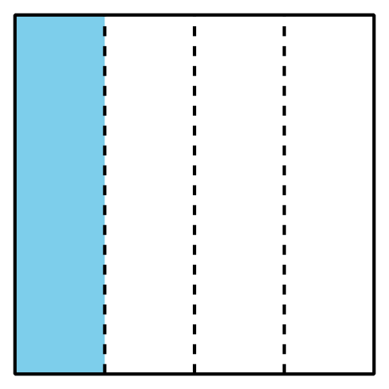
- Diego’s little brother was upset because he thought his piece of cornbread was smaller than Diego’s. What would you tell him?

Images for Activity Synthesis
© CC BY 2021 Illustrative Mathematics®

