Lesson 9: Time to the Nearest Minute
- Let’s tell and write time to the nearest minute.

Warm-up: Estimation Exploration: On the One Hand . . . .
This clock only has an hour hand.
What time could it be?
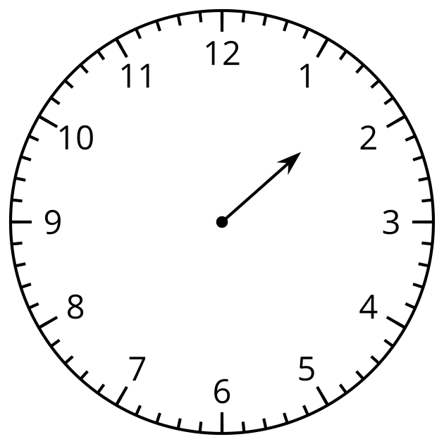
Record an estimate that is:
too early | about right | too late

9.1: Just a Clock on the Wall
- Lin says the time shown on the clock is 1:37 p.m.
- Diego says the time is 1:35 p.m.
- Who do you agree with? Explain or show your reasoning.
- 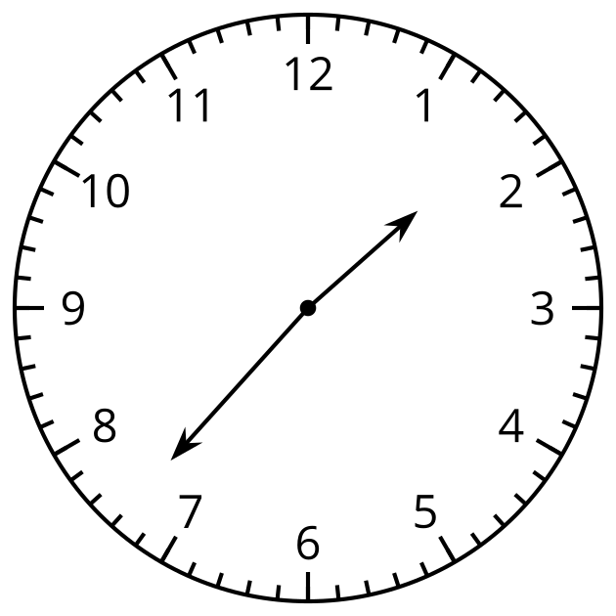
- What time is shown on each clock?
- A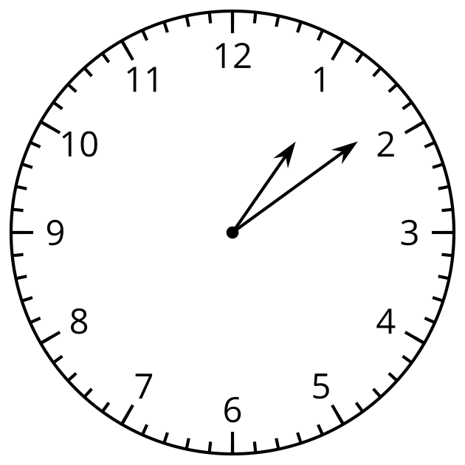
- B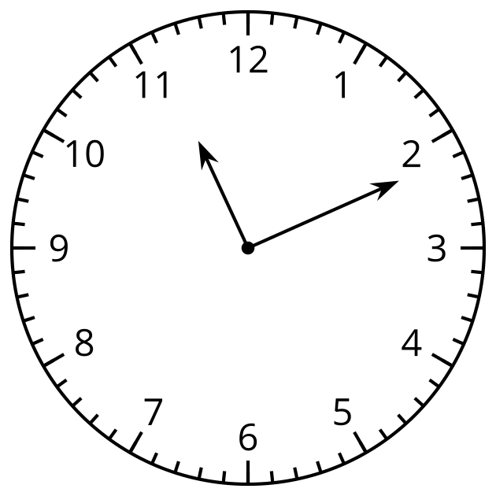
- C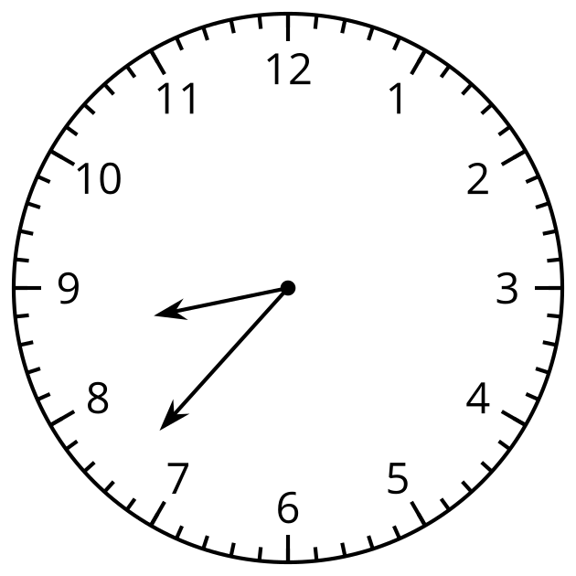
- D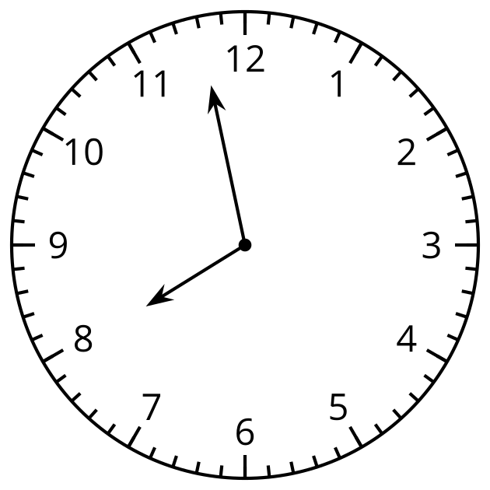

9.2: Show Time
- Show the time given on each clock.
- A 2:36 PM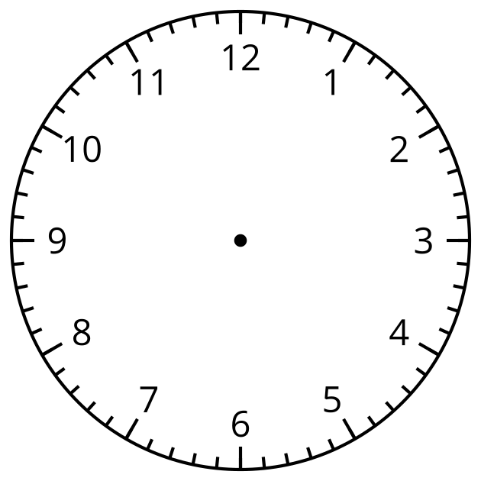
- B 3:18 PM
- C 12:17 PM
- D 9:02 PM
- Draw a time on this clock. Trade with a partner and tell the time on their clock.
- 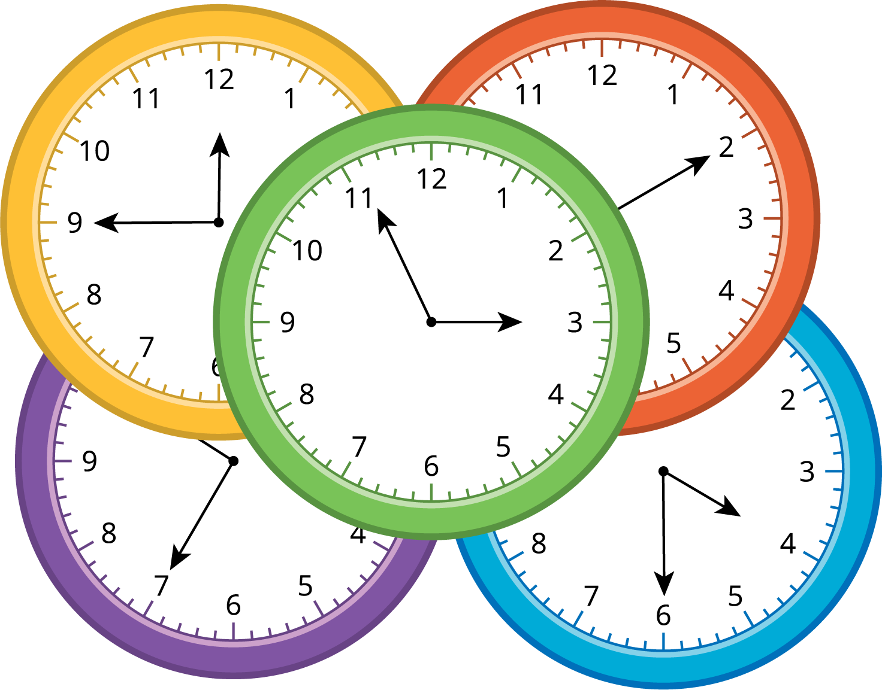
© CC BY 2021 Illustrative Mathematics®

