Unit 4 Lesson 16: Rewriting Equations for Perspectives

1 No Bad Apples (Warm up)

Student Task Statement
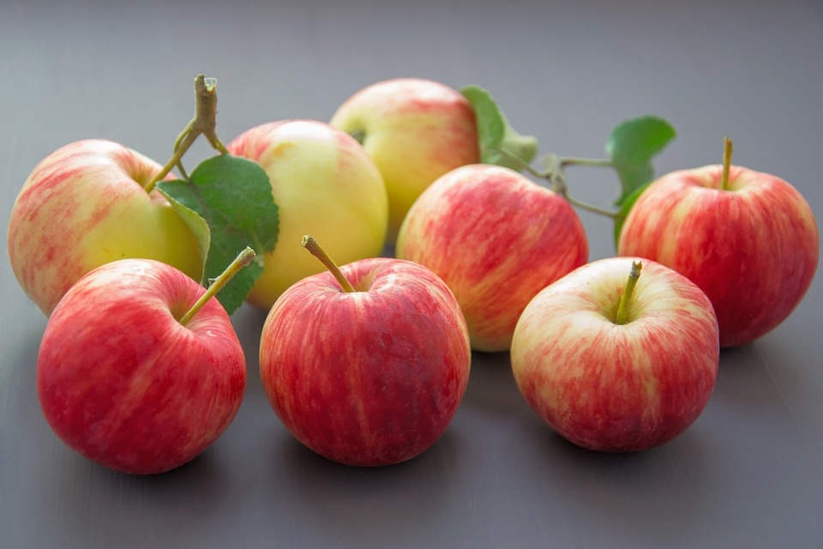
Which option would you select? Use mathematical reasoning to explain your selection.
Option A: Each apple costs $0.97 and are on sale with a “Buy 2, Get 1 Free” offer.
Option B: Bags of 6 apples are on sale “2 for $7.50” but you must buy 2 bags.

2 A Charity Shopping Trip

Student Task Statement
A person has collected a lot of money for providing clothing to those in need. They go to a store to buy several clothing items with the money collected.
Match each description in column A with an equation from column B that represents the situation. Be prepared to explain your reasoning.
- Take turns with your partner to match a description of a situation with an equation that represents the situation.
  - For each match that you find, explain to your partner how you know it’s a match.
  - For each match that your partner finds, listen carefully to their explanation. If you disagree, discuss your thinking and work to reach an agreement.
- A store charges $6 for each shirt sold. A person buys $x$ shirts and pays $y$ dollars for the total.
- A store charges $6 for each pair of shorts sold. They also offer a $3 coupon to be used on the entire order. A person buys $x$ pairs of shorts and pays $y$ dollars for the total after using the coupon.
- A store charges $6 for 3 pairs of socks. A person buys $x$ pairs of socks and pays $y$ dollars for the total.
- A store charges $6 for each pair of shoes sold and also charges $3 to lace up all of the shoes in the entire order. A person buys $x$ pairs of shoes and pays $y$ for the total including lacing up all the shoes.
- A store charges $3 for 6 handkerchiefs. A person buys $x$ handkerchiefs and pays $y$ for the total.
- A store charges $3 for each pair of gloves sold. They also offer a $6 coupon to be used on the entire order when there are more than 4 pairs of gloves purchased. A person buys $x$ pairs of gloves (with $x>4$) and pays $y$ dollars for the total after using the coupon.
- $y=6x$
- $y=\frac{6x}{3}$
- $y=\frac{3x}{6}$
- $y=3x−6$
- $y=6x−3$
- $y=6x+3$

3 Isolate the $x$

Student Task Statement
Rearrange the equations so that one side of the equation is only $x$. Be prepared to explain or show your reasoning.
- $T=x−2$
- $T=2x$
- $T=2x−1$
- $T=\frac{x}{2}$
- $T=2(x−1)$
- $T=\frac{x−1}{2}$
© CC BY 2019 by Illustrative Mathematics®

