Unit 5 Lesson 8 Cumulative Practice Problems
- Suppose that during its flight, the elevation $e$ (in feet) of a certain airplane and its time $t$, in minutes since takeoff, are related by a linear equation. Consider the graph of this equation, with time represented on the horizontal axis and elevation on the vertical axis. For each situation, decide if the slope is positive, zero, or negative.
  - The plane is cruising at an altitude of 37,000 feet above sea level.
  - The plane is descending at rate of 1000 feet per minute.
  - The plane is ascending at a rate of 2000 feet per minute.
- A group of hikers park their car at a trail head and walk into the forest to a campsite. The next morning, they head out on a hike from their campsite walking at a steady rate. The graph shows their distance in miles, $d$, from the car after $h$ hours of hiking.
  - How far is the campsite from their car? Explain how you know.
  - Write an equation that describes the relationship between $d$ and $h$.
  - After how many hours of hiking will they be 16 miles from their car? Explain or show your reasoning.
- 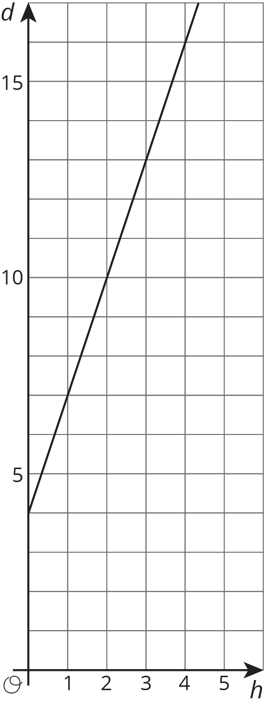
- (From Unit 5, Lesson 6.)
- Elena’s aunt pays her $1 for each call she makes to let people know about her aunt’s new business.
- The table shows how much money Diego receives for washing windows for his neighbors.
- number of windows | - number of dollars
- 27 | - 30
- 45 | - 50
- 81 | - 90
- Select all the statements about the situation that are true.
  - Elena makes more money for making 10 calls than Diego makes for washing 10 windows.
  - Diego makes more money for washing each window than Elena makes for making each call.
  - Elena makes the same amount of money for 20 calls as Diego makes for 18 windows.
  - Diego needs to wash 35 windows to make as much money as Elena makes for 40 calls.
  - The equation $y=\frac{9}{10}x$, where $y$ is number of dollars and $x$ is number of windows, represents Diego’s situation.
  - The equation $y=x$, where $y$ is the number of dollars and $x$ is the number of calls, represents Elena’s situation.
- (From Unit 5, Lesson 3.)
- Each square on a grid represents 1 unit on each side. Match the graphs with the slopes of the lines.
- 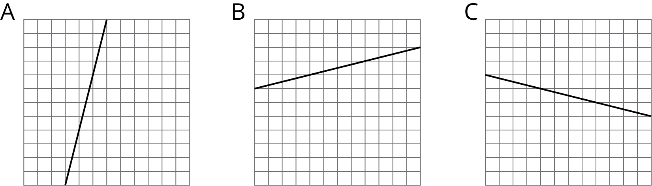
  - $\text{-}\frac{1}{4}$
  - $\frac{1}{4}$
  - 4
- Priya and Tyler are discussing the figures shown below. Priya thinks that B, C, and D are scaled copies of A. Tyler says B and D are scaled copies of A. Do you agree with Priya, or do you agree with Tyler? Explain your reasoning.
- (From Unit 2, Lesson 1.)
- Solve each equation, and check your solution.
- $\frac{1}{9}(2m−16)=\frac{1}{3}(2m+4)$
- $\text{-}4(r+2)=4(2−2r)$
- $12(5+2y)=4y−(6−9y)$

- (From Unit 4, Lesson 13.)
© CC BY Open Up Resources. Adaptations CC BY IM.

