Lesson 15: Estimating Population Measures of Center

15.1: Describing the Center
Would you use the median or mean to describe the center of each data set? Explain your reasoning.
Heights of 50 basketball players
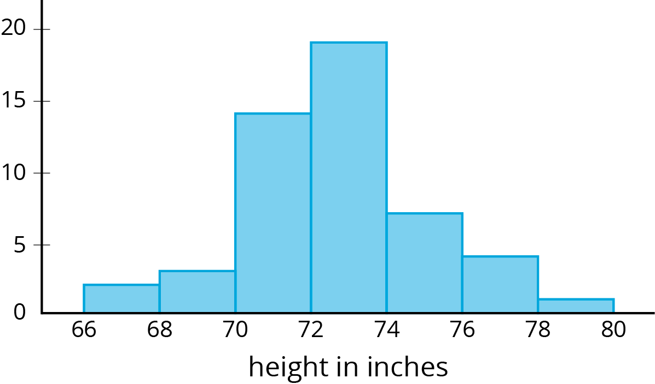
Ages of 30 people at a family dinner party
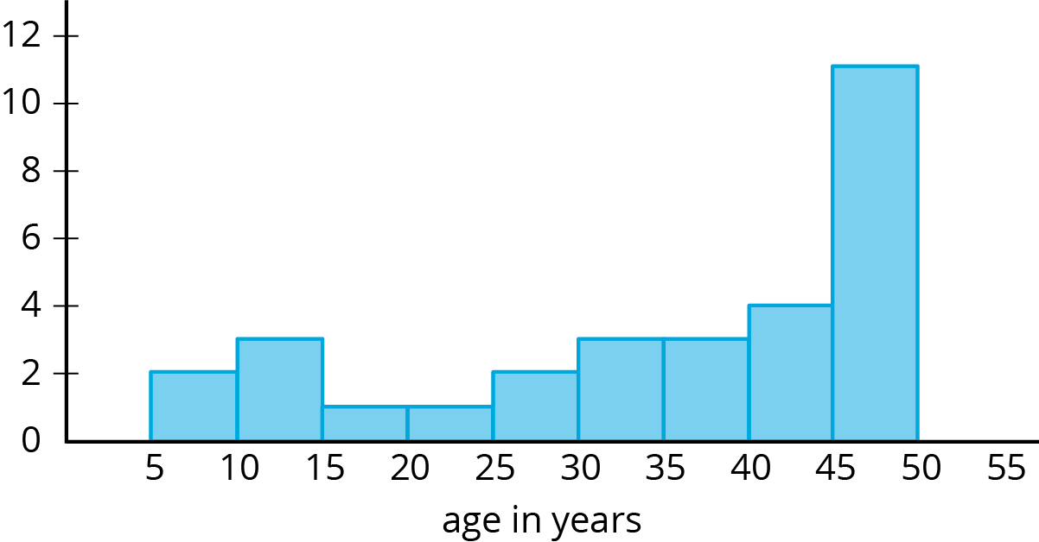

Backpack weights of sixth-grade students
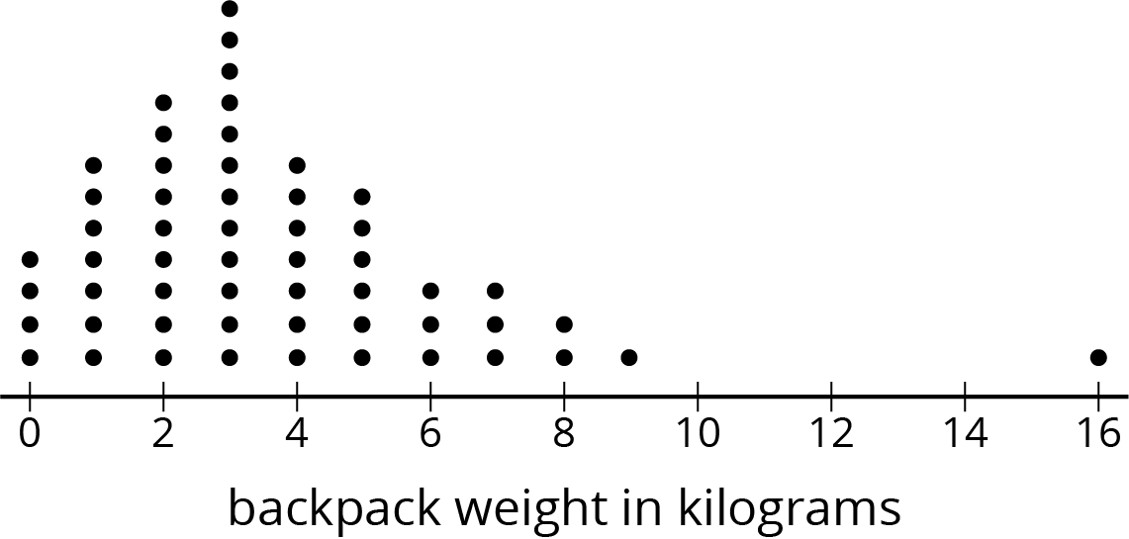
How many books students read over summer break
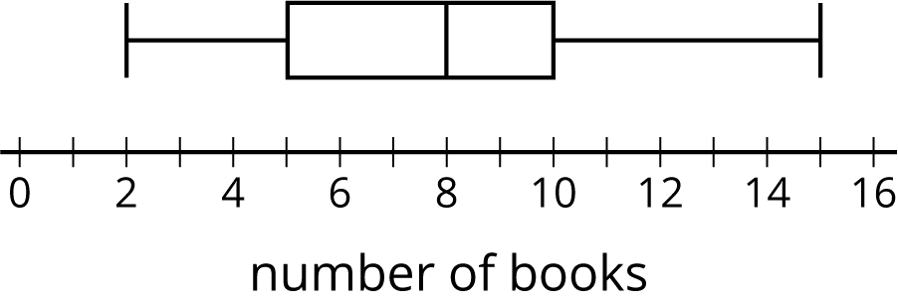

15.2: Three Different TV Shows
Here are the ages (in years) of a random sample of 10 viewers for 3 different television shows. The shows are titled, “Science Experiments YOU Can Do,” “Learning to Read,” and “Trivia the Game Show.”
sample 1
6
6
5
4
8
5
7
8
6
6
sample 2
15
14
12
13
12
10
12
11
10
8
sample 3
43
60
50
36
58
50
73
59
69
51
- Calculate the mean for one of the samples. Make sure each person in your group works with a different sample. Record the answers for all three samples.
- Which show do you think each sample represents? Explain your reasoning
.

15.3: Who’s Watching What?
Here are three more samples of viewer ages collected for these same 3 television shows.
sample 4
57
71
5
54
52
13
59
65
10
71
sample 5
15
5
4
5
4
3
25
2
8
3
sample 6
6
11
9
56
1
3
11
10
11
2
- Calculate the mean for one of these samples. Record all three answers.
- Which show do you think each of these samples represents? Explain your reasoning.
- For each show, estimate the mean age for all the show's viewers.
- Calculate the mean absolute deviation for one of the shows' samples. Make sure each person in your group works with a different sample. Record all three answers.
 | - Learning  to Read | - Science  Experiments  YOU Can Do | - Trivia the  Game Show
- Which sample?
- MAD
- What do the different values for the MAD tell you about each group?
- An advertiser has a commercial that appeals to 15- to 16-year-olds. Based on these samples, are any of these shows a good fit for this commercial? Explain or show your reasoning.

15.4: Movie Reviews
A movie rating website has many people rate a new movie on a scale of 0 to 100. Here is a dot plot showing a random sample of 20 of these reviews.
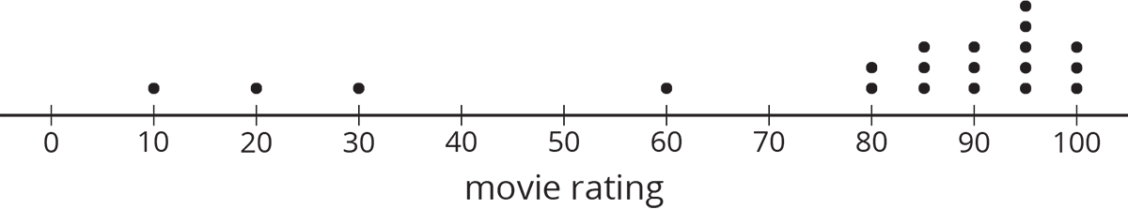
- Would the mean or median be a better measure for the center of this data? Explain your reasoning.
- Use the sample to estimate the measure of center that you chose for all the reviews.
- For this sample, the mean absolute deviation is 19.6, and the interquartile range is 15. Which of these values is associated with the measure of center that you chose?
- Movies must have an average rating of 75 or more from all the reviews on the website to be considered for an award. Do you think this movie will be considered for the award? Use the measure of center and measure of variability that you chose to justify your answer.

Are you ready for more?
Estimate typical temperatures in the United States today by looking up current temperatures in several places across the country. Use the data you collect to decide on the appropriate measure of center for the country, and calculate the related measure of variation for your sample.

Lesson 15 Summary
Some populations have greater variability than others. For example, we would expect greater variability in the weights of dogs at a dog park than at a beagle meetup.
Dog park:
Mean weight: 12.8 kg MAD: 2.3 kg
Beagle meetup:
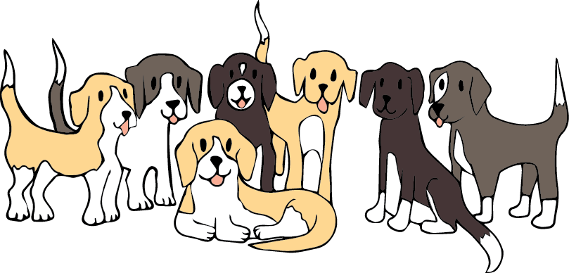
Mean weight: 10.1 kg MAD: 0.8 kg
The lower MAD indicates there is less variability in the weights of the beagles. We would expect that the mean weight from a sample that is randomly selected from a group of beagles will provide a more accurate estimate of the mean weight of all the beagles than a sample of the same size from the dogs at the dog park.
In general, a sample of a similar size from a population with less variability is more likely to have a mean that is close to the population mean.
© CC BY Open Up Resources. Adaptations CC BY IM.

