Unit 3 Lesson 12 Cumulative Practice Problems
- Here is a tape diagram that shows how far two students walked.
- 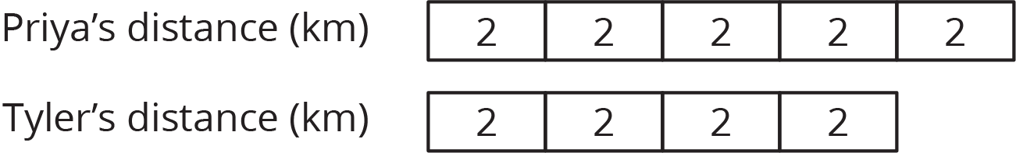
  - What percentage of Priya’s distance did Tyler walk?
  - What percentage of Tyler’s distance did Priya walk?
- A bakery makes 40 different flavors of muffins. 25% of the flavors have chocolate as one of the ingredients. Draw a tape diagram to show how many flavors have chocolate and how many don’t.
- There are 70 students in the school band. 40% of them are sixth graders, 20% are seventh graders, and the rest are eighth graders.
  - How many band members are sixth graders?
  - How many band members are seventh graders?
  - What percentage of the band members are eighth graders? Explain your reasoning.
- Jada has a monthly budget for her cell phone bill. Last month she spent 120% of her budget, and the bill was $60. What is Jada’s monthly budget? Explain or show your reasoning.
- (From Unit 3, Lesson 11.)
- Which is a better deal, 5 tickets for $12.50 or 8 tickets for $20.16? Explain your reasoning.
- (From Unit 3, Lesson 9.)
- An athlete runs 8 miles in 50 minutes on a treadmill. At this rate:
  - How long will it take the athlete to run 9 miles?
  - How far can the athlete run in 1 hour?
- (From Unit 3, Lesson 8.)
© CC BY Open Up Resources. Adaptations CC BY IM.

