Lesson 11: Distintas formas de sumar y de restar

Standards Alignments
Addressing | 2.MD.B.6, 2.NBT.B.5

Teacher-facing Learning Goals
- On a number line, represent place value methods for solving addition and subtraction equations that may involve composing or decomposing a ten.

Student-facing Learning Goals
- Sumemos y restemos usando una decena.

Lesson Purpose
The purpose of this lesson is for students to represent sums and differences on the number line with an emphasis on the strategy of using a ten to count up or count back.
In previous lessons, students learned to look for ways to decompose a number in an expression to get to a ten when adding or subtracting numbers mentally in Number Talks. They have learned to use this method when adding or subtracting larger numbers which require composing or decomposing a ten.
In this lesson, students use the number line to represent these methods. These methods do not require students to explicitly compose or decompose a ten. The number line helps students see how others use what they know about the structure of whole numbers, properties of operations, and place value (MP7) to add and subtract within 100. The number choices in the expressions used in this lesson are designed to elicit methods based on looking for ways to make a ten or get to a ten. However, many students may prefer to use other strategies or representations, such as base-ten blocks or diagrams, to find the values. Look for ways to connect these students with peers who use different methods and can explain why they chose their method based on what they noticed about the numbers in the expressions.

Access for:

Students with Disabilities
- Action and Expression (Activity 1)

Instructional Routines
MLR7 Compare and Connect (Activity 2), Number Talk (Warm-up)

Materials to Gather
- Base-ten blocks: Activity 2
- Tools for creating a visual display: Activity 2

Materials to Copy
- Number Line to 100 (groups of 1): Activity 1
- Number Line to 100 (groups of 1): Activity 2

Lesson Timeline
Warm-up | 10 min
Activity 1 | 15 min
Activity 2 | 20 min
Lesson Synthesis | 10 min
Cool-down | 5 min

Teacher Reflection Question
What evidence are you seeing that students are looking at the relationship between the numbers in an expression to select their method? What progress have you seen students make toward using methods based on the properties of operations and place value?

Cool-down
(to be completed at the end of the lesson) 5min
Sumas y diferencias

Standards Alignments
Addressing | 2.MD.B.6, 2.NBT.B.5

Student-facing Task Statement
- Encuentra el valor de $38+28$.
Usa una recta numérica para representar cómo pensaste.
- Encuentra el valor de $57−19$.
Usa una recta numérica para representar cómo pensaste.

Student Responses
- 66. Sample response:
- 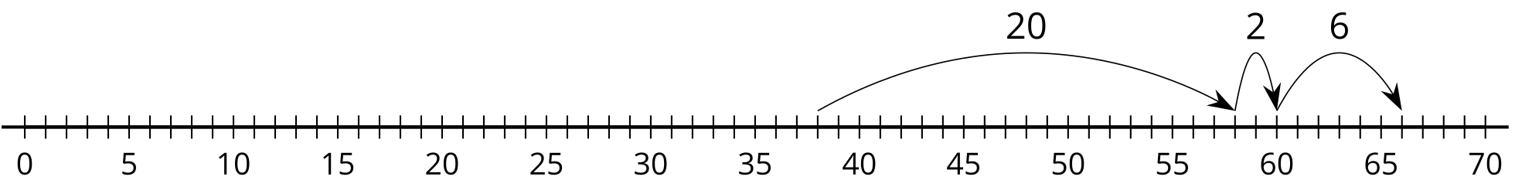
- 38. Sample response:
- 