Lesson 17: Más problemas sobre perímetros

Standards Alignments
Building On | 4.NF.B.3.b
Addressing | 4.MD.A.2, 4.MD.A.3, 4.OA.A.2

Teacher-facing Learning Goals
- Solve problems involving perimeter using multiplicative comparison and addition or subtraction of fractions (including mixed numbers)

Student-facing Learning Goals
- Resolvamos problemas sobre el perímetro de varias figuras.

Lesson Purpose
The purpose of this lesson is for students to solve geometric problems using their understanding of length measurements, unit conversion, multiplicative comparison, and addition or subtraction of fractions.
In a previous lesson, students were reminded about the relationship between the side lengths and the perimeter of a rectangle and reasoned multiplicatively to solve problems about those measurements. In this lesson, they continue to do so but in contexts that require them to convert the units and interpret them. Students also consider the perimeter of other quadrilaterals.
This lesson has a Student Section Summary.

Access for:

Students with Disabilities
- Representation (Activity 2)

English Learners
- MLR7 (Activity 1)

Instructional Routines
True or False (Warm-up)

Materials to Copy
- Missing Measurements - Large, Spanish (groups of 12): Activity 2
- Missing Measurements - Small, Spanish (groups of 4): Activity 2

Lesson Timeline
Warm-up | 10 min
Activity 1 | 15 min
Activity 2 | 20 min
Lesson Synthesis | 10 min
Cool-down | 5 min

Teacher Reflection Question
As students shared their ideas today, how did you ensure all students’ voices were heard? In what ways did you show that all voices are valued and important for collective learning?

Cool-down
(to be completed at the end of the lesson) 5min
Un rectángulo y un trapecio

Standards Alignments
Addressing | 4.MD.A.2, 4.MD.A.3, 4.OA.A.2

Student-facing Task Statement
- Encuentra el perímetro del rectángulo. Muestra cómo razonaste.
- 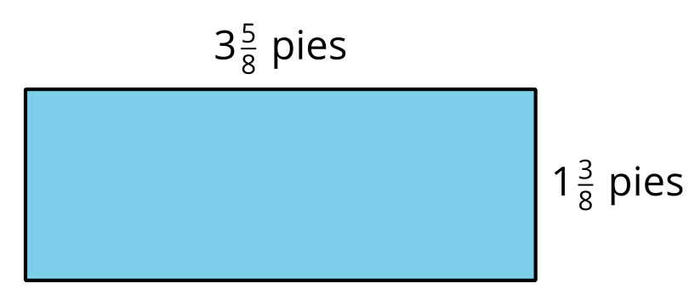
- El perímetro de un trapecio es 10 yardas.
- ¿El perímetro del trapecio es cuántas veces el perímetro del rectángulo? Explica o muestra cómo razonaste.

Student Responses
- 10 feet. Sample reasoning:
  - $3\frac{5}{8}+1\frac{3}{8}=5$ and twice that length is 10.
  - $\left(2×3\frac{5}{8}\right)+\left(1\frac{5}{8}×2\right)=6\frac{10}{8}+2\frac{6}{8}=8\frac{16}{8}=10$
- 3 times. Sample reasoning: One yard is 3 feet, so 10 yards is $10×3$ or 30 feet, and 30 is 3 times 10.

